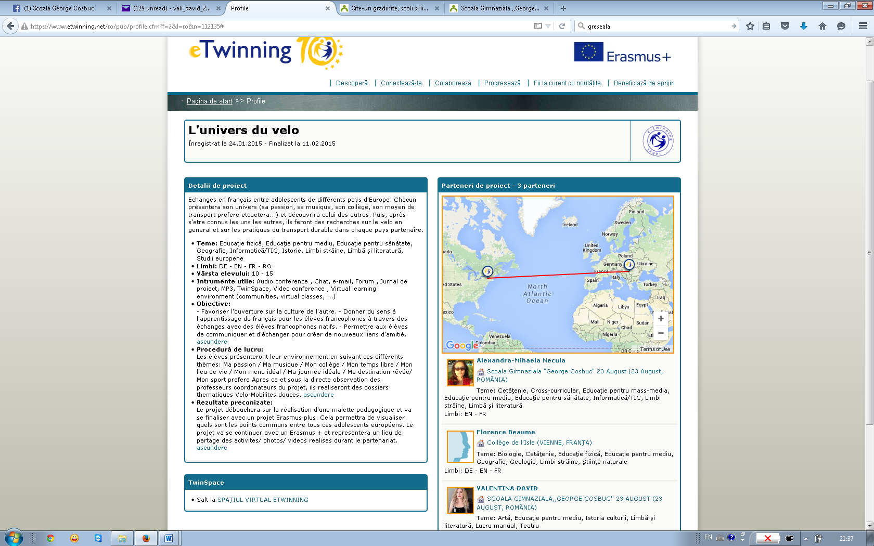
https://www.etwinning.net/ro/pub/profile.cfm?f=2&l=ro&n=112135#

