LICEENII revistă bilingvă
Aprilie 2017
COLEGIUL TEHNIC “GHEORGHE ASACHI”
BOTOȘANI
Aprilie 2017
Cuprins:
- Christmas Traditions Around the World …………………..………p. 2
- Coutumes de Noel en Roumanie / Noel en Provence …………...p. 3 - 4
- Obiceiuri și tradiții pentru anul care vine ………………………..…....p. 5
- Easter in Romania ………….…..p. 6
- Un peu de français – Le Petit Prince ………………………………..…p. 7
- About Facebook ……………..…p. 8
- ATOR – o alternativă de petrecere a timpului liber ……………….…p. 10
- Do you want to watch some interesting movies? …………...p. 11
- Drawing – a part of youngsters’ lives / Popularity and shyness in high school …………………………p. 13
- The emotional life of adolescents …………………………………p. 14
- How to prepare for an EXAM…p.15
- The Stress of the Baccalaureate Exam ………………………..…p.16
- Famous Romanian people – Constantin Brâncuși ………..…p. 17
- Traditional Romanian music – past and present …………………....p. 18
- Top 10 most beautiful places in the world ………………………p. 19-21
- Din nou despre BAC…pe românește……………………..p. 22
- Projects and places…………p. 23-26
- Un message de nos partenaires de France …………………......p. 27-30
- The Effects of Vices on Humans, especially teenagers………...…p. 30
- The Vices QUIZ…………..…..p. 31
- Herd behavior sau efectul de turmă …………………………...…….p. 32
- How to Make Decisions……….p. 33
- Success – Bill Gates’ advice ….p.33

Dragii noștri elevi,
Chiar dacă vremurile pe care le trăim nu sunt ușoare pentru nimeni, creativitatea, talentul, dorința de performanță și de împlinire nu au dispărut, datorită faptului că profesorii au rămas la fel de sufletiști și de implicați, iar elevii sunt tot mai conștienți că numai prin efort susținut pot obține rezultate care să le asigure un viitor frumos.
Faptul acesta, că trebuie să știți carte, că nu puteți conta doar pe înzestrarea voastră naturală, vă creează dintr-o dată o răspundere foarte mare. N-aveți ce face! Cum să fie astăzi un tânăr important pentru societate sau chiar pentru sine însuși, dacă nu știe carte? N-aveți ce face, trebuie să vă supuneți, să învățați, să trudiți încă de tineri! Să vă spuneți: ne pregătim! Aici joacă un mare rol inițiativa și aici trebuie să puneți de la voi ceva, să nu așteptați să vi se dea armura gata făcută, ci să vă faceți voi armura voastră. Noi vă furnizăm uneltele!
În faza aceasta în care sunteți, nu e totul a învăța bine la toate. În primul rând trebuie să aveți ținută morală, să învățați demnitate. Să învățați să fiți OAMENI.
Sunteți acum, în liceu, tocmai la vârsta aceasta și, după cum spune anticul, la început a fost ceață, pe urmă au venit norii, apoi ploaia și abia la sfârșit a venit vremea frumoasă. Sunteți acum în ceață, sau în cel mai bun caz, în anii nebulozității. Vă doresc să ajungeți la vârsta adevăratei frumuseți și vă doresc ceva mai mult, pentru țara aceasta: să fiți voi vremea frumoasă!
Prof. Diana Moruzi, director

Christmas Traditions
Around the World
Christmas is the most popular holiday of the year and traditions differ from one area to another, from one country to another. Superstitions also play an important role in the traditional Christmas practices.
In many regions of France, Christmas celebrations start with St Nicholas’ day on the 6th of December when children get sweets and little gifts. The cities are decorated, especially in the Alsace region, where they say the first decorated Christmas trees appeared as far back as the 14th century. On Christmas Eve children put their polished shoes in front of the stove and hope that ‘Père Noël’ (Father Christmas) will fill their shoes with candies and chocolate. Christmas Day, the 25th of December, is a public holiday and families get together for a big feast. On this day presents are exchanged too.
The Christmas season in Italy begins on the first Sunday of Advent, four Sundays before Christmas. Christmas Fairs feature fireworks and bonfires along with holiday music. Families go to the supermarkets to shop for Christmas gifts and new figures for the manger scene which is called a Presepio. It comprises large numbers of biblical characters, angels, animals and people from everyday life. Nativity scenes are very popular in Italy and are generally found in every household. Before the Presepio families usually gather each morning or evening of novena (an ancient tradition of devotional praying in Christianity) to light candles and pray.

The weather is warm and mild in Mexico during the Christmas season. Families shop for gifts, ornaments, and good things to eat in the market stalls which are called puestos. Their homes are decorated with lilies and evergreens. Family members cut intricate designs in brown paper bags to make lanterns or farolitos. Then they light a candle inside and set the farolitos along sidewalks, on windowsills, on rooftops and outdoor walls to enlight the community with the spirit of Christmas.
Dutch children in Holland, or the Netherlands, eagerly await the arrival of Sinterklaas on St. Nicholas Day on December 6. Sinterklaas is a kind bishop. He wears red robes and a tall, pointed miter on his head. Sinterklaas travels by ship from Spain to Amsterdam's harbor every winter. He brings his white horse and a huge sack full of gifts for children. Families celebrate St. Nicholas Eve at home with lots of good food, hot chocolate, and a letterbanket, the "letter cake" made in the shape of the first letter of the family's last name.
German families prepare for Christmas throughout cold December. Four Sundays before Christmas, they make an Advent wreath of fir or pine branches that has four colored candles. They light a candle on the wreath each Sunday, sing Christmas songs and eat Christmas cookies. In the weeks leading up to Christmas, homes are filled with the delightful smells of baking loaves of sweet bread, cakes filled with candied fruits, and spicy cookies called lebkuchen.
The small number of Christians in China call Christmas Sheng Dan Jieh, which Means Holy Birth Festival. Their homes are decorated with evergreens, posters, paper chains and bright lights. Families put up a Christmas tree called the "tree of light" and decorate it with beautiful lanterns, flowers, and red paper chains which symbolize happiness. They cut out red pagodas to paste on the windows.

Puscasu Gina & Ursu Alexandra, XII D

Coutumes de Noel en Roumanie

Noël est une fête chrétienne commémorant chaque année la naissance de Jesús de Nazareth, appelée Nativité, et célébrée le 25 décembre dans les calendriers grégorien et julien.
En Roumanie, Noël est une fête très importante. Noël est la fête qui nous unit. Habituellement toute la famille se rassemble devant un repas de fête et chante des chansons specifiques, les chants de Noël qui sont une partie importante de la tradition roumaine. De porte en porte, les ‘colindatori’ reçoivent en retour et selon la tradition: des ‘covrigi’, gros bretzels secs, des beignets, des bonbons, des pommes et de l'argent. La veille de Noël toute la famille décore l’arbre de Noël qui est un autre symbole de Noël. Les gens vont à l'église pour prier.

En ce qui concerne la nourriture, le menu est très spécial, plein et savoureux. Avant Noël, il y a une période de jeune, les gens renoncent aux tentations de la chair et de l’âme. Une partie importante avant Noël est la nourriture, les plats pour le dîner de Noël dont les femmes leur donnent beaucoup d’attention. Sacrifié le jour de l'Ignat (quelques jours avant Noël), le porc est minutieusement préparé: des produits de charcuterie, jambon fumé, etc. On fait ‘piftie’ (gelée de viande), des saucisses fraîches de porc, qui seront ultérieurement grillées ou frites, garnies de ‘muraturi’ (cornichons, piments-tomate et tomates vertes en saumure), ‘sarmale’ (Boulette de hachis roulee dans une feuille de choucroute) qui sont le plat national par excellence.

Noel en Provence

En France, Noël est le temps du regroupement familial et de la générosité marquée par des cadeaux est des bonbons pour les enfants. Chaque région a ses propres traditions culinaires françaises liées au nouvel an avec des plats de dinde, chapon, poulet ou boudin blanc. Les plats sont accompagnés du vin Muscadet, Anjou, Sauterne, Champagne.

J'ai rêvé que les guerres n'existaient pas
que la terre ne se détruisait pas
que l'ozone ne nous étouffait pas
que la vie durait éternellement ici-bas...
J'ai rêvé que le Père Noël existait vraiment
et qu'il faisait de nos rêves d'adultes d'enfants un bouquet de réalité
odorante et plein de fantaisie et de musique dansante.

Au cours de la periode de Noël des desserts traditionnels sont servis:

Bûche de Noël
Un gateau au chocolat qui, à la base, était un biscuit génoise, sur lequel était étalée de la crème au beurre parfumé au café, au chocolat, qu'on roulait ensuite pour lui donner la forme d'une bûche, qu'on recouvrait ensuite d'une fine couche de crème au beurre avec une poche munie d'une douille ‘chemin de fer’.

Le pain calendeau – le pain de Noël
Un pain traditionnel fait dans le sud de la France
Un autre aspect important de Noël consiste en scènes de la naissance du Sauveur. Dans le sud de la France, en Provence, en crèches sont introduit les trois sages, les bergers, des vieux villageois qui sont habillés en costumes traditionnels.

Carausu Sabina & Terinte Cosmin, XII D

Obiceiuri și tradiții pentru anul care vine !

Lăsarea în urmă a vechiului an și intrarea într-un nou an este marcată de fiecare dată prin obiceiuri care îi încântă nu doar pe cei mici, dar și pe cei mari. Acestea diferă de la o zonă la alta în funcție de specificul local și nu trebuie ratate dacă ați hotărât să vă petreceți cumpăna dintre ani în altă parte decât acasă.
În dimineața zilei de 1 ianuarie, copiii merg din casă în casă urând gazdelor sănătate și roade bogate în noul an. Profesorii sunt întâmpinaţi de grupuri de elevi încă de dinainte de vacanţa de iarnă cu colinde la şcoală. Ei vestesc evenimentele veniirii Fiului lui Dumnezeu ca prunc prin colind, însă la fel de emoţionant este şi momentul de sorcovă despre care dorim să vorbim.
Sorcova este unul dintre cele mai îndrăgite obiceiuri de Anul Nou şi are o semnificație aparte, una ce ține de structura sufletească, de datini și așteptările pe care le are cel sorcovit de la Noul An: să fie un an bogat, să fie sănătos el și familia lui.
Numele de “sorcova” vine cel mai probabil de la cuvântul bulgar “surov” (verde fraged), aluzie la ramura abia îmbobocită, ruptă dintr-un arbor. Astăzi, copii aruncă semințe (înlocuite cu orez decorticat, deoarece semințele date în bătătură, sau pe pragul ușii gazdei, imită semănatul din toamnă a grâului sau semănatul din primăvară,cu nădejdea încolţirii şi să dea rod bogat. Pentru a avea mai mult pace şi linişte în anul ce începe, trebuie să aveți grijă să nu rămâneți nesorcoviți. Nu uitați să le dăruiți copiilor covrigi, cozonac, mere, bani ca tot ceea ce v-au cântat să se împlinească.
Aşadar elevii din clasele a IX a B, D H şi a X a A, B, C, D, H ai Colegiului Tehnic ‘Gheorghe Asachi’ coordonaţi de d-ra prof. Mariana Fortoeş au ţinut să transmită conducerii şcolii şi întregului colectiv de profesori din şcoală gândurile bune pentru Noul An 2017 şi o aleasă sorcovă din ţinutul moldovei:
Sorcova să trăiţi mulţi ani fericiţi!
Să trăiţi, să trăiţi
Întru mulţi ani fericiţi
Şă ca pomii să-nfloriţi.
Şi ca toamna cea bogată,
Fie casa-ndestulată
Tot cu mesele întinse
Cu făcliile aprinse
Să petreceţi împreună
Până-n veci cu voie bună.
Câtă şindrilă pe casă,
Atâţia galbeni pe masă.
Ca viţa de vie
La Sfânta Marie
Anul Nou ce vine,
Cu zile senine
Tare ca piatra
Iute ca săgeata
Tare ca fierul
Iute ca oţelul.
Şi ca pomii să-nfloriţi
Şi ca ei să-mbătrâniţi
Şi ca toamna cea bogată
Fie casa-ndestulată.

La anul şi La mulţi ani!

Prof. Mariana Fortoeş
EASTER IN ROMANIA

Easter is the time of the Christian year when Christians remember the Death and Resurrection of Jesus Christ. They believe that Jesus, the son of God, died for everyone's wrong-doings and then came back to life three days later to defeat death and evil: so if you believe in Him you will live forever in Heaven.
For Christians, the full Easter period lasted for a long time. Easter officially starts with Lent on Ash Wednesday, 46 days before Easter Day. (Lent lasts for 40 days but you don't count the Sundays!) Then 39 days after Easter Day, Christians celebrate Ascension Day, when they remember Jesus going back into Heaven and promising to come back to earth one day. Easter officially ends 49 days after Easter Day with the Christian Festival of Pentecost or Whitsun, when Christians remember that God sent his Holy Spirit to help Christians. So Easter is a very busy time for Christians!
In many languages, the words for "Easter" and "Passover" are identical or very similar.
Prof. Tănase Anamaria
Un peu de français
Le Petit Prince

«Le Petit Prince» est l’oeuvre la plus connue d'Antoine de Saint-Exupéry. Publié en 1943, c'est un conte poétique et philosophique sous l'apparence d'un conte pour enfants. Dans ce conte, Saint-Exupéry relate, avec beaucoup de poésie, le voyage extraordinaire d’un enfant à la découverte du monde et de ses réalités. Sans doute l’un des livres les plus lus et les plus connus des petits et des grands.
Voici un résumé du conte:
L’auteur, aviateur, tombe avec son avion en plein désert du Sahara. Pendant qu’il s’efforce de réparer son appareil, apparaît un petit garçon qui lui demande de lui dessiner un mouton. L’auteur apprend aussi que ce « Petit Prince » vient de l’astéroïde B 612 où il a laissé trois volcans et une rose.
Avant d’arriver sur la Terre, il a visité d’autres planètes et rencontré des gens bizarres: un roi, un vaniteux, un buveur, un allumeur de réverbères, un géographe… Sur la Terre, il a pu parler avec un renard qui lui a appris que pour connaître il faut « apprivoiser », et que cela rend les choses et les hommes uniques. « L’essentiel est invisible pour les yeux », dit-il.
Pour retrouver sa rose, Le Petit Prince repart chez lui en se faisant mordre par un serpent venimeux: c’est trop loin, il ne peut pas emporter son « écorce ». L’aviateur, qui a fini de réparer son avion, quitte lui aussi le désert. Il espère toujours le retour du Petit Prince et nous prie de le prévenir si jamais nous le rencontrons.
Voici une liste des citations et phrases marquantes du Petit Prince, pour les petits, certes, mais aussi pour ceux qui n'ont pas oublié leur enfance, et leurs rêves.
- L’ autorité repose d’ abord sur la raison. Si tu ordonnes à ton peuple d’ aller se jeter à la mer, il fera la révolution. J’ ai le droit d’ exiger l’ obéissance parce que mes ordres sont raisonnables.
- On ne voit bien qu’avec le cœur. L’essentiel est invisible pour les yeux.
- Tu te jugeras donc toi-même, lui répondit le roi. C’est le plus difficile. Il est bien plus difficile de se juger soi-même que de juger autrui.
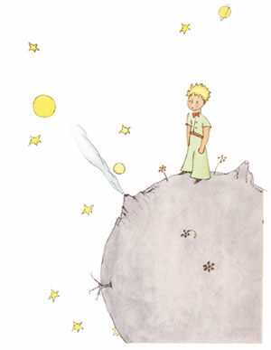
- Ce n’ était qu’ un renard semblable à cent mille autres. Mais j’en ai fait mon ami, et il est maintenant unique au monde.
- Tu es responsable pour toujours de ce que tu as apprivoisé.
- Qu’est-ce que signifie «apprivoiser»? dit le Petit prince. – C’est une chose trop oubliée, dit le renard. Ca signifie «créer des liens…».
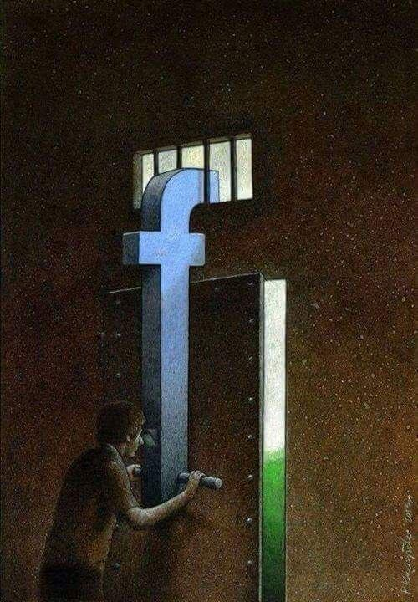
- Les hommes n’ont plus le temps de rien connaître. Ils achètent des choses toutes faites chez les marchands. Mais comme il n’existe point de marchands d’amis, les hommes n’ont plus d’amis.
- Fais de ta vie un rêve, et d’un rêve, une réalité.
- C’est le temps que tu as perdu pour ta rose qui fait ta rose si importante.
- Toutes les grandes personnes ont d’ abord été des enfants, mais peu d’ entre elles s’en souviennent.
- Les yeux sont aveugles, il faut chercher avec le cœur.
- Si tu réussis à bien te juger, c'est que tu es un véritable sage.
- On risque de pleurer un peu si l'on s'est laissé apprivoiser.

Je vous invite à la lecture du Petit Prince!

Prof. Marinela Niculăeş

About Facebook

I can say that Facebook is probably the best social site in the world. Am I right? I believe I am. Through this site, many friendships were formed but also disbanded.
First of all, Facebook is a common site that allows you to find up-to-date news, enjoy great songs shared by famous artists, discover pictures of our friends as well as a great number of jokes. This is the good part of this site, but there are bad parts too.
Once attracted to this virtual world we will begin to be trapped in ourselves and we will certainly not communicate nearly as much as we used to. The ‘New Generation’ is so strongly attracted to this site that they spend most of their time scrolling through Facebook to find out new things, and more often than not these things are unimportant. This generation refuses to leave their home to make new friends and have inter - human interactions. They live their lives through this virtual world, they talk with their 'loved' ones online, if there is a festival in their town, they never bother to go see it live .What they do is just wait for one of their friends to post pictures so that they can later Love or WOW them. ‘Like’ has become old-school.
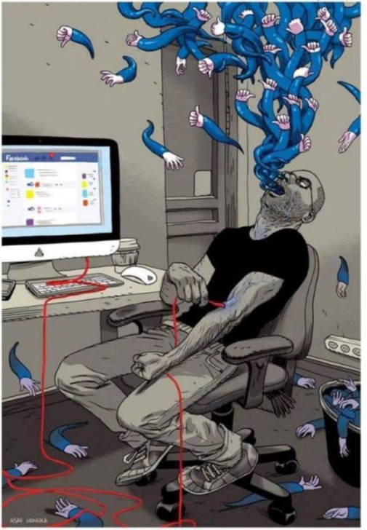
Secondly, I would say that there are people living from 'Likes'. I understand; you feel good when you have 80-100 likes a picture, at least in my case, but you, dear friend, do 800 likes help you sleep peacefully at night? Friends, take it easier with popularity. Last week I stumbled across a girl who had many Likers on her pictures, between 600 and 800. The truth is, she did look pretty good. I could say that she was like a 'Likes Goddess'. My 100 likes did not deserve to be compared to those of a person with so many likes. If you, Goddess, are reading this article, I want you know that you have passed the experiment.

In conclusion folks, I would advise you to let loose of this virtual world and do something constructive. Go out in the park, take the train and travel anywhere in the country to see that real life is much more fun than the virtual one.

Gradinaciuc Constantin, XII E

ATOR - o alternativă de petrecere a timpului liber

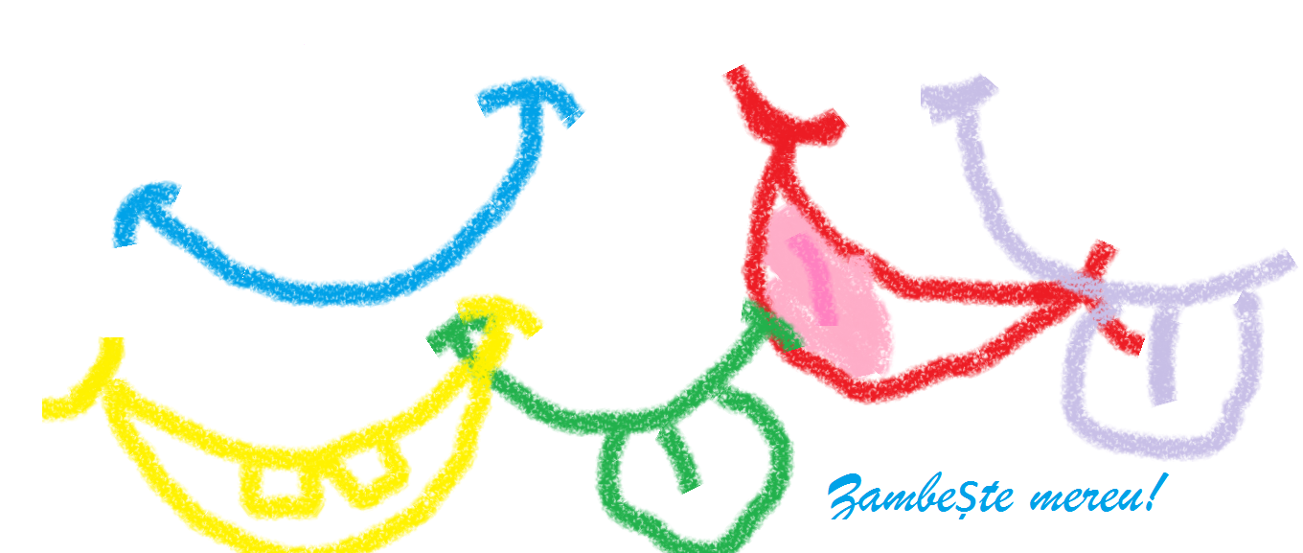

ATOR - Asociația Tineretul Ortodox Român

"Suntem un grup de tineri entuziaști, responsabili, dornici de a fi de folos și de a fructifica la maxim talanții pe care i-am primit. Valorile noastre sunt: credința în Dumnezeu, iubirea de țară și neam, educația și cultura, iubirea de frumos și libertatea. Ne-am reunit sub denumirea de ATOR (Asociația tinerilor ortodocși români ) pentru a aduce bucurie pe chipul aproapelui și pentru a face un pas spre implinirea spirituală." Așa le place să se recomande, insă eu pot spune, cu mâna pe inimă, că acești tineri, impreună cu îndrumătorii lor, reușesc să fie mult mai mult decât o asociație. Ei sunt, de fapt, o mare FAMILIE. Da, da, ați citit bine: FAMILIE! Acesta este cuvântul perfect pentru a-i descrie. O familie călduroasă, grijulie și iubitoare, care își dorește cu adevărat fericirea fiecărui membru și mai ales fericirea fiecărui om. Ceea ce m-a impresionat profund a fost abilitatea lor, și cât de bine se descurcă în realizarea acestei dorințe, pentru că, după cum bine știți : E FAIN SĂ VREI insă , din păcate, nu toți se luptă și nu toți depun eforturi pentru dorințele lor .Tot așa FAIN vrea și își dorește fericirea noastră, societatea, dar nu tot așa fain se descurcă.

Se pare că ATOR a pătruns în adâncul sufletului și a citit toate secretele unui tânar. Punând în valoare toate plăcerile acestuia: socializare, contemporaneitate, călătorie, muzică, dans, le oferă tot ceea ce au nevoie pentru a fi fericiți și pentru a reuși: ascultare, afecțiune, încredere, compasiune. Această asociație ne dezvaluie un mod mult mai frumos de a învața, de a ne forma caracterele, de a ne educa. De la ei am aflat cât de multe lucruri folositoare putem învăța cu zâmbetul pe buze și tot de la ei am învățat cât de educative sunt călatoriile și câți oamni-genii sunt și în zilele noastre, având personal onoarea să fac cunoștință cu unii dintre ei. Hmmm...șmecherie cu buton, nu?! Și cu manual de instrucțiuni :)). Cred că ei, de fapt, îmbină utilul cu plăcutul...SIGUR!!!! Sigur asta fac. Cât de mișto poate fi! De acord, așa-i?!

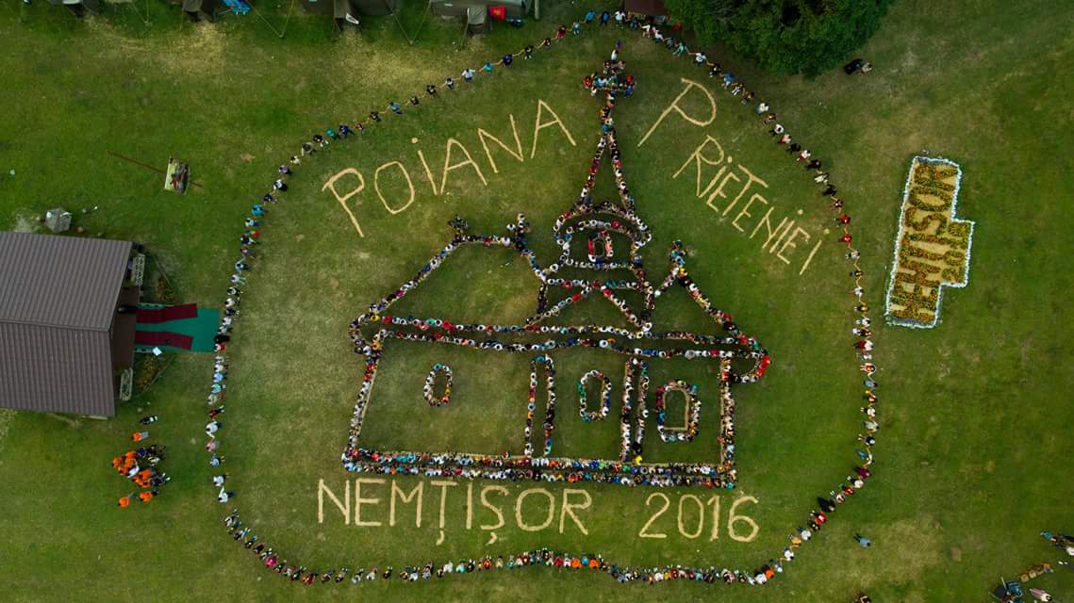
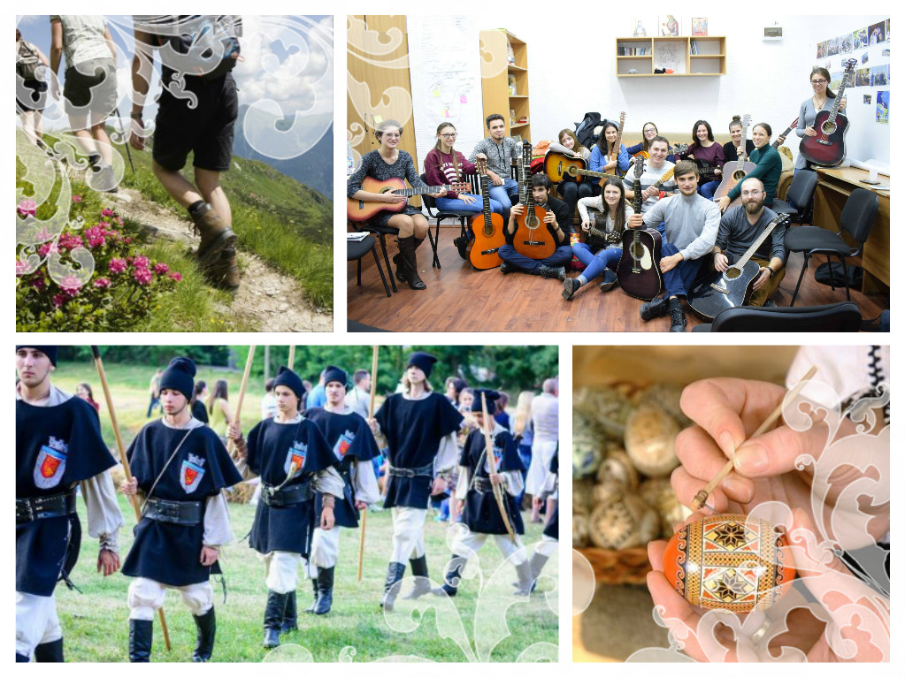

În spatele acestor tineri stau oameni binecuvântați cărora li se cuvine tot meritul și fără de care nimic nu ar fi fost posibil. Ei depun adevăratele eforturi și sacrificii pentru funcționarea "motoarșului" ATOR, fără a aștepta ceva in schimb în afara unor zâmbete sincere. Acești oameni sunt preoții și slujitorii Bunului nostru Dumnezeu. Niște îngeri ,dacă ar fi să mă intrebați pe mine. Ei călăuzesc calea tinerilor și îi ajută să aleagă ceea ce este bun și de ajutor sufletelor, pentru reușita în viață, pentru SUCCES! Astăzi, poate mai mult că niciodată, avem nevoie de LUMINĂ , de îndrumare, și asta putem gasi cu ușurință în cadrul acestei frumoase familii. Aș putea să vă spun mult mai multe, însă nu vreau să vă plictisesc :)). Vă mai dau totuși un mic sfat: mergeți în una din taberele ATOR, și vă promit că nu veți regreta.
VĂ DORESC NUMAI BINE!!!
Cazacu Roxana, XII E

Do you want to watch some interesting movies but you don’t know what to choose?

If I've got your attention, in the following lines I'll introduce to you some titles that you might like. The first on this list is Zootopia, an animation movie which might not sound so good, but it is more than decent.

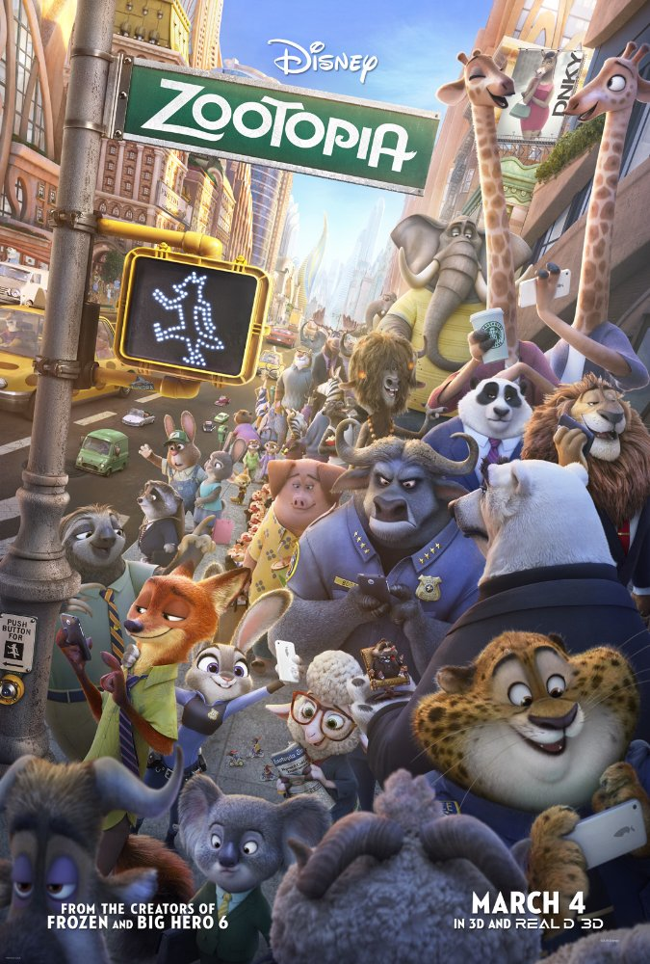

Storyline
From the largest elephant to the smallest shrew, the city of Zootopia is a mammal metropolis where various animals live and thrive. When Judy Hopps becomes the first rabbit to join the police force, she quickly learns how tough it is to enforce the law. Determined to prove herself, Judy jumps at the opportunity to solve a mysterious case. Unfortunately, that means working with Nick Wilde, a wily fox who makes her job even harder.

The next title on this list is Deadpool, a movie that falls in three genres: action, adventure and comedy.

Storyline
This is the origin story of former Special Forces operative turned mercenary Wade Wilson, who after being subjected to a rogue experiment that leaves him with accelerated healing powers, adopts the alter ego Deadpool. Armed with his new abilities and a dark, twisted sense of humor, Deadpool hunts down the man who nearly destroyed his life.

The third title of this list is: Anthropoid.

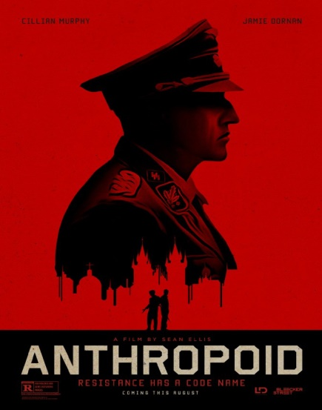

Storyline
Anthropoid is based on the extraordinary true story of Operation Anthropoid, the World War II mission to assassinate SS General Reinhard Heydrich. The Reich's third in command after Hitler and Himmler, Heydrich was the main architect behind the Final Solution and the leader of occupying Nazi forces in Czechoslovakia whose reign of terror prompted self-exiled Czech and Slovak soldiers to hatch a top-secret mission that would change the face of Europe forever.

We could continue with Angry Birds, the 3D animated comedy which will help us finally find out why birds are so angry. The movie takes us to an island populated entirely by happy, flightless birds - or almost entirely. In this paradise, Red, a bird with a temper problem, speedy Chuck and the volatile Bomb have always been outsiders. But when the island is visited by mysterious green piggies, it's up to these unlikely outcasts to figure out what the pigs are up to.

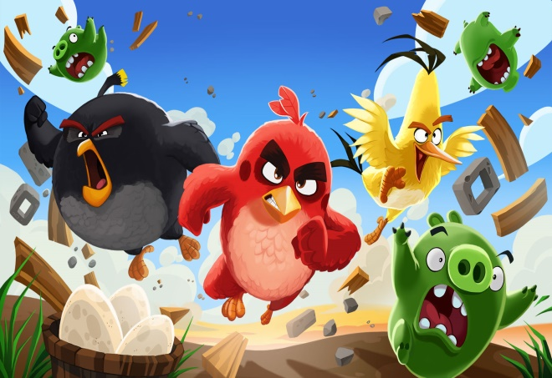

Rotaru Paul & Roman Corneliu, XII D

Drawing
– a part of youngsters’ lives

Young people today choose to express themselves in different ways. One of them is the drawing. You start with the first two lines and finish with geometric figures. You don’t have to have talent, just let your heart be driven away. Drawing is a technique that lies in the graphical representation of an object, a figure, an art in which a person uses various drawing instruments to mark paper and define himself / herself. That can easily be exploited by people, especially teenagers.

I chose youngsters because I see them attracted both by drawing as well as music. By using a pen or a pencil they manage to ‘draw’ their feelings and thoughts on paper.
Over time I have noticed the ever increasing drawing influence on young people. A study shows that over 53% of youth aged 16-18 tend to draw something at least once a day.
Most of them use drawing to get rid of stress and to occupy their free time. This activity is a good therapy form against stress. Therefore scientists have come to their aid with an interesting challenge: ‘Coloring books’ that support people with a hectic pace of life.
‘When I draw, I feel free of all the commotion around me’ (Andrei)
‘Drawing is a part of my life’ (Maria)

Pînzaru Adelina & Buhă Cosmina, XII D

Popularity and shyness in high school

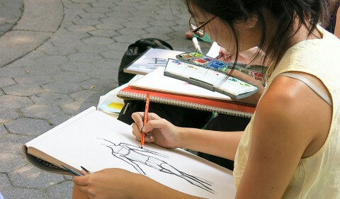
POPULARITY = the quality of being known, sympathized
SHYNESS = lacking boldness, comfort, especially around other people

Popularity and shyness are polar opposites. Students differentiate themselves through their character: some are introverts while others are extroverts.
• I would say that popularity is not just about clothing or make-up; the attitude that people choose to adopt also matters. A popular person should stand out through his /her knowledge, his / her friendship to others.
• Shyness is manifested in introverts. Usually it affects teenagers because there are cases in which they are abused verbally and physically.
• Differentiation should not exist. There are different types of characters. We just have to accept ourselves and one another as we are and be more tolerant.

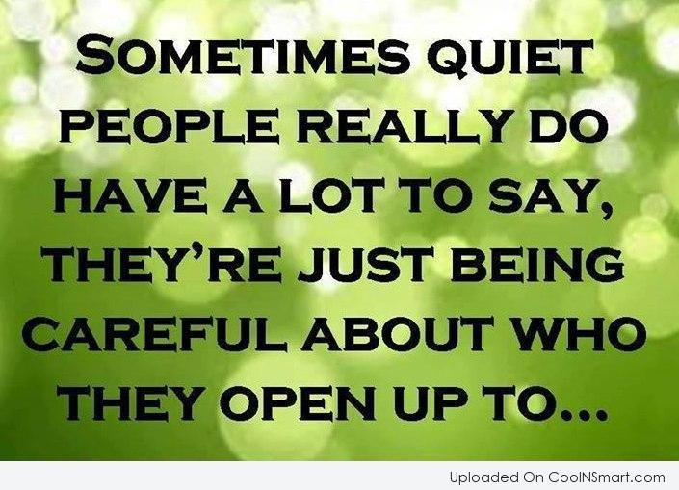

Cristescu Florentina, XII E

The emotional life of
adolescents

Anyone who is or was an adolescent knows that time of life is full of emotional turmoil. Adolescence is often a time of intense fear and anxiety, loneliness, guilt, shame, exuberance, anger, infatuation and joy.
Adolescents are commonly understood to experience emotion more intensely than adults and to cycle more quickly through moods in their day-to-day lives. A study in Emotion investigates at what age emotions are most intense in adolescents, how rapidly they change and the influence of coping strategies on how teens respond to their emotions.
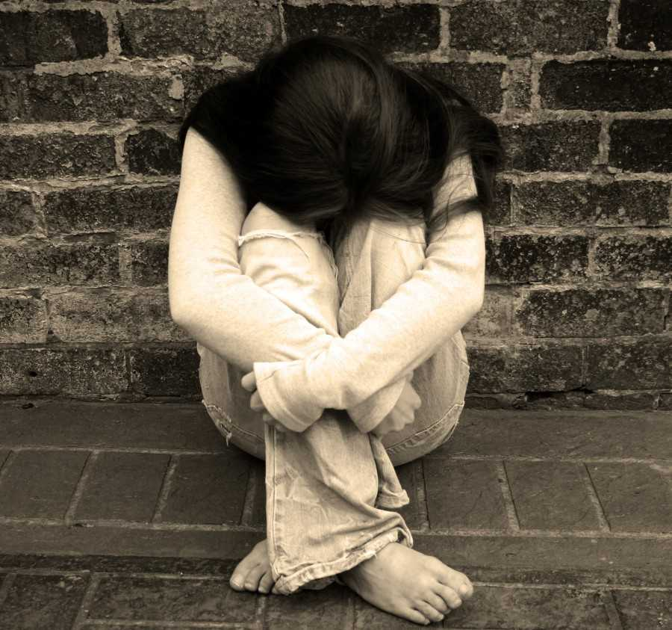
The study aims to understand whether older teens, who tend to be less emotionally reactive than younger teens, simply experience less intense emotions than younger teens or whether they experience equally intense emotions but are better at managing them.
Separating whether a teen is experiencing intense emotion, but coping with it or experiencing emotions that are less intense is a complicated process. In this study, teens were asked to respond to some emotional pictures naturally and others using a coping technique they'd been taught.

Social Situations and Sensitivity Matter
Adolescents tend to be intensely interested in friendships and highly sensitive to social influence and peer rejection. Navigating changing and expanding friendships and evolving social cues and rules is complicated and emotionally fraught at this age.
And for some it's more difficult than for others. Some adolescents tend to be more sensitive to rejection than others. These teens anxiously anticipate and perceive rejection. They are more vulnerable to feelings of rejection and ostracism. For them, it is more difficult to learn strategies to cope with painful emotional situations than it is for the average teen, which puts them at risk of low self-esteem, relationship violence and trouble functioning with kids their age.
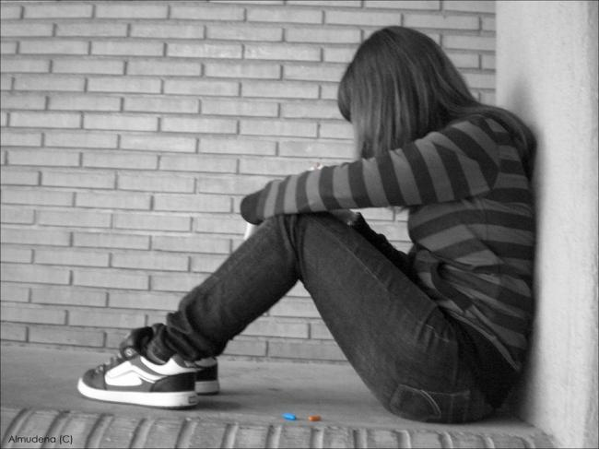
These sensitive teens do tend to make progress developing coping skills as they move through the teen years and many do not develop social or emotional problems. Early positive social experiences or having different coping skills, such as the ability to delay gratification or exert self-control, may account for these differences.
Whether you're parenting an adolescent, caring for one or simply are an adolescent it's helpful to better understand what is happening, emotionally, during this tumultuous time. The results from this study suggest that early adolescence is a critical time in the development of healthy coping skills and that these skills may be particularly important for teens sensitive to rejection.

Țurcanu Carmen-Elena, XII D

How to prepare for an EXAM

Give yourself enough time to study!
Preparing for exams should start earlier than the last days before the exams. Set out a timetable for your study.
- Organize your study space!
Make sure you have enough space to spread your textbooks and notes out. Have you got enough light? Is your chair comfortable? Are your computer games out of sight? Try to get rid of all distractions, and make sure you feel as comfortable and able to focus as possible.
- Practice with old exams!
One of the most efficient ways to prepare for exams is to practice by doing past versions of the exam that you are going to take.
- Explain your answer to others!
Parents and little brothers and sisters don’t have to be annoying around exam time! Use them to your advantage. Explain an answer to a question to them.
Preparing for an exam can be stressful and time-consuming, but it doesn’t necessarily have to be like that. There’s no need to stress out too much. By doing a couple of simple things ahead of time, you can ensure that you are confident and ready for anything that comes up during the exam.

Ifrim Sorina & Acatrinei Diana, XII C
The Stress of the Baccalaureate Exam
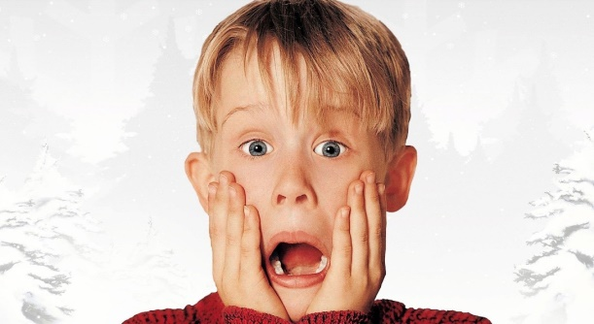

An important moment in the life of a teenager is the BAC exam and admission to University. The stress of the Baccalaureate exam, along with the transition to another level - student life - can cause a lot of tension as well as mental and physical fatigue.

The consequences of stress

One of the main consequences of stress that affects young people in this period is low school results. If you get to the third stage of manifestation of stress, the risk of developing serious illnesses like migraines, heart disease, ulcers, stroke, etc. is very high.
There are other consequences of stressful periods, which can manifest on a long term (sometimes a lifetime). These are: frustration, poor tolerance to contradictory discussions, anxiety, panic attacks, poor memory capacity, inability to concentrate, decreased attention, sleeping disorders, mood problems, depression, high blood pressure, coronary artery disease, etc.

The best way to avoid all these is to be well prepared for your exam. There is nothing more reassuring than knowing that you have studied and that there are few things that can cause difficulty to you.

Ifrim Sorina, XII C

Perle BAC

"Moromeții are ca personaj pe Marin Moromete, care are o viziune despre lume în care țăranul român avea copii, pe care îi bătea, deoarece ei cereau haine și fugeau cu oile la oraș, mai ales unul dintre frați, Nilă".

"Jocurile sunt importante pentru dezvoltarea ta în fața colegilor, adică ăia care se oftică când le spui că ai ajuns la un nivel peste ei"

”Ion este roman psihologic, tratează zbuciumul său când sărută pământul ca pe o iubită.”
Famous Romanian people – Constantin Brâncuși

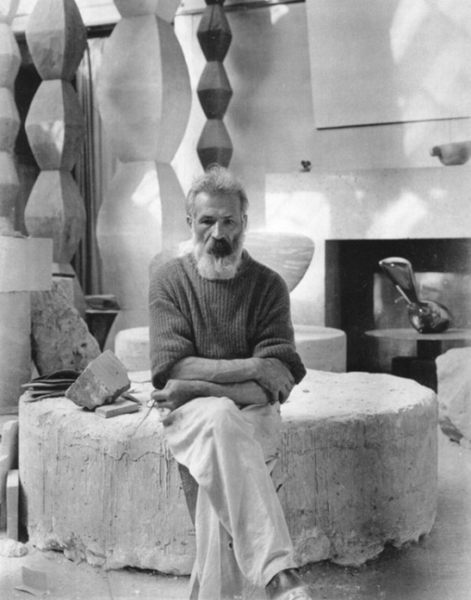
February 19, 1876 – March 16, 1957

Constantin Brâncuși was a Romanian sculptor, painter and photographer who made his career in France.
Considered a pioneer of modernism, one of the most influential sculptors of the 20th-century, Brâncuși is called the patriarch of modern sculpture.
Brâncuși grew up in the village of Hobiţa, Gorj, near Târgu Jiu, close to Romania's Carpathian Mountains.
At the age of nine, Brâncuși left the village to work in the nearest large town.
At 11 he went into the service of a grocer in Slatina; and then he became a domestic in a public house in Craiova where he remained for several years.
When he was 18, Brâncuși created a violin by hand with materials he found around his workplace. Impressed by Brâncuși's talent for carving, an industrialist entered him in the Craiova School of Arts and Crafts, where he pursued his love for woodworking, graduating with honors in 1898.
In 1903, Brâncuși traveled to Munich and from there to Paris. In Paris, he was welcomed by the community of artists and intellectuals brimming with new ideas.
His works became popular in France, Romania and the United States.
Collectors, notably John Quinn, bought his pieces, and reviewers praised his works.
In 1913 Brâncuși's work was displayed at both Le Salon des Indépendants and the first exhibition in the U.S. of modern art, the Armory Show.
Brâncuși died on March 16, 1957, aged 81.
He was buried in the Cemetery of Montparnasse in Paris.
This cemetery also displays statues that Brâncuși carved for deceased artists.
Some of his works: Poarta de la Târgu Jiu, 1937 (The Gate), Masa Tăcerii, 1938 (The Silent Table), Coloana fără sfârșit, 1937 (The endless column)

Molocea Florina, XII C

Traditional music (past and present) – Romanian folklore music

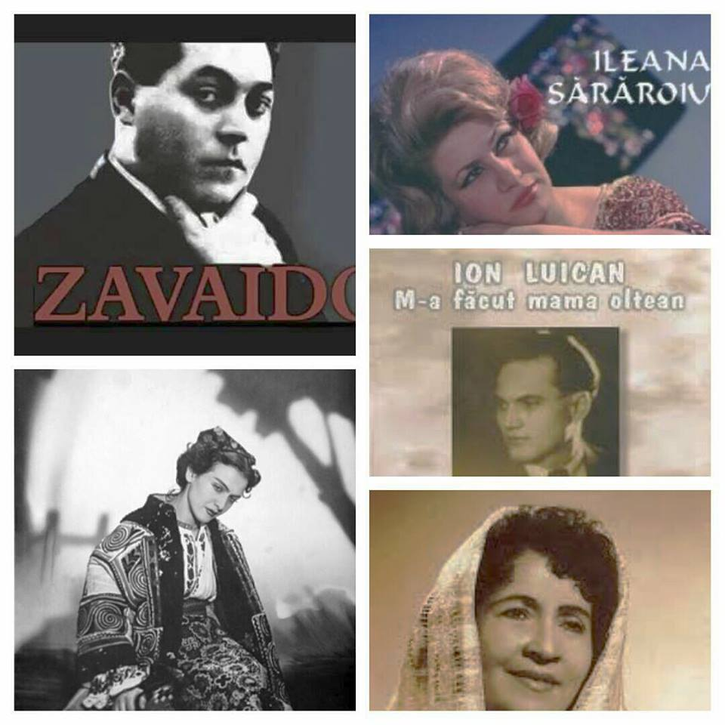

‘Pasiunea mea pentru muzica populară am avut-o din copilărie. Chiar dacă timpul a trecut nu m-am îndreptat spre un alt drum deoarece știu și simt că muzica mă definește întru-totul. Sunt hotărâtă să mă dedic muzicii populare pentru că ea mă definește ca persoană și prezintă baza originii neamului meu.’ (Bejan Daliana, clasa a XII-a E)
The traditional music is defined by the creations of its ancestors transmitted from generation to generation. It reflects the spirituality, culture and feeling of the people . For me the traditional music is comfort to my soul. When you have joy you can listen to a song playing and when you’re sad you can listen to a ‘doina’ (a Romanian musical tune style), a ballad, a violin song and the musical notes give you comfort.
A feature of Romanian culture is the special relationship between folklore and the learned culture, determined by two factors. First, the rural character of the Romanian communities resulted in an exceptionally vital and creative traditional culture. Folk creations (the best known is the ballad Miorița) were the main literary genre until the 18th century. They were both a source of inspiration for cultivated creators and a structural model.
Unforgettable Romanian Artists:
Maria Tănase, Romanian singer and actress. Her music ranged from traditional Romanian music to romance, tango, chanson and operetta.
Maria Tănase has a similar importance in Romania to that of Édith Piaf in France. In her nearly three-decade-long career, she was admired for her originality, voice, physical beauty and charisma. In Romania, she is still regarded as a major cultural icon of the 20th century, the queen of the Romanian traditional music. Among her songs are these ones: Cine iubește și lasă (1937), Ciuleandra (1956) and Până când nu te iubeam.
Maria Lătărețu, the ‘bird from Grj’, an artist who dedicated her entire life to music. Since traditional Romanian music is often surprising Lie ciocârlie is one of the famous songs of musical folklore. The imitation of the skylark trills is the most attractive feature of this song. Beyond these trills, Ciocârlia (The Skylark) is actually a sad song. However, it became famous in Romanian popular culture mainly because it is a very difficult song to sing. This song, launched by Maria Lătărețu, became, over time, a part of the musical heritage of the Romanians.
There are many other artists worth mentioning: Ileana Sararoiu, Zavaidoc, Ion Luican, Maria Ciobanu, Irina Loghin, Sofia Vicoveanca and many others.
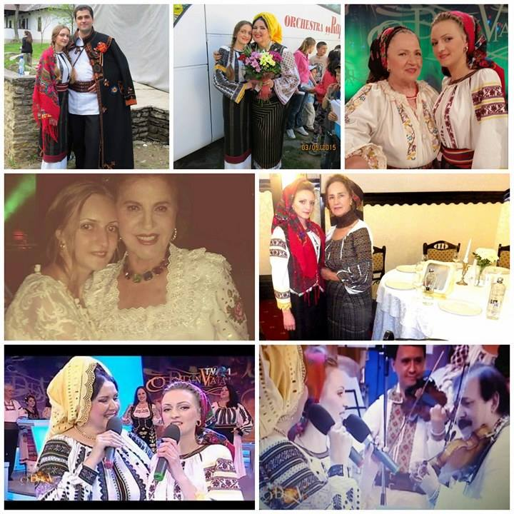

Bejan Daliana, XII E

Top 10 most beautiful places in the world

1. Papua New Guinea
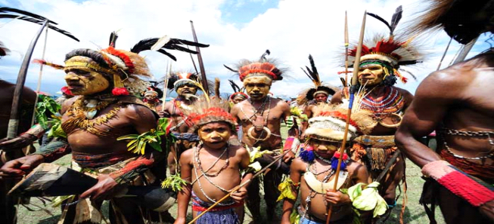
Given that we are talking about one of the least favorite tourist destinations, we are just utterly amazed that some of the most exotic creatures of the planet can be found here. In this corner of the world, the bulk of humanity lives in rural communities remaining for hundreds and hundreds of years, and Port Moresby is the perfect place to start exploring groups here.
2.Olavango Delta, Botswana
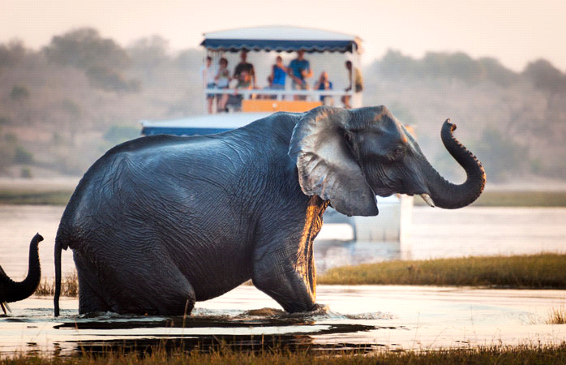
Technically, the Olavango Delta is part of the Kalahari Desert, but the delta is a totally different experience. Visit it in the months of July and August and you will witness the miracle of the yearly migration of elephants, lions, buffaloes, giraffes and several others, while making their way through the desert to reach the delta.
3.Canadian Rockies, Canada
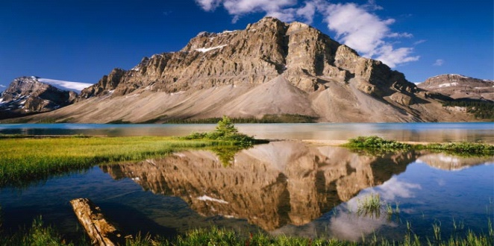
Few people can boast about having seen so many Rocky giants who stretch from Canada all the way to the US-Mexico border. Also the place houses as many as four national parks (Yoho, Banff, Jasper and Kootenay), so beautiful that they were taken under the ‘wing’ of UNESCO. We talk about habitats of rare and endangered species such as the grizzly.

4.Yukatán, Mexico
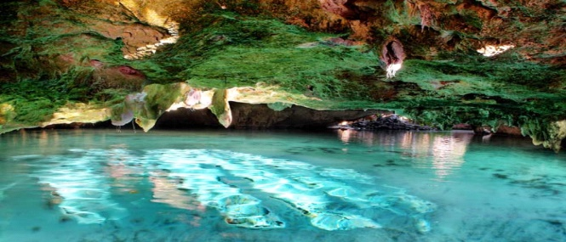
The breathtaking beaches have something to do with the reputation of Yukatá, but equally beautiful (at least) are the cenotes that slowly made their place under the earth's crust. These sinkholes are from limestone rocks that have collapsed and turned into some of the most beautiful natural pools on the planet. And they are perfect for diving and scuba diving and the best part is that they are quite affordable.

- Bialowieza Forest, Poland

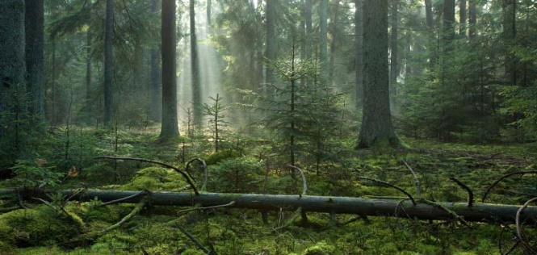
With one foot in Poland and one in Belarus, Bialowieza Forest, it is one of the last and largest remaining parts of the immense primeval forest that once stretched across the European Plain. The forest is home to 800 European bison, Europe's heaviest land animal. The Białowieża Forest World Heritage site covers a total area of 141,885 ha. Since the border between the two countries runs through the forest, there is a border crossing available for hikers and cyclists.
6.Canyon, Arizona, USA
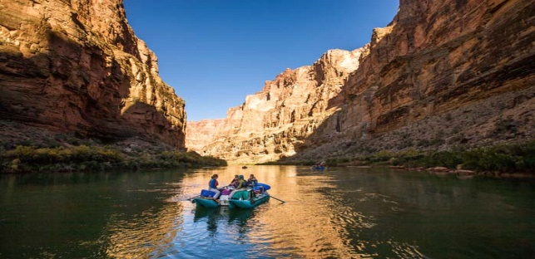
The Grand Canyon is a river valley in the Colorado Plateau. It is not the deepest canyon in the world but it is famous for its visually overwhelming size and its intricate and colorful landscape. The Grand Canyon is 277 miles (446 km) long, up to 18 miles (29 km) wide and attains a depth of over a mile. It is one of the wonders of nature.
7.North American Prairie, Montana, USA
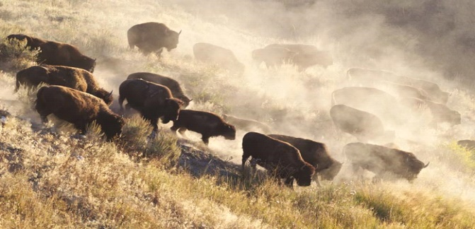
The national parks have emerged as a lifeline and the poor buffalo escaped from total extinction. Today, the number reached 500.000 and the National Bison Range in Montana refuge has had great merit in saving this species. From Missoula, the park is more than affordable and the traveler expects to enjoy the magnificent scenery, either by car or on foot.
8.Madagascar
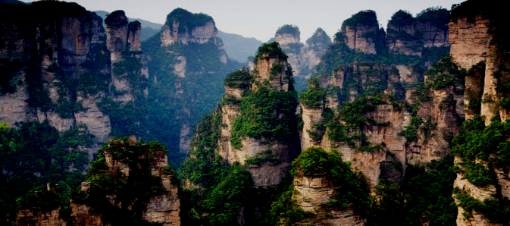
Madagascar is the fourth largest island and its long isolation from the neighboring continents has resulted in a unique mix of plants and animals, many found nowhere else in the world. This has led some ecologists to refer to Madagascar as the ‘eighth continent’. Of the 10,000 plants native to Madagascar, 90% are found nowhere else in the world.
9.Galapagos Islands
They are an amazing archipelago of volcanic islands distributed on either side of the Equator in the Pacific Ocean. The islands are known for their vast number of endemic species and were studied by Charles Darwin during the voyage of the Beagle, as his observations and collections contributed to the inception of Darwin's most disputed theory of evolution by natural selection. 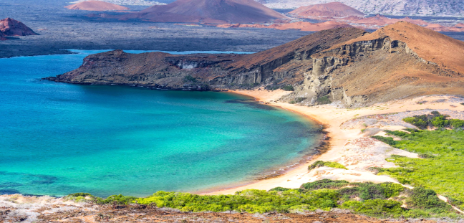
10.Jodhpur, India
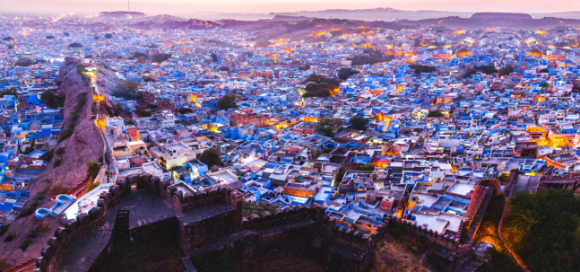
Also known as the Blue City due to the heaps of houses painted in different shades of azure, those who know Jodhpur surely know something about its temples, palaces, spices and its history. Also it is impossible not to be impressed even a little. And if there is one thing for which the city is known, it is the co-resident population made up of hundreds of furry gray langur, a group of Old World monkeys. Gray langurs are large and fairly terrestrial, inhabiting forest, open lightly wooded habitats, and urban areas on the Indian subcontinent.

Avârvărei Georgiana-Alexandra, XII E
Din nou despre BAC…pe românește

EXAMEN?!
Da, semestrul acesta vorbim despre EXAMENUL DE BACALAUREAT. Ferice de noi căci suntem atât de bucuroși când auzim aceste cuvinte împreună....IEEI!! Cu acest prilej propun să recunoaștem cu toții că ne simțim speriați într-o oarecare măsură, deci haideți să nu ne mai dăm zmei. Ce spuneți? Curaj! Nu mai este la modă vorba „La distracție înainte, la război înapoi”. Acum că am crescut și ne-am maturizat, presupun, zic sa vorbim puțin și să tratăm lucrurile ca atare.
Ce este Bacalaureatul? Simplu - este un examen care se susține la absolvirea liceului, la mai multe discipline de învățământ. Promovarea Bacalaureatului înseamnă încheierea unui ciclu de pregătire și este necesară pentru admiterea în învățământul superior. La data de 17 martie 1801, printr-un decret dat de Napoleon Bonaparte, a luat naștere examenul de bacalaureat, punându-se astfel bazele învățământului modern în Franța.
În România, încă din perioada interbelică, liceul era conceput ca școală de cultură generală, specializarea urmând să se facă la universitate sau în școli speciale, iar în anul 1925 s-a introdus Bacalaureatul de către Dr. Constantin Angelescu, în calitatea sa de Ministru al Instrucțiunii Publice. La acel moment liceul era foarte dificil de absolvit, Bacalaureatul fiind cu adevărat un examen de maturitate. Acum, că am stabilt aceste noțiuni, vreau să ne dăm seama cu toții că nu este atât de dificil să promovăm acest examen cu brio, bine, asta doar în cazul în care nu vă alegeți un profil care nu vă avantajează, cum am făcut eu de altfel, alegând matematică-informatică, fiindcă veți începe să plângeți și să vă panicați, săpându-vă singuri groapa.
Deci, dacă încă mai este timp, gândiți-vă că la sfârșitul celor patru ani de liceu va exista și un examen, așa că sfatul meu este să va transferați și nu vă faceți griji în legătură cu prieteniile ce s-au legat, căci așa vor rămane. În rest, rămâne doar să vă focusați toată atenția spre învățătură căci nimeni nu și-a dat sufletul cu o carte într-o mână și cu un pix în cealaltă. Eu? De abia aștept să se termine toată această alergătură. Acum, ce-i drept, mă întristează, dar sunt mai mult ca sigură că la sfârșit voi avea un sentiment de foarte bine. Mai este puțin. Capul sus, curaj, mergem încrezători înainte. Pumnii strânși, degetele încrucișate și multe zâmbete pe chip pentru toți absolvenții! – ne vedem pe șcenă; aduceți și multă voie bună la pachet.
Cuvânt pentru cei care abia au început să guste din viață: Distrați-vă, implicați-vă în tot felul de proiecte și nu uitați să absorbiți cât mai multă informație căci nimeni nu iartă delăsarea.

Andrada-Ilinca Andriucă, XII A

Projects and places

As a teacher, I have always advised and encouraged my students to be open to all possibilities and, more importantly, to get involved in any activity that can enrich their knowledge and broaden their horizon. I can only hope that they will understand the absolute necessity of going beyond people’s expectations and seeing the world with their own eyes and analyzing its potential with their own mind.
Sometimes we are quite narrow-minded and we pass false judgement about people and places without actually knowing what we are talking about. I am referring only to myself in a particular situation which was my mobility to Lithuania, a country that I knew little about and which, I admit, I was not eager to visit. I would like to thank Mrs. Carmen Mandache, the teacher of French, who is responsible for the on-going project ‘Au Fil de Nos Cours d’ Eau’, because due to her I was able to understand better what I was telling my students not to do – never jump at conclusions if you do not know the realities for a fact.
Lithuania, the country that I wasn’t keen on visiting, is one of the most amazing countries and I would always go back there for another visit. I loved the people, the beautiful girls, their hospitality, the landscapes, their food, the old buildings, their modern road and constructions, their respect to nature and life in general, their seriousness and playfulness at the same time.
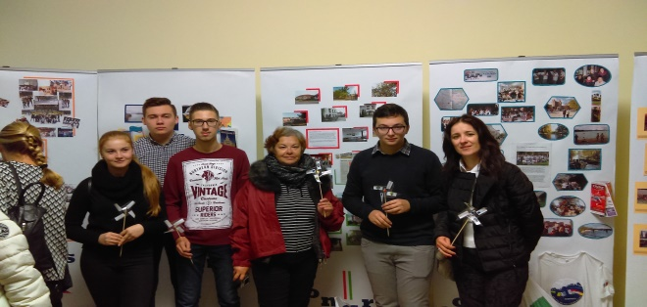
From the beginning, I was impressed by the people’s hospitality and good mood. They did their best to make us feel welcome and forget how far we had travelled.
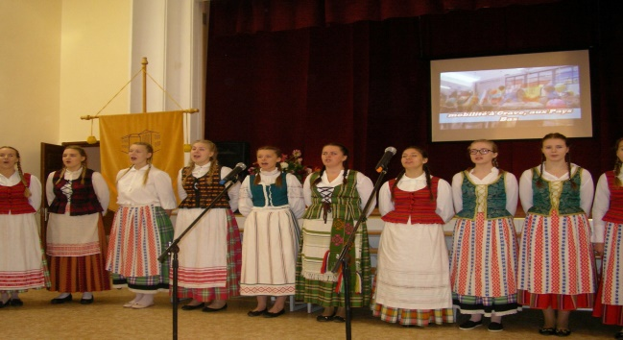
Then we realized that we had more in common than we had thought, traditions, customs and many others.
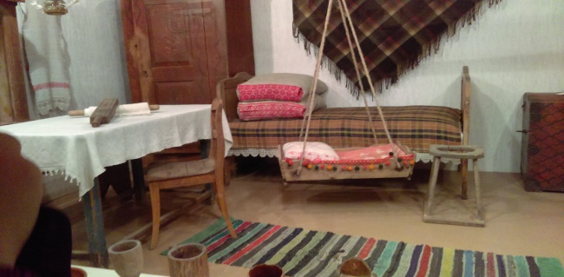
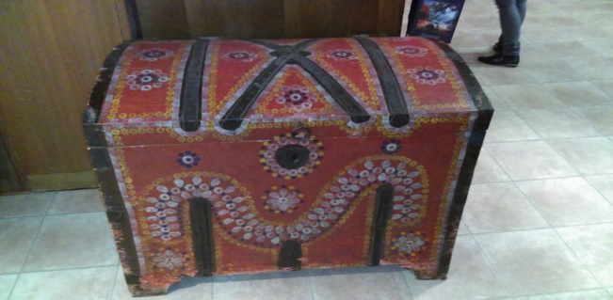
We did a lot of activities together like discovering the city of Ukmerge in a ‘treasure hunt’ which combined nature and technology in a great way.
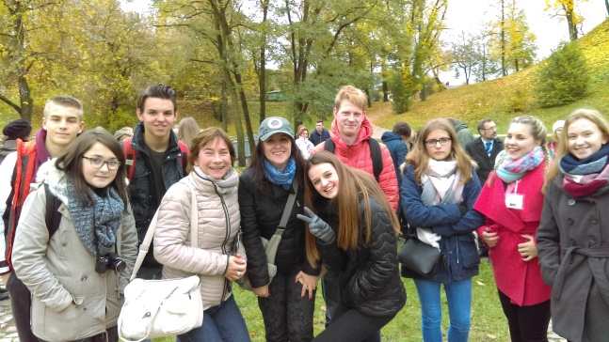
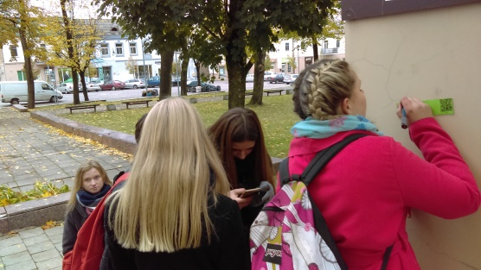
And we played and learned about the history of the little town that we were visiting and for a while we forgot that we were seven countries.
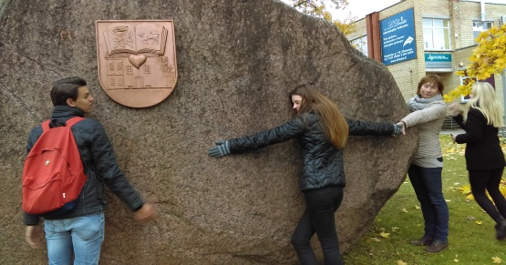
Then we discovered how important nature is to them, how they treat and respect their environment, how civilized they are and how much they invested into protecting nature and showing people what beautiful places they have. They are proud of their country and demonstrate that through their actions. The Treetops Walking Path is one of the places that we visited and it is unique in Eastern Europe. The path is at the level of the tree crowns and it lasts for 300 meters, evenly going up to 21 meters high. There are 13 stops on the path which are assigned to help you get to know and experience the variety of Lithuanian forests. On the 14th stop which is on the highest point on the tower (34 meters above the forest tops), the breathtaking view of the Sventoji river curves opens up, and the tower tops of the St. Matthew’s church, which is the highest in Lithuania, arises over the forest.
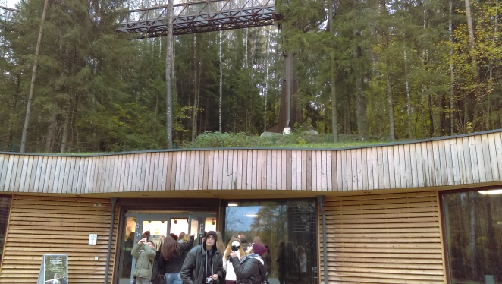
The visit to the capital of the country, Vilnius, was another pleasant surprise for us. Vilnius is known for the architecture of its Old Town, declared a UNESCO World Heritage Site in 1994. Its Jewish influence until the 20th century has led to it being described as the ‘Jerusalem of Lithuania’. In 2009, Vilnius was the European Capital of Culture, together with the Austrian city of Linz.
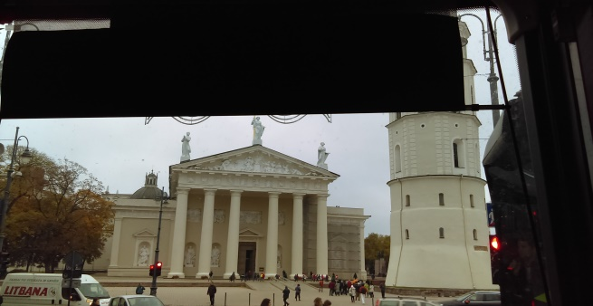
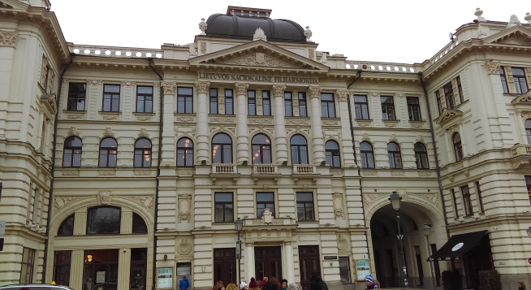
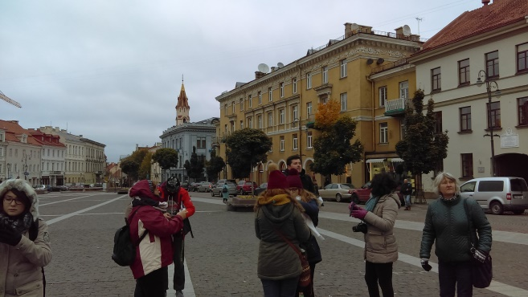
It’s difficult to say everything only by using a few pictures and even fewer words, especially when you have taken hundreds of pictures and when you have just as many memories, so I cannot stop here, even though it’s taken me 2 pages already.
An activity that I loved was the one of the song rehearsal because again I could see the people’s implication, their good organization and even better disposition. I saw around 30 students coming from 7 countries singing together and enjoying themselves due to a great music Lithuanian teacher that shall not be forgotten. She was so determined, yet so amusing that everybody had fun during this activity.
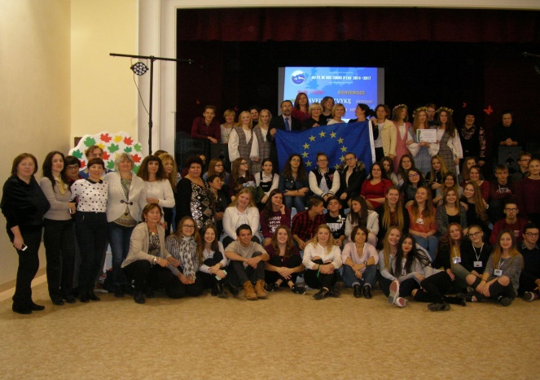
Another activity, another part of Lithuania, another lesson of History for those willing to see and listen was the visit of the Trakai Island Castle. Trakai was one of the main centers of the Grand Duchy of Lithuania and the castle held great strategic importance.
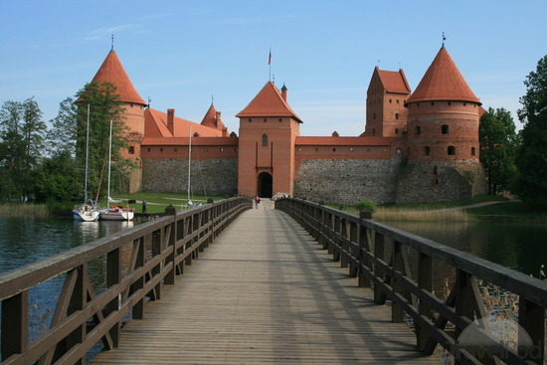
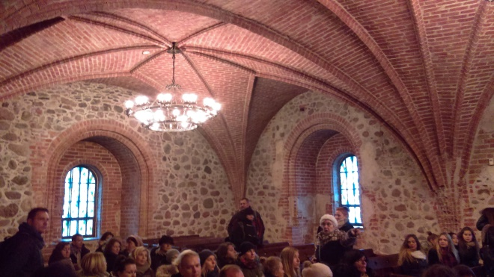
One of the surprises that we had was that each and every room of the castle was heated through a system that we couldn’t see and despite the cold weather it was very warm inside.
There is still so much to be said about this great country and the activities that we participated in that I have difficulty choosing one or two more. I liked their food and the fact that one of their activities included Lithuanian students cooking traditional dishes of each country involved in the project and this is the Romanian table. What a great idea!
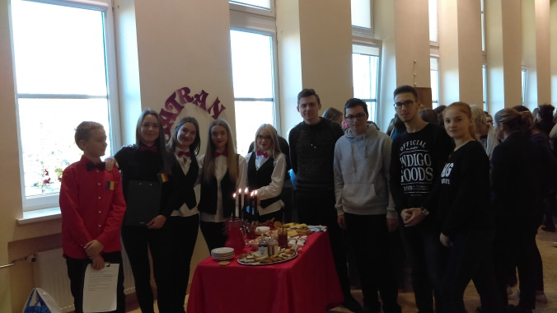
The students that joined us in this adventure were just as impressed as I was and I know that because they said so and because on the last day of the week in Lithuania they didn’t feel like leaving anymore which was more than words could express. So in the end I am glad to have had the opportunity of seeing this country and meeting these amazing people and I would like to congratulate and thank the Lithuanian team for showing us what they are like.
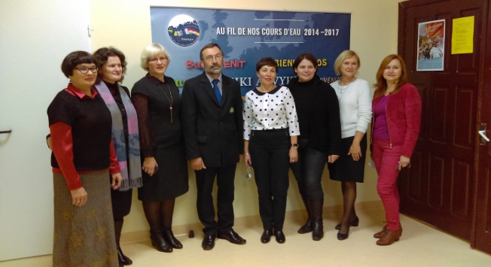
Prof. Tănase Anamaria
Un message de nos partenaires de France

PROJET EUROPEEN « AU FIL DE NOS COURS D'H2O »
ERASMUS + - 2014/2017
Ce projet a pour objectif de faire prendre conscience aux élèves de nos 7 établissements européens (Espagne, Grèce, Hongrie, Lituanie, Pays-Bas, Roumanie et France), de l'ensemble de la communauté scolaire et des familles de la nécessité de mieux connaître son cours d'eau afin d'appréhender les problématiques liées à l'usage de l'eau (au niveau de sa région mais aussi des autres régions européennes).
Les professeurs et les élèves des différents pays travaillent depuis septembre 2014 en étroite coopération afin de partager leurs résultats et leurs recherches et restent en communication par le biais d'un blog enrichi régulièrement.
Le travail avec ces six pays aussi différents par leur situation en Europe que par leurs traditions nous enrichit tous profondément.
La Roumanie fait partie de ces pays à la fois si éloigné de nous géographiquement et avec qui nous partageons depuis des siècles des relations politiques, économiques et culturelles riches.
Les relations politiques entre la France et la Roumanie sont très anciennes. En effet, le soutien apporté par la France à la double candidature de la Roumanie à l’adhésion à l’Union européenne et à l’OTAN s’est inscrit dans cette tradition de relations privilégiées unissant nos deux pays.
Depuis 2008, année où a été signée la nouvelle feuille de route (2013-2018) du partenariat stratégique bilatéral, les échanges entre nos deux pays ont été nombreux afin de travailler à l’approfondissement de ces liens, notamment dans le domaine économique, et pour aborder les grands enjeux européens et internationaux. En effet, la France reste le quatrième partenaire commercial de la Roumanie. La structure et l’ampleur du commerce bilatéral sont en grande partie déterminées par la nature des investissements français en Roumanie, majoritairement concentrés dans l’industrie.
A notre échelle, les premiers liens créés, l'ont été en France lors de notre première rencontre au cours de la 1ère réunion transnationale en novembre 2014. Nous avons échangé avec une partie de l'équipe roumaine : Carmen Mandache, professeur de français, Diana Moruzi, proviseur du lycée et Catharina...Ils nous ont présenté leur pays, leur région, leur rivière, leur lycée dans un français parfait.
Comme le Colegiul Tehnic Gheorghe Asachi à Botosani en Roumanie, nous avons en France au Lycée Général et Technologique de Mirepoix, un pôle technologique ce qui permet à nos élèves de partager avec les élèves roumains une activité qui consiste à créer et à assembler les pièces d'un système qui permettra d'embarquer des sondes de mesure de qualité de l'eau de notre rivière sur un quadricoptère.
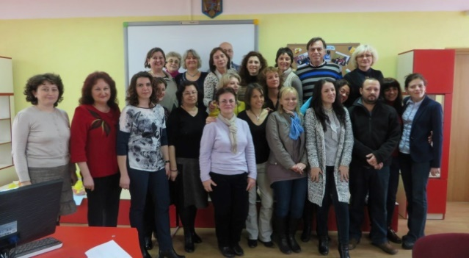
Nous partageons également d'autres activités avec la Roumanie et les 5 autres pays, aussi riches et variées que : la création d'un jeu de société (activité O2), d'un blog (O3), d'une chanson au fil du fleuve (O4) , d'un album photo (O6) , d'une entreprise fictive liée au fleuve (O7), d'un catalogue de ponts (O11), d'un Dico thématique illustré multilingue (O16), de travaux sur le recueil de texte (O8), sur L'industrie et agriculture de notre fleuve (O13) , sur le Théâtre (O15) , sur la géographie d'un cours d'eau (O17) , sur des articles sur les fleuves et les pratiques pédagogiques en Europe (O18).
Les travaux menés au sein de chaque établissement sont importants car ils conduisent à plus d'autonomie, d'ouverture et d'indépendance. Ils sont en lien avec l'acquisition par nos élèves d'une meilleure connaissance de leur environnement.
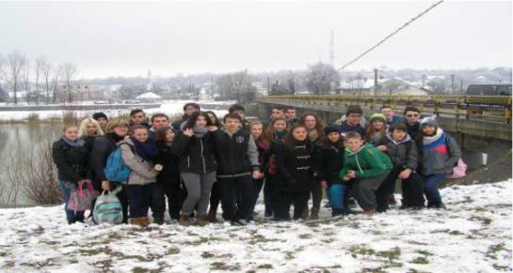
La COP21 qui vient de s'achever et a abouti à un accord historique montre également que les actions pour l'environnement sont nécessaires et possibles malgré les divergences entre les pays du monde entier. Même si le chemin est encore long, nous pouvons, à notre petite échelle participer à ce changement. C'est ce que nous faisons avec notre projet. Mieux connaître son environnement et celui qui nous entoure en Europe pour mieux le protéger.
Par ailleurs, dans le cadre de ce projet, les mobilités d'élèves dans les différents pays partenaires permettent aux élèves et aux professeurs de découvrir l'environnement et la culture de chacun mais aussi d'échanger des idées, des pratiques, de mieux connaître la langue et le système d'enseignement scolaire des différents partenaires.
Lors de la mobilité en Roumanie à laquelle 4 de nos élèves français ont eu la chance de participer, nous avons rencontré la grande, chaleureuse et enthousiaste équipe roumaine : Carmen, Anamaria, Catharina, Manuela, Simona, Livia Petrune, Livia Munteanu, Rodica, Irina, Gaby, …

Les professeurs des sept pays européens réunis lors de la mobilité en Roumanie
Nous avons pu participer, au cours de ce séjour, à différentes activités telles que le vote du logo du projet, le théâtre forum des élèves roumains ou encore découvrir la rivière Siret....
Nous avons été surpris de voir que beaucoup de personnes parlaient très bien français en Roumanie. La Roumanie est en effet un pays francophone et membre actif de la Francophonie. La diffusion de la langue française en Roumanie remonte au XVIIIème siècle.
Le français est aujourd’hui étudié par plus de la moitié des élèves et parlé par un Roumain sur quatre, même si l'anglais le remplace peu à peu.Cela permet une coopération culturelle, scientifique et technique entre nos deux pays. En effet, la France accueille près de 5.000 étudiants roumains (3ème pays d’accueil après le Royaume-Uni et l’Italie pour les jeunes Roumains) et la Roumanie plus de 1.000 étudiants français, notamment dans les filières de médecine.
D'autre part, la France a, au cours des siècles, accueilli de nombreux intellectuels, chercheurs, artistes d’origine roumaine : Cioran, Brancusi, Eliade, Ionesco, Anna de Noailles, Enesco…Ainsi, à chaque échange, les liens entre nous tous se renforcent.
Comme le disait Carole Lafont, professeur d'espagnol au lycée de Mirepoix lors de la mobilité en France qui s'est déroulée du 11 au 16 octobre 2015 : « Les activités transdisciplinaires menées dans nos 7 pays sont l'incarnation d'une Europe de la connaissance, une connaissance riche de la confrontation des cultures et des expériences.
C'est un véritable enrichissement pour tous dans cette période de doutes, de montée des extrémismes et de rejet de la différence en Europe.
Nous savons l'importance de ce type d'échange à l'heure où certains peuples affirment leur volonté de s'accroitre au dépens de leurs voisins ou d'autres se cloisonnent et se ferment.
Nos élèves, jeunes européens, représentent un espoir pour l'Europe de demain, une Europe enthousiaste, passionnée, bienveillante, ouverte, et accueillante. »
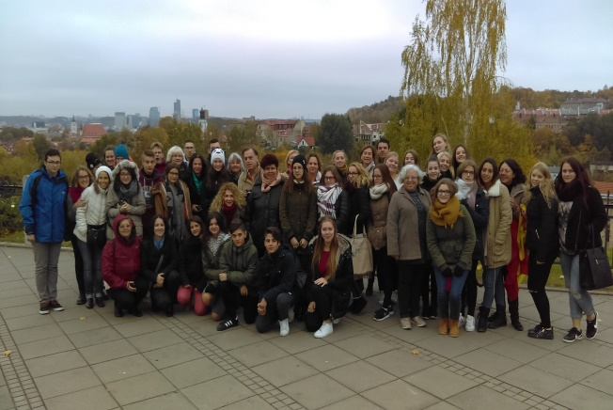
C'est, en effet, l'occasion pour nos élèves de mieux comprendre ce que les mots solidarité, coopération, partage, convivialité et tolérance veulent dire. Comme nos gouvernements respectifs en donnent l'exemple.
En effet, le Président Iohannis a participé à la marche républicaine du 11 janvier 2015, à la suite des attentats terroristes de Paris. La France, elle, a témoigné sa solidarité à la Roumanie, à la suite du tragique incendie d’une discothèque le 30 octobre à Bucarest.
Enfin, la Roumanie nous a également apporté son soutien lors des récents attentats survenus dans la nuit du 13 au 14 novembre. C'est donc avec grand plaisir que nous avons partagé et que nous partagerons encore pendant quelques mois toutes ces expériences avec nos amis roumains.
Grâce à ce projet, nous est offerte l'opportunité de construire et de faire vivre l'Europe. Profitons-en !!!

L'équipe Erasmus + de Mirepoix – France

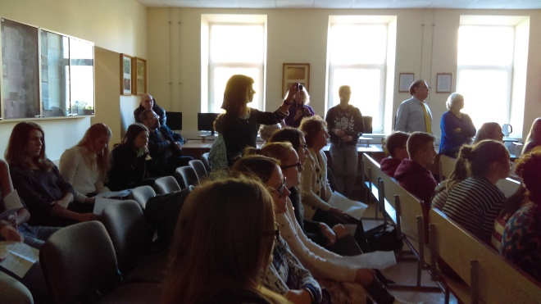
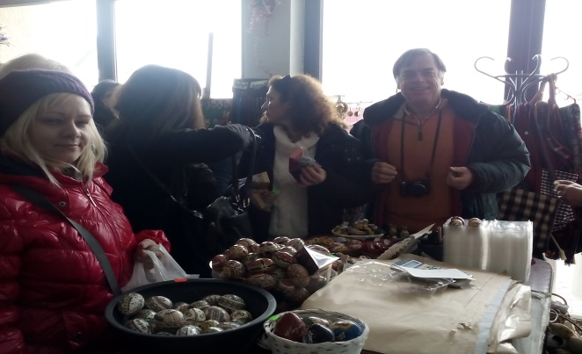
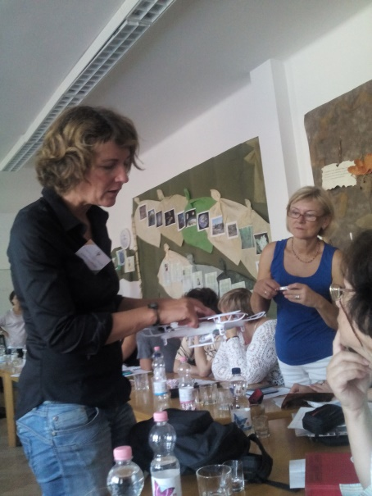
The effects of vices on humans
We live in the 21st century. Everybody has a vice or an addiction, whether it affects them in any way or not. But there are no benefits to an individual. In many of the cases, vices produce negative and long-lasting consequences which can be: physical, mental or emotional, depending on the person.
Today’s generation is facing a great deal of vices like drug addiction (from easy to hard ones), smoking, computer games, drinking alcohol, social networking, gambling which has been more accessible to the public. Most youths today spend much of their time indulging themselves in vices instead of doing something constructive with their lives. This has made many good ideas die and it is a pity that nobody seems to be taking this problem as seriously as they should.
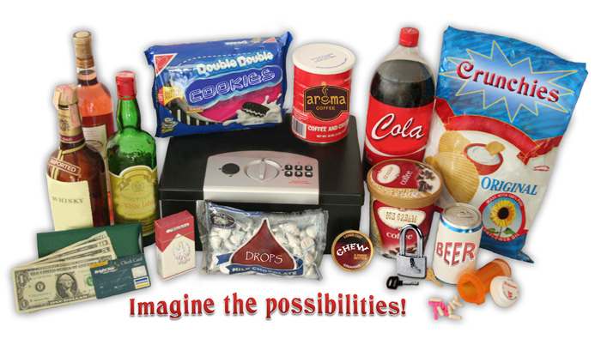
Time, commodities, health and education are affected by these vices. What’s really bad is that these vices appear from a young age now. These addictions may inhibit the productivity and further effectiveness of a person, since they waste time, concentration and financial resources on useless and harmful things. So be careful what you choose because it may cost you! Definitely not in a financial way!
A few vices are sufficient to darken many virtues.
Vezeteu Tudor, XII E

THE VICES QUIZ
Pick Your Poison!

Twenty Questions for Video Gaming Addiction

Am I a video game addict? The following self-test should give you some food for thought and act as a guide to judge your own situation.
- Do you often relive gaming experiences or think about future ones?
- Do you hide or lie about your gaming?
- Do you get very angry when someone or something interrupts a game?
- Have you ever taken a break from gaming and binged uncontrollably upon your return?
- When upset, do you soothe yourself with games or plans to play?
- Do you find yourself gaming in the early morning?
- Do you find ways to game when away from home?
- Do you set limits with gaming and then break them, playing hours longer than intended?
- Do you lose hours of sleep to gaming?
- Have you called in sick or late to work or skipped classes to game?
- Have you sworn off a game, uninstalled it, and later returned to it?
- Do you feel shame and guilt about your gaming?
- Does gaming contribute to arguments in your relationships?
- Has gaming taken the place of any hobbies or sports you used to enjoy?
- Do you forget appointments or deadlines for school when gaming?
- Have you lost contact with friends and family since gaming?
- Do you spend real money in-game?
- Have you stolen money for gaming?
- Do you find yourself bored with most everything else in your life?
- Are the people in your life worried about your gaming?

If you have answered YES to several of these questions you had better start reconsidering your attitude to gaming.

Herd behavior
sau
Efectul de turma

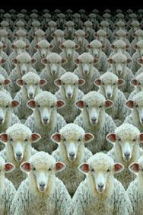

The herd instinct is defined as the obedience of the individual to the mass, blindly and without reflection.

Why do we do this?
It's simple. There are three main reasons:
1. Usually people are too lazy to get involved, think and make a decision for themselves so they are happy to do what others do because it is easy and fast, it does not require any thinking time and they feel more comfortable this way.
2. Human beings are social creatures and prefer living in groups. Humans need to socialize for their own mental health. Being used to live in groups, we think that we will feel excluded if we don't go by the others’ rules but we shouldn’t always obey without thinking and we must learn how to take a decision on our own, even if is different from the others’ ideas and it may sometimes be hard.
3. Lack of self-confidence. Some people don't have enough self-confidence and they tend to take somebody's example because they think that model represents them and they are willing to accept it easily. However, life is more than living behind the others; life means being able to fight for yourself and trusting your actions even if some situations bring doubt and nervousness. In the end, you will know that whatever you decide, there is nobody to blame but yourself.
Advantages & disadvantages
Advantages:
It is easy, fast and confortable, you will not be judged and you don’t feel excluded.
Disadvantages:
There are big chances for the person who will take the decision on your behalf to make mistakes or that the decision that is taken doesn't suit you. You may lose something or somebody and you don't gain experience to build your future life.
Conclusion
In conclusion, no matter how bad you think your decision is, take the decision on your own even if you may be wrong because that way at least you will not be sorry and in the future you may be more independent and self-confident.

Viziteu Gabriel, XII E

How to Make Decisions. Main steps:

Write about your fears.

Identify the worst case scenario.

Consider whether the decision you make will be permanent.

Talk to a friend or a family member.

Stay calm.

Get as much information as possible.

Use the ‘five whys’ steps to understand the problem.

Think about who’s affected and how.

List all of your options.

Make a spreadsheet to weigh the potential benefits and losses of your decisions.

Learn to distinguish between an impulse and an intelligent decision.

Trust your instincts.

Have a backup plan.

MUCH EASIER, ISN’T IT?

“I like my job because it involves learning. I like being around smart people who are trying to figure out new things. I like the fact that if people really try they can figure out how to invent things that actually have an impact. I don't like to waste time where I'm not hearing new things or being creative,” Bill Gates

With an estimated net worth of $79.2 billion, Gates remains the richest man in the world, a record he's held for 15 of the past 20 years, according to Forbes. But since stepping down as CEO of Microsoft in 2000, Gates has devoted more and more of his time to giving his money away to worthy causes. Through his philanthropic work with the Bill & Melinda Gates Foundation, he and his wife focus on improving educational outcomes, expanding health care access across the world, and increasing economic opportunity for low-income households.

Colectivul de redacție

Redactor șef: Anamaria Tănase

Colaboratori:

Prof. Diana Moruzi
Prof. Marinela Niculăeș
Prof. Mariana Fortoeș
Prof. Sophie Mandrou

Redactori:

Andrada-Ilinca Andriucă, XII A
Constantin Gradinaciuc, XII E
Cazacu Roxana, XII E
Daliana Bejan, XII E

Tehnoredactare și grafică:

Prof. Anamaria Tănase

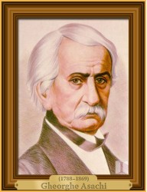
Gheorghe Asachi (1788 - d1869) a fost un poet, prozator și dramaturg român care s-a născut la Herța, în nordul Moldovei. Precursor al generației pașoptiste, Gheorghe Asachi a fost unul din întemeietorii nuvelei istorice la noi, a condus numeroase reviste literare, a recuperat manuscrisul Țiganiadei, epopeea bufă a lui Ion Budai-Deleanu. A fost îndrumător cultural în domenii diverse: teatru, școală, presă, activitate tipografică. Asachi a fost și unul din întemeietorii Academiei Mihăilene. A publicat prima gazetă româneasca din Moldova, Albina Românească (1829). În poezie, abordează toate speciile: ode, elegii, sonete, imnuri, fabule, meditații, balade. A scris și nuvele istorice (Dragoș, Petru Rareș, Rucsandra Doamna ș.a.), care au constituit sursa de inspirație pentru nuvelele lui Costache Negruzzi.
A fost o personalitate complexă, îndrumător și animator al vietii artistice și culturale, organizator al școlilor naționale din Moldova, unul din pionierii picturii românești și inițiatorul învățământului artistic în școlile moldovenești.
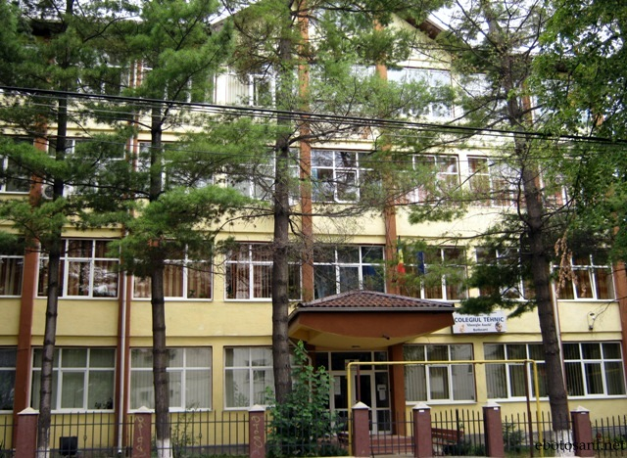
COLEGIUL TEHNIC GHEORGHE ASACHI BOTOȘANI
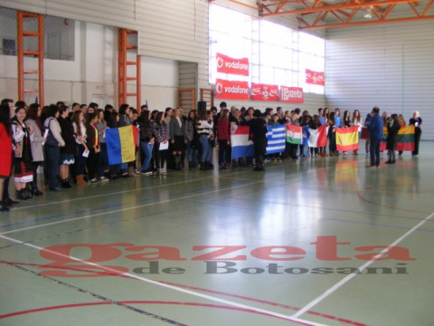
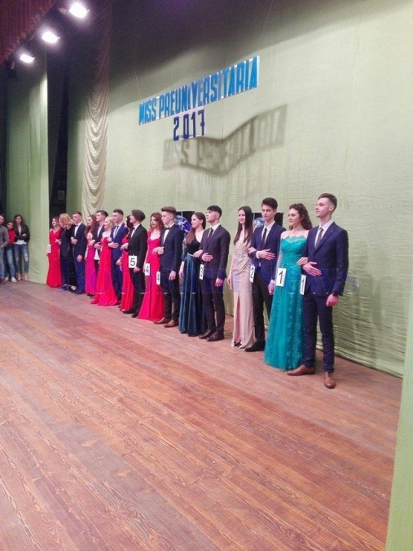
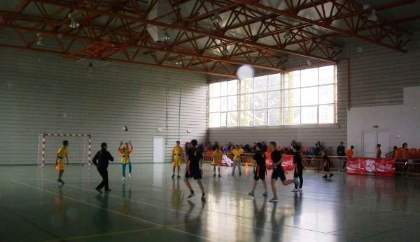
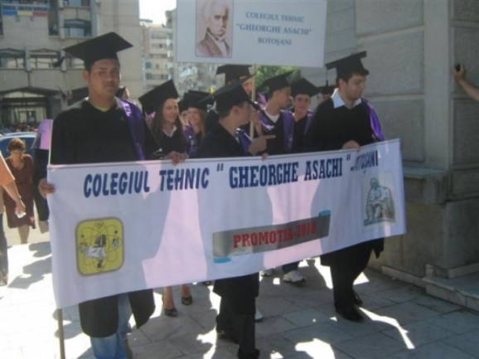
“Omul cel înțelept deși se pleacă plăcerilor acestei zile, totuși, își alege un minut de singurătate, spre a putea cugeta. ”
Gheorghe Asachi, citat despre înțelepciune
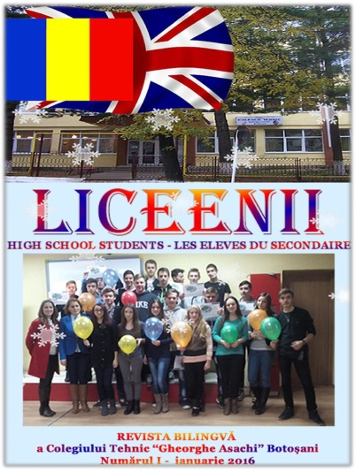
Revistă înregistrată la Biblioteca Națională a României ISSN 2392 - 6236

