THE MOST HORRIBLE BOOK I HAVE EVER READ
REVISTA ÎN ENGLEZĂ A ELEVILOR DE LA LICEUL TEORETIC ”BOLYAI FARKAS,” TÂRGU-MUREȘ
12.05.2020.
Redactat de: Puskás-Bajkó Albina
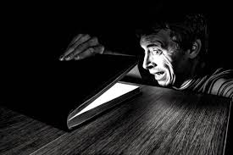
Stephen King, Pet Sematary
Bíró Laura, X.B
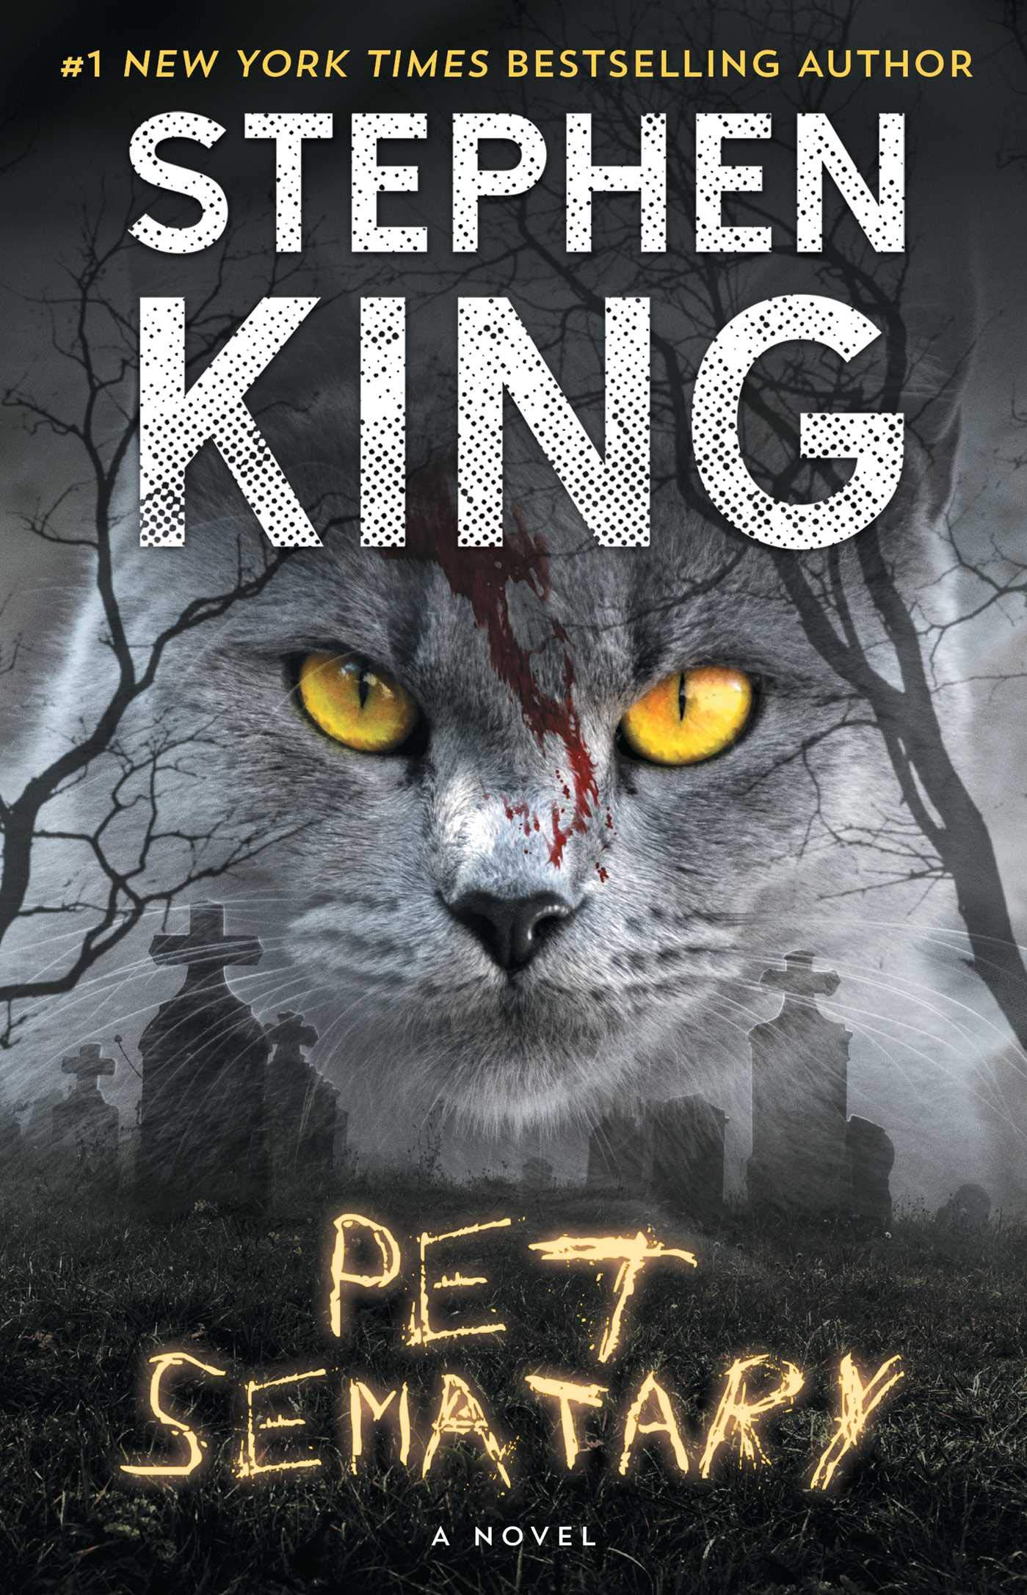
Usually I read romantic or fantasy books but my best friend recommended to me the ”Pet Sematary” written by Stephen King. I really hate horror stories but I decided to read this book.
”Pet Sematary” follows family man Louis Creed’s move from Chicago to Ludlow because he becomes the director of the University of Maine’s health service. He moves to the small town of Ludlow with his wife Rachael, daughter Ellie and toddler Gage. They also have a family cat named Church. Shortly after moving , the family is introduced to the pet cemetery by their friendly neighbour Jud Crandall. Later on, Louis finds out the uncanny secrets that lie just beyond the pet cemetery.
”Pet Sematary” didn’t scare me, but it certainly gave me chills. There are many uncomfortable scenes, much of them including corpses. If these are themes you’re not used to reading about then you may find it disturbing. For me, it wasn’t so much about what was happening in these scenes, it was how the writer painted the picture that made me cringe. He knows exactly how to write a good book.
I think this book has a really good plot and it is written great. Do yourself a favour and read this book.

Jay Asher, ”13 reasons why”
Dénes Boróka, XI.H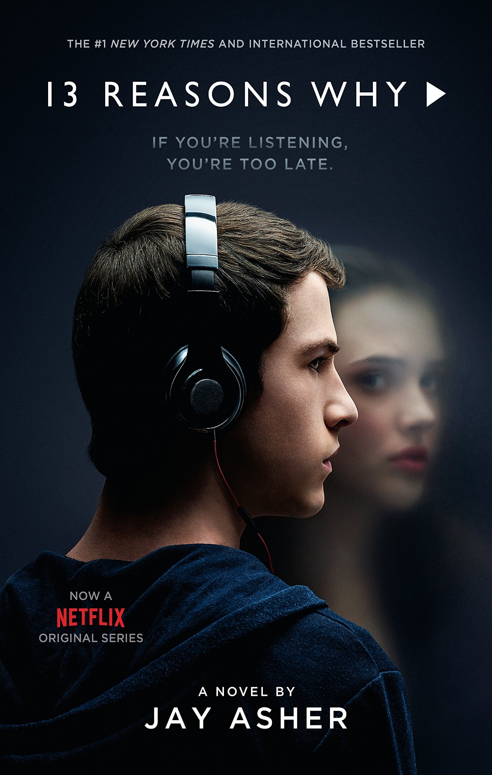

The most horrible book I have ever read is ”13 reasons why”. High school student Clay Jensen receives a mysterious package in the mail with seven cassette tapes recorded by Hannah Baker, a classmate who recently died by suicide. The tapes had also been sent to several other of her classmates, instructing each of them to visit each person mentioned. As he listens to the tapes, he learns that there is a side for each person to whom Hannah attributes her reasons for killing herself. Justin Foley started a rumor at school that Hannah was a "slut" after they kissed once in the park. Alex Standall reinforced the rumor by awarding Hannah "Best Ass" on a "hot or not" list. Alex's ex-girlfriend Jessica Davis, who had once been Hannah's friend, spread rumors that Hannah was the reason she and Alex broke up. Marcus Cooley tried to take advantage of Hannah during a date.Tyler Down stalked her and took photographs of her while spying in her window. Courtney Crimson spread stories about sexual "toys" she "found" in Hannah's room and later ditched her at a party. Zach Dempsey made unwanted advances toward her. After she rejected him, he took away her "notes of encouragement" from the only class that she looked forward to. Ryan Shaver published one of her poems in the school paper without her knowledge, and it was harshly criticized. Jenny Kurtz crashed her car into a stop sign and chose not to report it; this event eventually led to the death of a classmate. At this point, the tapes come to Clay, to whom Hannah apologizes for including because he does not deserve to be on the list; they had genuine feelings for each other, and kissed once at a party.
She mentions Justin again on a second tape, saying he left Jessica lying unconscious on a bed at a party. Hannah hid in a closet and witnessed someone raping her. Hannah says on the tape that Justin knew about this and let it happen. She also says that it's 'our fault' implying that she also blames herself for letting it happen. The next person listed is Bryce Walker, who is revealed to be Jessica's rapist. Hannah was walking past a party at Courtney's. Courtney, Bryce and some of the others were in the hot tub in just their underwear. Everyone left Hannah in the hot tub by herself and then Bryce got in and started to touch Hannah. Hannah tried to resist him but he forced himself on her and raped her. The last tape is for Mr Porter, a temporary school counsellor who told Hannah that if she was unwilling to press charges against "the boy" who raped her, she should "try to move on", even after Hannah expressed a desire to kill herself. After sending the tapes to the next person on the list, Clay returns to school and runs into his classmate Skye Miller, whom he suspects is also suicidal. The novel ends with Clay reaching out to her.
I was very surprised by this book because the story can happen in the real life. Hannah is a very naive at the beginning story. She trusted those people. In the real life some people can stay careful because this life is unreliable. Day to day she has disappointment and begins to change herself. I think this book presented some people who have problems in their life and they can’t change it. This book is a little horrible but I really like it. I recommend it to everyone.

Monica Hesse, Girl in the Blue Coat
Papp Tessza, X.B
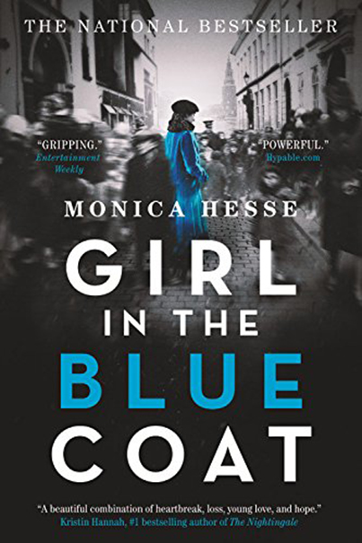

Two months ago I read a historical book entitled ‘’Girl in the blue coat’’ by Monica Hesse. This novel set the backdrop of occupied Amsterdam during the Second World War. It tells the story of Hanneke. She was trying to stifle painful memories of her dead lover. Hanneke made black market deliveries and one of her customers asked her to find a missing Jewish girl, Mirjam. She accepted this mysterious offer and grew as a character over the course of the book from someone blinded by grief, to courageous girl who puts her own life in danger to save a girl she has never met. In my opinion she was so headstrong, she didn’t care anymore about her family. I think it was a big mistake. She lied to her parents about her illegal activities. She could not forget Bas, her old boyfriend, she just kept thinking about him. There was nothing radical about the story telling and that was boring and horrible. I recommend this book for anyone interested in history. It may not be too heart wrenchingly memorable.

Stephen King, Finders Keepers
Kelemen Kriszta, X.B
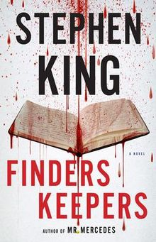
I really enjoyed ”Finders Keeper” by Stephen King , but there are also stronger parts in it.This well-written book is a thriller or crime story and it is the second volume in a trilogy focusing on Detective Bill Hodges, following Mr. Mercedes. The book is about the murder of reclusive writer John Rothstein, his missing notebooks and the release of his killer from prison after 35 years.
It is nearly as good as Agatha Christie’s books. One of the weakest things about is that, the language is strong and a little bit ugly. In contrast ,the action is extremly interesting and realistic.
The plot is gripping right from the start.The genius is John Rothstein, an iconic auther who created a famous character,called Jimmy Gold, but who hasn’t published a book for decades. Morris Bellamy is angry, not just because Rothstein has stopped providing books,but because Jimmy Gold has sold out a career in advertising. Morris kills Rothstein and empties his safe of cash, but the real treasure is the notebooks containing at least one more Gold novel.Morris hide the money and the notebooks,and then he is locked away for another crime.Decades later, a boy named Pete Saubers finds the treasure and now it is Pete and his family that Bill Hodges,Holly Gibney,and Jerome Robinson must rescue from the ever-more mad and vengeful Morris when he’s released from prison after 35 years.
I highly recommend ”Finders Keepers” to anyone who enjoys thriller or crime stories. However, if you prefer more romantic or descriptive novels, then you should give it a miss. Personally, I think that this book could be absolutly fantastic, but unfortunetly, it is not my type.

Stephen King, IT
Kutasi Eszter, X.B

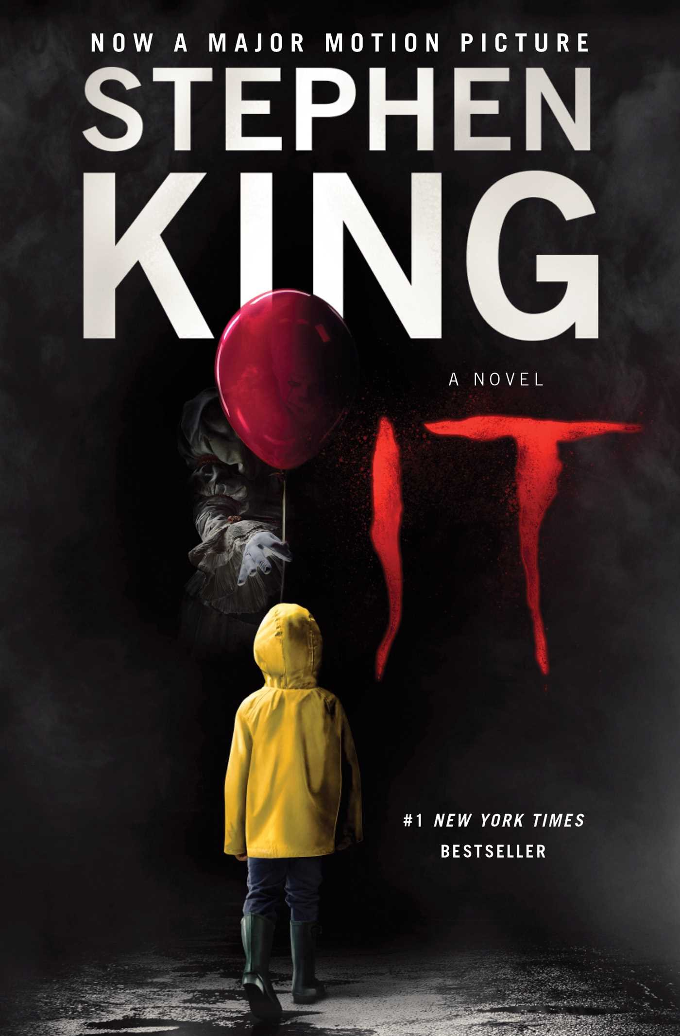

Written by Stephen King, “IT” was a book that impacted heavily upon my teenage years. It was at that time both the biggest and the scariest book I’d ever read.
It’s a book about childhood, in particular the special elements like friendships that seem they will last forever, days and lives that will last forever. I cannot think of many authors who can capture what it was like to be a kid better than King. He remembers things vividly and through his words allows us to remember the excitement, the awkwardness, the ability to laugh genuinely and hard at the dumbest of things. But it is not all fun, there are the bullies, there is the feeling of inadequacy and isolation. This is not just a horror story, indeed it is less about horror and more about coming of age.
As always with any book, you should focus on the positives first and foremost. As already mentioned, this is not simply a horror book, the scary moments are few and far between and all the more powerful for it. This is a book that allows us to relive the most potent time of our lives - our childhood. King’s narrative details the young and adult lives of Bill, Richie, Stan, Bev, Eddie and Mike (The Loser’s Club) and at the same time bring to life the cursed town of Derry.
I think, this book is the most fantastic and the most horrible book at the same time.

The most horrible book I have ever read
Nágó Márk, XI.H
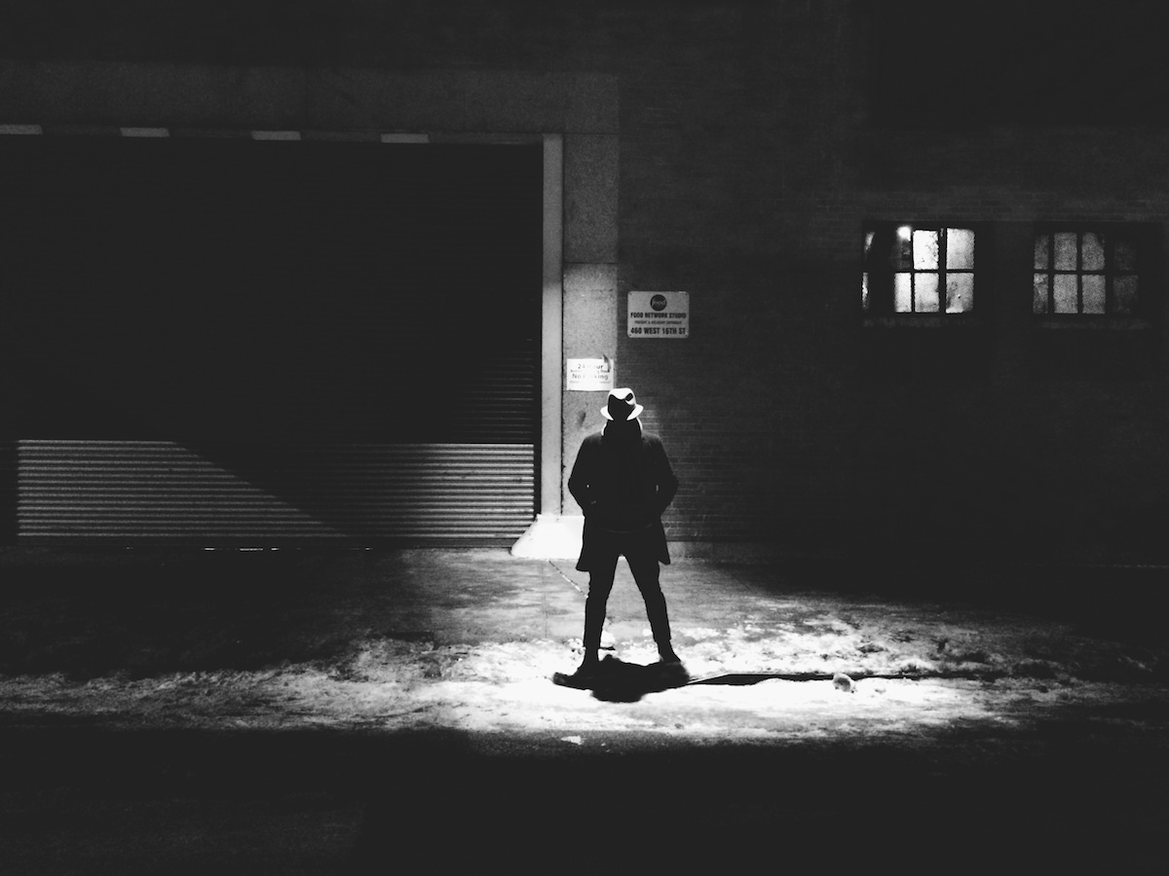

Reading books is essential in the life of any human being. Probably one of the most satisfying feeling in the world is when you smell the scent of a new book when you are holding it in your hands. Reading drives you closer to express yourself and your feelings in words with incredibly ease.
It is a patently obvious that the books which are compulsory, exhibited by the Ministry of Education are tending to be less interesting. Therefore, now I understand the quote ‘The book chooses you, not you choose the book’. But yet, I have never met with a ‘Horrible Book’. All the books I have read were incredibly astonishing, opening my eyes in different topics to see more clearly.
The books I choose are usually built up on a scientific topic which, in my opinion, cannot lead to a disappointing result. Was I to tell what a ‘Horrible Book’ could be, I would say that the lack in imagination and dull writing style leads to a horrible outcome.
All sums up to this particular result, I have never read bad books, and I look forward to keeping this gold habit of mine.

Dracula by Bram Stoker
Fodor Nóra, X.B
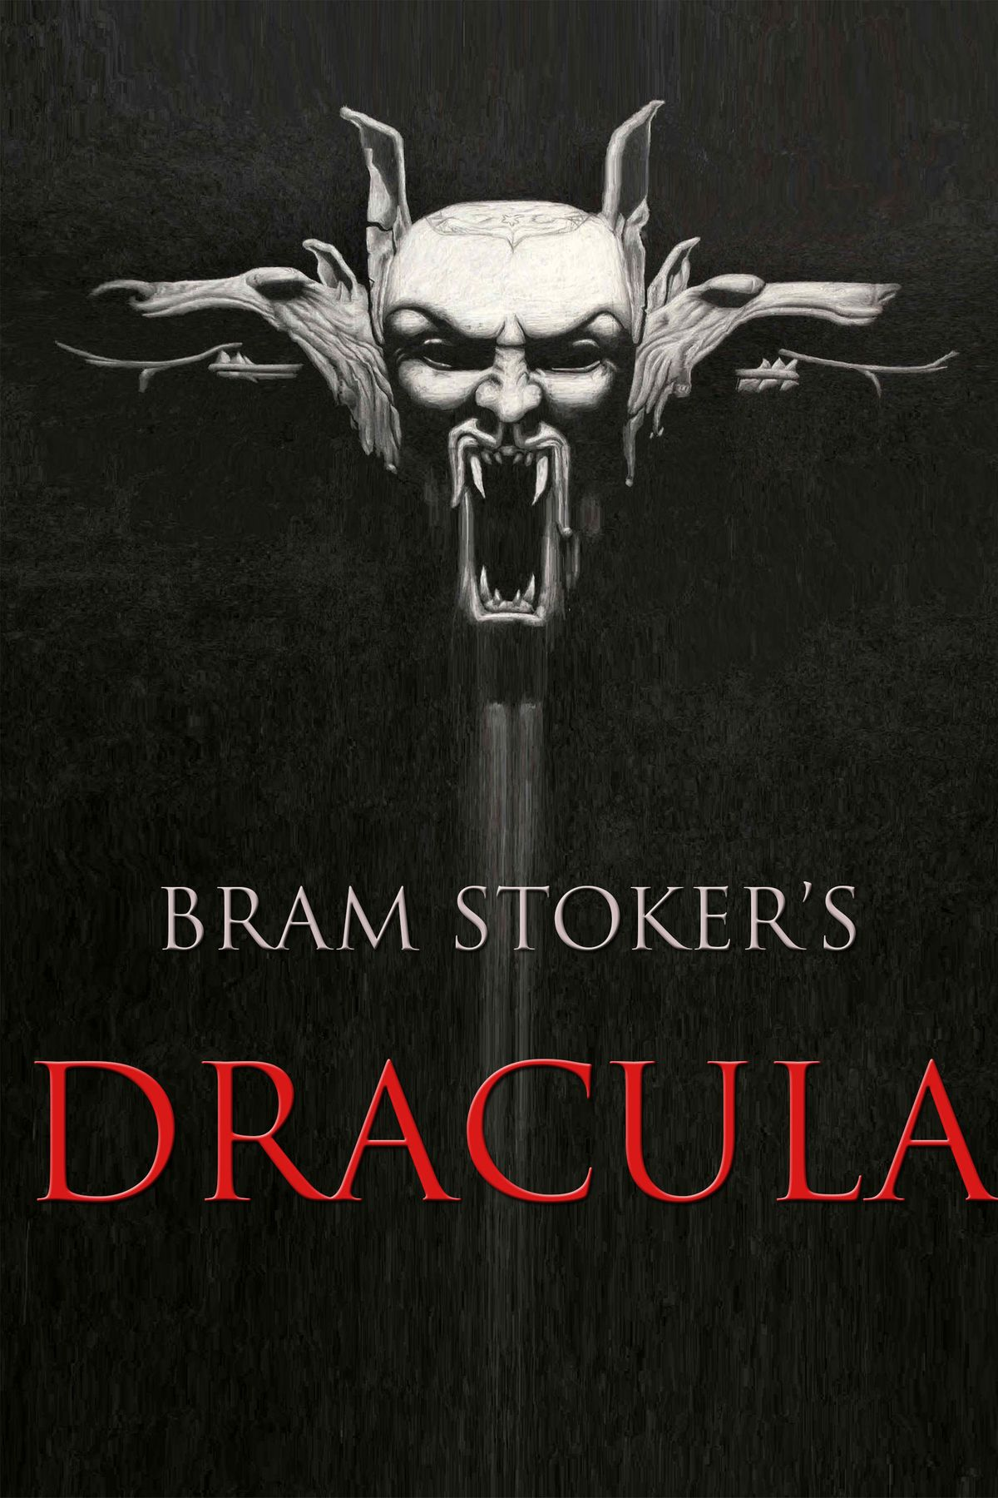

Abraham “Bram” Stoker was an Irish writer born in the mid-nineteenth century. His life was not particularly noteworthy until he moved to London. He is one of the forefathers of the gothic genre.
The novel begins with Jonathan Harker, a legal clerk who has been sent to visit a foreign Count who is planning on moving to England. This Count, Dracula, is a very mysterious man, but Harker does not suspect him of anything sinister until he realises that Dracula has locked him inside of the castle – he is a prisoner. The Count, meanwhile, is crawling up and down the building wearing Harker’s clothes and pretending to be him as he sends letters and makes himself known in town. From this point onwards, the story follows the mysterious story of Count Dracula. He moves to England, as he planned, and, there he produces pure chaos.
The characters are so distinct that, what with their layered narratives, this novel feels much longer than it actually is. Dracula’s castle was made so real to me through his language; it was easy to see how a nineteenth-century reader would be afraid of the Count.
I can’t hide how special this book is, and how desperate I am to recommend it to anyone and everyone. If I had one critique, it would be that the book does seem a little slow at times, but I never really felt that this stopped me from enjoying the story. If anything, it made me love it all the more!

Heather Morris, The Tattoist of Auschwitz
Zongor Dániel, X.B
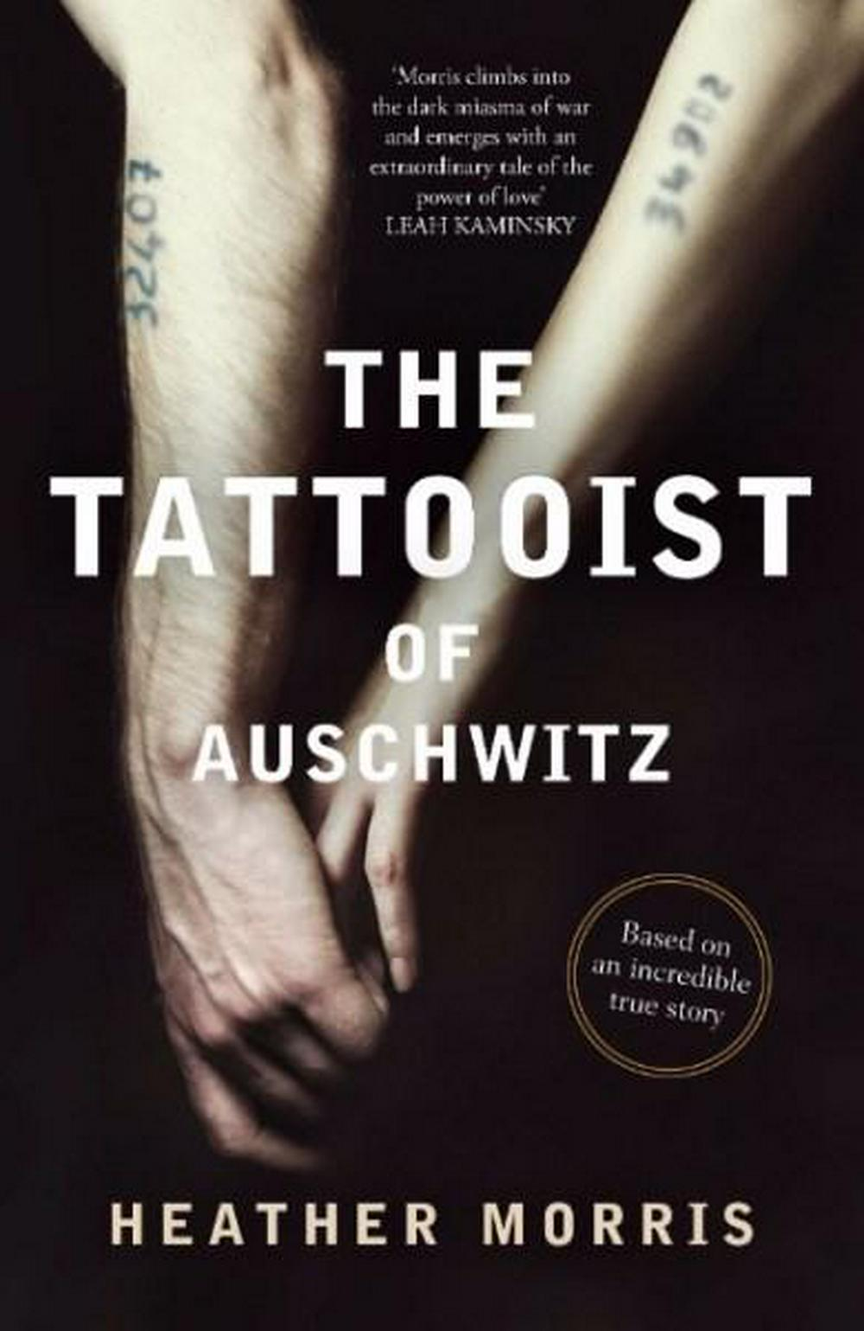

The book’s title is ”The Tattooist of Auschwitz”, written by Heather Morris, the novel’s theme is about a love story in the Auschwitz –Birkenau concentration camp, based on a true story. The main characters are Lale Sokolov, a tattooist in Auschwitz, and a young woman , Gita, a prisoner.

Lale Sokolov is well-dressed, a charmer, a ladies’ man. He is also a Jew. On the first transport from Slovakia to Auschwitz in 1942, Lale immediately stands out to his fellow prisoners. In the camp, he is looked up to, looked out for, and put to work in the privileged position of Tätowierer– the tattooist – to mark his fellow prisoners, forever. One of them is a young woman, Gita, who steals his heart at first glance. His life given new purpose, Lale does his best through the struggle and suffering to use his position for good. At the end of the book the lovers escape and they live a happy life in Australia.

This story is full of beauty and hope, but there is a reason why I don’t like this book: the description is very punctual, the writer presents the desperate and scary world of the concentration camp, more notably the inhuman circumstances where the prisoners were living, how many people died daily in this place and the suffering of those people who survived this “hell”. I think this is one of the biggest tragedies in the human history, when I read those lines and I imagined what I read I get very emotional and sad. I’m unable to this day to read this book again, because nevertheless this book is having a happy ending and presents a love story, it made several dark and sad memories for me.

In conclusion, this novel is the most horrible book I have ever read, for the reason that gives many details about human suffering and presents this horroristic place. I only recommend this book for people who are having enough strong mentally to understand and imagine the descriptive story.

