EARTH DAY JOURNAL ENTRIES

REVISTA ÎN LIMBA ENGLEZĂ A LICEULUI TEORETIC ”BOLYAI FARKAS”
NR.2, 07.05.20
EDITATĂ DE: PUSKÁS-BAJKÓ ALBINA

SITA DÁVID, IX.C

26th of April 2020
Dear journal today I went with my father and we bought
some plants for the garden because it’s spring and
we need some new things here and also they are sooo
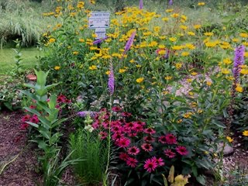
beautiful .

Also we bought some recycle bags so if we go next time
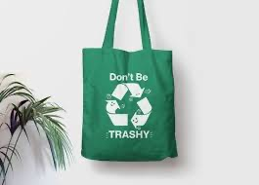
to show we don’t have to buy
some plastic bags :)

Also it has nice color
12th of March 2020
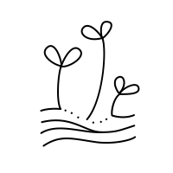
Our seeds are growing it’s soooooo cool .
I may draw them…

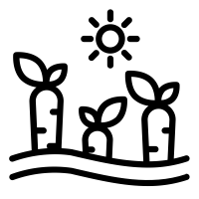
Our plantsss are growing yaaaay
We have a carrot and some potatoes
Its 1st of June and today
we went with school
to collect trash from parks and from the nearest lake
. The weather was nice and we had a good
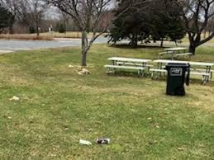
time together :)

I can’t believe how people can be like that :(
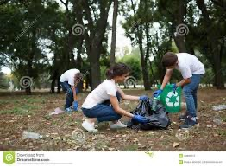
Oh my headmaster made a picture of us here is ahahah

Its like 11pm and I’m reading a book of worldwide recycle and its interesting…okay not a book just a online book you know ahahaha
Dear diary it’s like 6am and I’m
up because yesterday I went early to sleeeep.
Soooo I was thinking about the necessarily of a car
I mean why we don’t use bikes…bikes are cool like cars..
Sooo I decided to ask my parents if
We can have a no car week
21th of May 2020

15pm and 23th of may…..
It was a while when I wrote in u buouuuut I asked from my parents aaaand
They said that we can dooooo so yay
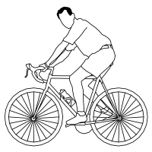
No car week here u ooo

Today I will ___________ for Earth.
I asked some people to fill this missing part and draw something
- Pray
- Drink
- Dance
- Read
- Meditate
- Sleep
- Run on the International Earth day Marathon
- Smoke
- Go to church
- Do my makeup
- Recycle
- Not use plastic bags
- Make a music
- Live healthy
Soo i asked many people but I forgot to write my own thing for earth
Hmmmm i think
Everyday I will do everything for Earth

30th of August 2021
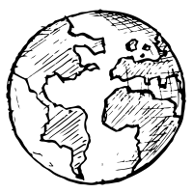
13th of January 2020

Recycle don’t be a trash(er)

Pick up not drop

They can’t stop all of us(humans against trash)
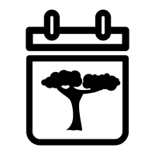

Plant a tree not trash!

Be with Earth not against it

31th of March 2020

better world

Recycle bags

Peace
ss

Earth love
Saving things and resources

Dont drop trash

clean

Bike

Creative brainstorm about recycle …maybe
Ill ask my friends for
More ideas
22th of February 2020 9am
I believe in helping the Earth because..

We can help the earth because

I thought about what if
We go to grab some trash
But I don’t know how to assemble people
For this activity…

Helping :
- More bins
- Punishment

7pm
I believe…….

9pm
I believe in helping the Earth because
I know we can do it….and
If we
Do it together we can make this
Im sure….because this World is our
Home
And if we want truly…we will help him to live.
Dear diary…today
Is the 17th of March and I went out with my
Friends for a walk…it was longer than I expected but it
Was awesome ….but there is a problem..
We went in woods and in parks and we were at a lake..
Everywhere we saw trash like EVERYWHERE…
I made some photos…
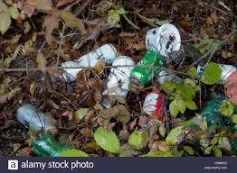
Ill but them here :((
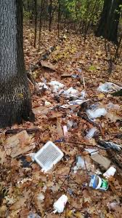
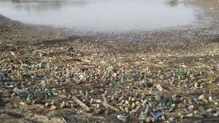
We failed as humans….
2nd of April

Trash everywhere
No recycling…..
My friends just drop any trash what they have in their back

Good dayssssssss.
Today is 3rd of April…..we are
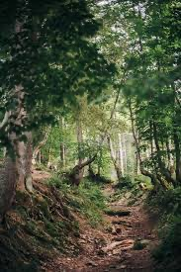
On a school trip..the place is too beauty..
Like no one ever touched it…

6th of April…we are going home :(((
The trip was soooo cool I will miss it…
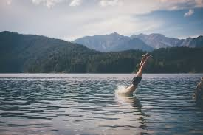
Now we go back to city…no fresh air…trASH on streets…
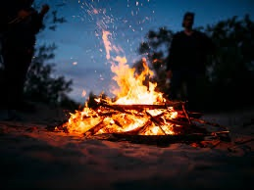
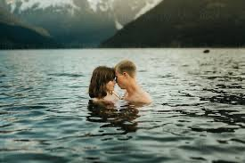
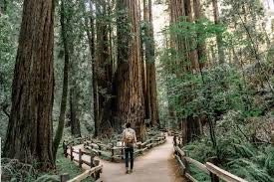
btw…i just met a gorgeous girl….we are together..
Dear diary..today it is the 5th of April
My dear school made a
Recycle day and it was awful…This was because of
Earth day…
We had to decorate the Yard and the classrooms
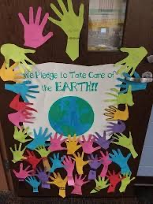
After that we had something like a party but it was soo
Borig..

In my opinion it is a stupid thing because we do a party and decorate for Earth but HEY…
It is all made of wood…we played w father
Like idiots..
This is not the right way to celebrate
The Earth day

21th of March
Today we decided with my big brother
Thomas to plant some trees in the woods- 7am

9am
Breeeeeakfast..hmmm I think I will eat cereal
But we don’t have milk at home so ill go to buy

11am
We went to buy the tree

3pm we are in woods and we already planted 3 trees

3:04 pm
WE SAW A DEER!444444!!!

9PM
It was a awesome day :)

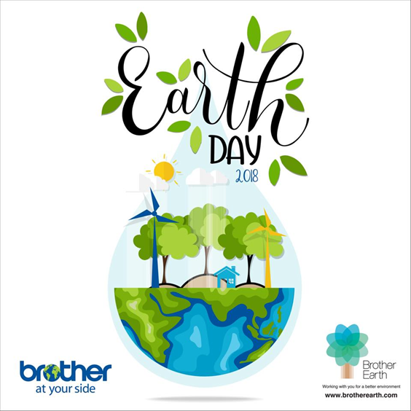

BRUSTUR BEATRICE, IX.G

- Why is it important to recycle?
Recycling is one of the best ways for you to have a positive impact on the world in which we live. Recycling is important to both the natural environment and us. We must act fast as the amount of waste we create is increasing all the time.
Increasing wealth means that people are buying more products and ultimately creating more waste.
Increasing population means that there are more people on the planet to create waste.
New packaging and technological products are being developed, much of these products contain materials that are not biodegradable.
- Does your family recycle?
My family recycles as much as possible. My mum reuses bags and we are carrying spring water in plastic bottles which we reuse many times, we use carton boxes several times, we give the leftovers from our food to the animals and old clothes and shoes we donate to somebody. We try to produce as little garbage as we can because you need to pay takes to take away your trash. My mum uses ecofriendly detergents and cleaning agents.
- We are lucky the Earth provides us with…
water, sunlight, fresh air, food, plants, animals, beautiful surroundings and all the supplies we need to live.
- Do you think your family could ever grow some of your own food?
We have a little garden at the countryside where we grow salad, onion, garlic, spices, strawberries, mulberries, plums, apples, raspberries, black currant. We also have beans, peas, potatoes, tomatoes, pepper, cabbage, cucumber, watermelon, eggplant and cauliflowers, sour cherry etc.
- What are five ways our school could start recycling?
I think that our school should use a good system of garbage collecting. Putting plastics, paper and glass in different containers is the first step toward recycling. Teachers can xerox on both sides of the paper not just one.
- How could saving the environment make people healthier?
A healthy environment can contribute immensely to good mental and physical wellbeing. Living in harmony with nature always was the wise men path. It’s no use to fight Mother Nature, who created our natural habitat at the very beginning and created us as part of it. We can think that we rule the world, but we are part of it so that the world and nature are influencing us. Like outside like inside. Like in Heaven, like on Earth.
- I believe in helping the Earth because…
The more we pollute or destroy the planet and live in an unnatural way, the more we need to clean up our own garbage and use other ways to rebalance our bodies and mind. All the chemicals we leashed in the air and in water, now is coming back to us in the air we breathe an in the water we drink, not to mention the electric pollution and the catastrophic nuclear events we created.
- What policies could our city make to save energy?
I think that we could save a lot of energy with a good implementation of some well-known programs, like bicycle roads, solar plants, electric cars. Local authorities could encourage people to make their houses more energy-efficient.
- Write a letter to a local politician about the importance of saving the environment.
Mr Mayor,
I ‘m the representative of the Local Green Movement and I would like to attract your attention on considering the critical importance the mather of protecting our envelopment.
I would like to ask you to make precise plans in the near future to re-establish the ecosystem with have been destroyed on the Somostető and the Weekend Telep. The many anthropogenic activities caused pollution which led to environmental degradation. This situation threatens the long-term health of the plants, animals and humans.
Air and water pollution and degradation are environmental issues that we are facing right now.
It is the authorities responsibility to take care of our city and the naturally beautiful space of this.
Tasking care of those natural parks from our city offers an excellent opportunity for the whole city to live close to nature and in better harmony with it.
Leading a balanced life in thees city also means to have access to some green places where we can recreate.
Healthy Air on Somostető could possibly have at least as many benefits.
So I kindly ask you to take action in the future for protecting at least this strategically important place from our city.
- Is it necessary to own a car?
I think despite the fact that a car pollutes very much, it is necessary to have one. In times like this, the buses do not circulate and if we need to do something important which is far away we can’t do it just if we own a car. It saves a lot of time and gives a lot of opportunities, which we wouldn’t have otherwise. Of course, we don’t need to use them all the time, I mean we can walk to the market or ride a bicycle to work, but in the modern life, it is necessary to own a car.
- Today, I will ________ for the Earth.
plant a tree...
- I see the effects of pollution when…
…. people are throwing chemicals and wastes in the rivers and in the
brooks besides their houses. In a very short time, these places become no-go zone for people and for animals as well. So that if you don’t keep your environment clean and safe, you can end up that you have no place to live.
- Create five Earth Day slogans to promote recycling.
Protecting our planet starts with you.
Go green before green goes.
May the forest be with you.
Reuse the Past, Recycle the Present, Save the Future.
Green is the new black.
Save the world, it’s the only one with chocolate
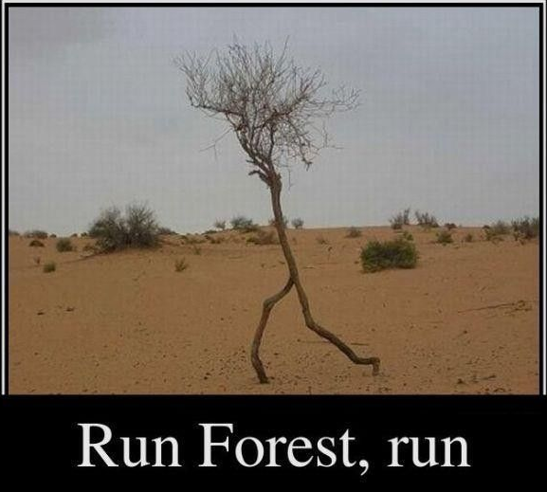

- When I recycle, I feel…
responsible and economical. I feel as if saving money for the future and organizing myself in a better way for survival.
- How can we use fewer natural resources?
If we implement more efficient strategies and don’t waste what we have, share with others our resources than perhaps we spare the natural resources.
- Make a list of everything you can think of to recycle.
We can recycle iron, paper, glass, tires, clothes, books, doors, windows, cars, computers, bicycles, etc.
- I am thankful for ________ resources, because…
water, air, sunshine, landscape, food…..without these, I know I probably
couldn’t survive.
- How can you teach people about the environment?
Unfortunately, I’m not too good at teaching, but I can bee very persistent if I want, and I could show a good example in this area.
- What are some great strategies for the environment that are already in place?
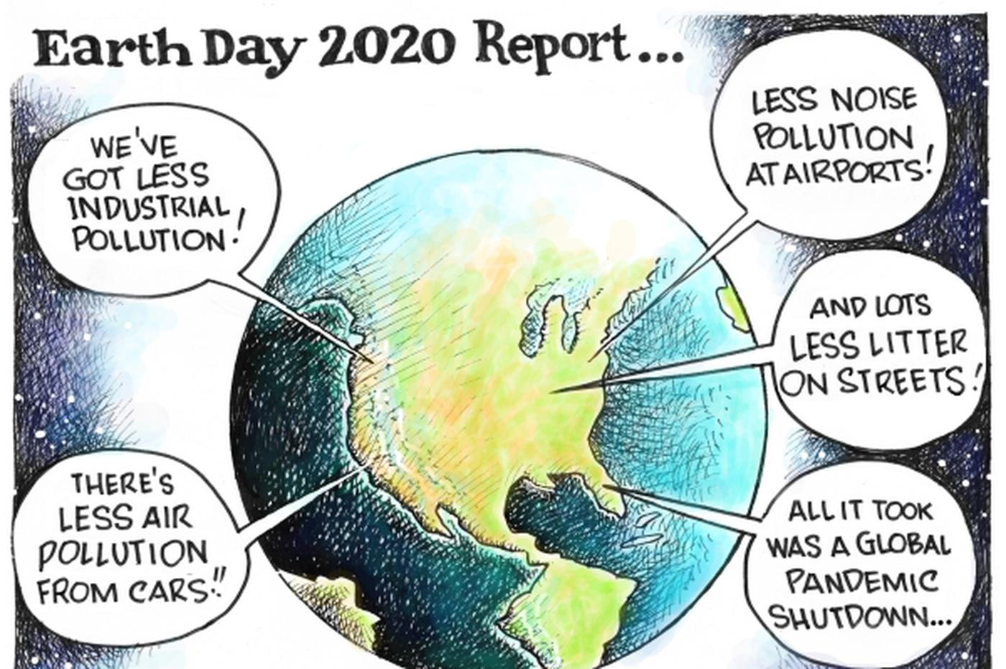
There are reglementations on national and on global level which are supposed to stop activities which are harmful to the environment. Some of them are well known, some of them are not. The most important rules are those regarding nuclear activities, mining technologies, radiation, chemical pollution, biological
weapons, gene manipulation, electronic frequencies, just to name a few.

- How can technology be good for the environment?
Modern technology can be created to meet necessities, like solar plants, bio gardening, environmentally friendly pesticides, natural cleaning solutions, bacterial cleaning of certain soils etc. Today almost everyone access to the internet and with that we don’t need so many papers, books, the internet saves many trees from cutting out.

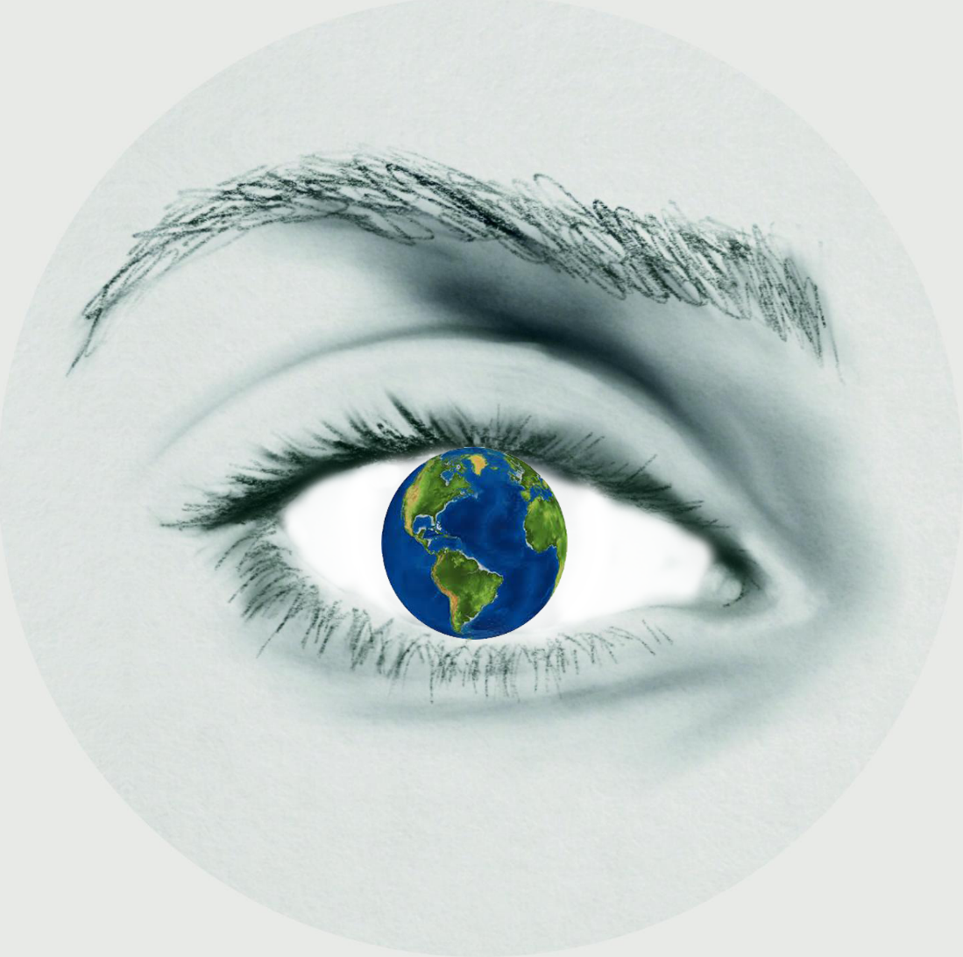

PATAKI ELŐD, IX.C
It is very important to recycle because we all use and throw a lot of things what might ruin our environment.
We are lucky the Earth provides us with the resources needed for life.
My family recycles.
I think my family could grow some of my food, like vegetables and fruits.
Five ways our school could start recycling are: 1. place recycle bins in the classes, 2. reward those children who use the recycle bins. 3. Learn about the importance of this. 4. Go often on field and collect garbage. 5. Keeping recitations about this theme.
Saving the environment makes people healthier because there will not be so many garbage, sickness.
I believe in helping the Earth because if we did not care about it the generations in the future will have very big problems and because I love the nature and I do not want to destroy it.
Our city could make for examples these policies to save energy:
Doing bicycle roads.
Making possible to recycle.
Using economical light bulb for street illumination.
Letter to a local politician about the importance of saving the environment:

Dear Mr. Mayor,

Thank you for making time to read my letter!

I wanted to warn you that we must to do some modifications to save the environment. Sadly, most of the people did nor recycle and they did not really care about what happened around them. The saving of the environment is very important. If we did not protect it, we will be in big trouble. This would cause the sweep of diseases and more other terrible things. We should make some policies to save the environment, for example

I hope that you will take into consideration my advice.

With all due respect,
Pataki Előd, student of ”Bolyai Farkas” High School

For the people who live in town it is necessary to own a car.
Today I will use less water for the Earth.
I see the effect of pollution when I go to a trip into the forest.
Five Earth Day slogans to promote recycling: More recycle, more health!
Recycle the trash, your home will smell fresh!
Recycle for the next generations.
Do not damage the nature, recycle!
Recycle if you like the nature!

When I recycle, I feel relief.
We can use fewer natural resources by having an electronic car and going to school with public transport or on foot.
We can recycle plastic, glass, metal.
I am grateful for environmental researches, because without them our environment would be in a very bad situation.
I can teach people about the environment by keeping recitations about this theme.
Making energy from the wind power, solar power.
The technology is good for the environment because with the help of it we can make energy from the sunlight, the wind and that way we did not have to harm the environment.

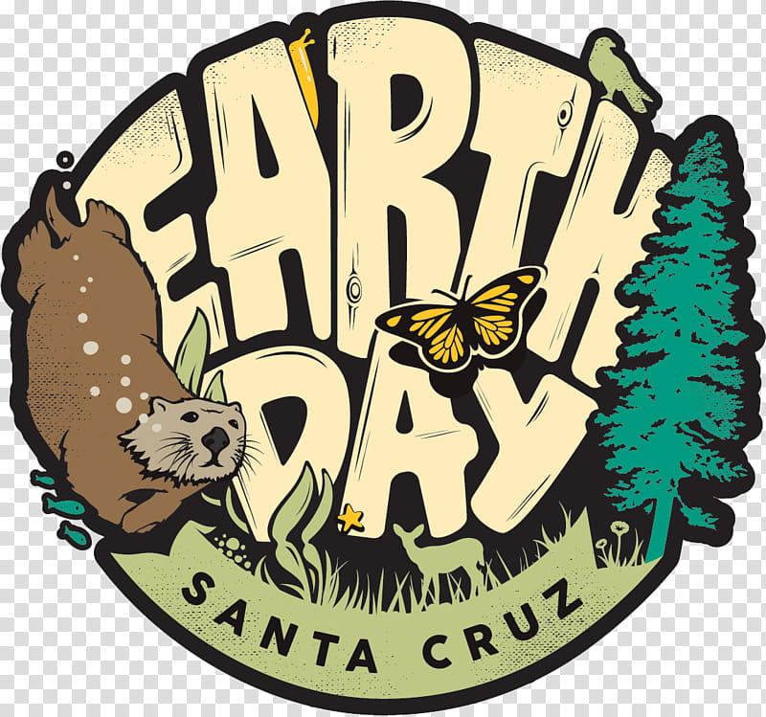

International Earth Day
KUCSVÁN LEVENTE IX.G

To recycle is important, because when we recycle, used materials are converted into new products, reducing the need to consume natural resources. Using recycled materials in the manufacturing process uses considerably less energy than that required for producing new products from raw materials-even when comparing all associated costs including transport. Recycling reduces the need for extracting refining and processing raw materials all of which create substantial air and water pollution. When we recycle, recyclable materials are reprocessed into new products, and as a result the amount of rubbish sent to landfill sites reduces. In summary recycling is important, because recycling conserves resources, saves energy, helps protect the environment and reduces landfill.

My family recycles, because it has reasons for example it sends less trash to our landfills, it helps save energy, it preserves our natural resources, it reduces air pollution, it reduces water pollution, it helps create new job, it is very easy. If you think that it makes no difference whether you recycle or not, think again. More than half of the waste that each of us produces each year can be recycled, but a lot of it ends up in landfills anyway. When each of us pays more attention to recycling, it all adds up and makes a real difference.

We are lucky the Earth provides us with an opportunity to air to breathe, water to drink, food to eat and space in which to live. We are also lucky that the ground is very large and there is a lot of water in it that can be used for many things. Earth also provides an opportunity to enjoy the environment. The essence of protecting the environment is to enjoy the Earth in which we live. Take time to listen to and search for birds, garden, visit the local park, trip or bike with friends and family. So enjoy!

Yes, I think it is my family could grow some of our own food, because the foods we produce ourselves like fruits like vegetables or the like will do very well. It can be a great reason to grow your own food providing for a family/on a low income, gardening is good for the soul, health and sustainability, fresh fruit and vegetables taste better and ethical reasons for growing your own food. In conclusion, a family can produce their food according to their preference, but no family can produce all the food it needs, most of the time my answer is yes, but there is a little no in it.

Five ways our school could start recycling are the following: 1.Reduce your paper use, keep a scrap paper tray in each classroom and make sure both sides of the paper are used. 2. Switch to recycled paper, although recycled paper is still slightly more expensive, if you can reduce your paper use then it may not cost any extra. 3. Refill plastic bottles, instead of throwing away plastic cups, encourage students to bring a plastic bottle to school which can be refilled again and again. 4. Recycle batteries, all schools have been provided with battery collection points. Make sure everyone has easy access to the battery recycling tube and encourage students to bring in their used batteries from home. 5. Compost food waste, my school can produce free quality compost from fruit waste, tea bags etc. Contact the recycling team for more information on setting up a school composting scheme.

Saving the environment makes people healthier, because saving the planet makes us healthier. When we recycle it we can also save lives. A healthier lifestyle can be said to be recyclable. In summary, recycling is equivalent to health.

I believe in helping the Earth because in any way we try to help ourselves, that is, to take our environment, we also take our own health. The above helps the Earth as these things make the Earth healthier, so to speak, we save what we have. This thing sums up the following: conserve water, be car-conscious, walk, bike or take public transit, reduce reuse, recycle, give composting a try.

Our city makes save energy could policies like save electricity, energy and everything you can do with politics as an example, save energy as much as possible I can’t say how you should justify it because I’m not a politician. Maybe we could introduce a policy where if people save more energy with everything they raise their salary or I don’t know.

A letter to a local politician
Dear local Politician,
Imagine a world where we do not have to worry about environment issues like deforestation, global warming and pollution. Your policies should provide protection for the environment and include ways to stop the deforestation, slow down global warming and the pollution rate.
Deforestation is a big problem in our city and you should look into creating policies aimed at stopping deforestation. Trees give off oxygen. Deforestation destroys the animals’ homes and cause many of the species to become extinct. Trees are a big part of our world and your policies should save them and conserve the forests. If we would cut trees oxygen in the atmosphere will reduce. Without trees the land becomes dry and desert-like, which also affects lakes and rivers.
The Global Warming rate is on the rise and your policies should try to cut the current rate in half. As Politician, you should create new laws. It is believed that carbon dioxide and other gases emitted by us and our technology is responsible for this problem. It causes the sea levels to rise because the warming is causing the glaciers and ice caps to melt. When glaciers and ice caps melt they caused the sea levels to rise, and people who live in coastal areas can be in danger. The Global Warming is also changing weather patterns and causing more storms, snow and rainfall.
Pollution has been a big part of the environmental issue because it kills trees, contaminates the water, soil, and the atmosphere. You should reduce the use of products that are biggest pollution. Recycling helps to reduce the amount of waste that goes to the landfills. I see people do it all the time at school, at the park and even on the street. Even our rivers, lakes and oceans are polluted which is fatal to the animals such as fishes, seabirds and whales. In some places the rivers and lakes are polluted from factory waste, sewage and ships.
In conclusion, I believe you have the power and influence as our Politician to create policies and laws that can help to better protect and save our environment. It will be beneficial to everyone in the world for us to stop the effects of environmental.
Sincerely, a man

An own car is not very necessary because it depends on a lot of things. You also need to look first if your family is letting go of the pens so you can buy a car that you need to keep up. Secondly, an auto can create a lot of pollutants, here too the answer would not be. Third, a car would do well anywhere and pollute a lot at any time. Finally, I would like to say that an auto would do well in a family just not to be too much because then it will be a big mess.

Today, with the above, I will comment for the Earth. In addition to the above, it can be said the Earth is a special planet that was created to be exploited as cleverly as we can. That is why each person has to contribute isn’t enough if only one person does it. I think that if all people contribute and do everything they can to consume less energy or to avoid polluting the Earth will move in a good direction.

I see the effects of pollution when I open my window and let out a lot of smoke from every industry that does evil. The effects of pollution can also be seen when I walk along rivers or lakes and people throw on other things without thinking about the effects they can have. You can also control the effects of pollution when there is a large deforestation.

Five Earth Day slogans to promote recycling
1.
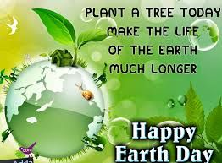
2.
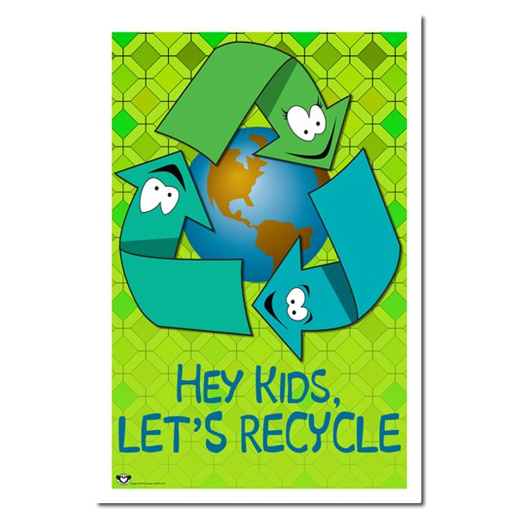
3.
4.
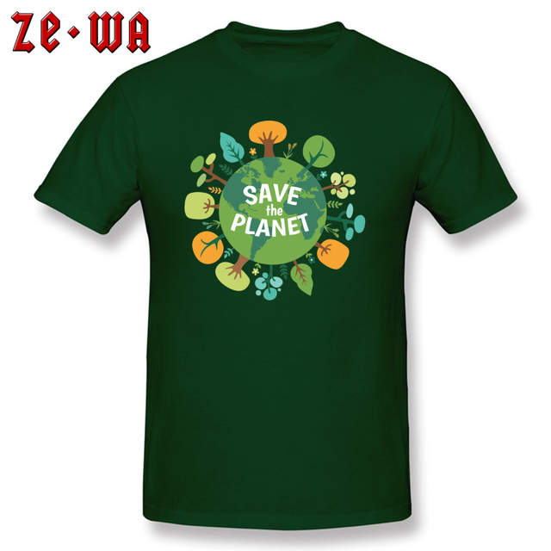

5.
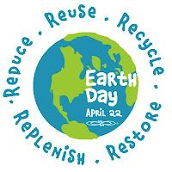
When I recycle, I feel like my soul is cleansed. I feel like I’ve made life healthy so it’s very good. Recycling is a new alternative to not recycling. Recycling may help you achieve personal fulfillment and alleviate those crushing nightly worries that humans may be destroying the earth and covering the planet in plastic. More and more people who have turned to recycling have more self-confidence they are objectively, more attractive they sleep better at night knowing that all their crap isn’t festering somewhere in a landfill. Recycling you can make a difference and have fun doing it’s easy and fun. Recycling may take a little more effort than not recycling but isn’t that a small price to pay for a healthier planet and better world for your kids I mean how hard is it to put your plastic bottle in the recycling bin instead of the trash it’s not that hard people. So recycling!

Reducing the use of natural resources is key to preserving the earth’s climate and mitigating the problems of climate change. Reducing the use of a variety of natural resources like trees, fuels and water can have a big impact on the overall sustainability of the earth is ecosystem. The world should strive to use less paper and wood, and eat less beef to reduce timber use and conservation of forestland to agricultural use. Other legal and political changes-such as banning importations of Amazonian wood, legally protecting ancient forests, and better regulating logging can help preserve forests, too. One of the easiest ways to reduce overuse of this resource is to purchase more water-efficient appliances, such as washing machines and toilets that use less water. Governments can also encourage these policies, as well as help build infrastructure for wastewater treatment.
List of everything I can think of to recycle:

1. Recycle all bottles, cans, and paper
2. Keep items relatively clean
3. Don’t mix plastic bags in with the rest of your recycled items
Do recycle:
- Rigid plastics/bottles – any plastic bottles or containers found in your kitchen
- Paper and cardboard – cereal/snack cardboard boxes; phonebooks, magazines, and mail; office paper, newspaper, and cardboard
- Metals – tin, aluminum, and steel cans
- Glass – food containers or jars; soft drink and beer bottles; wine and liquor bottles

I am thankful for natural resources, because they help a lot in energy every day and make life a big part of life.
People can be taught about the environment bz trying to teach them in different ways, for example lead by example; take your kids outside; teach children to use the appropriate receptacle for their waste: reduce, reduce, reduce, reuse, reuse and recycle as much as you can; Give them chores, like helping you classify your recyclables; Work together in a garden or compost project; teach them to close the faucet while brushing and bathing; turn it off; participate in a beach cleanup; give away to others the toys and clothes that you don’t use; the same way you teach kids to respect others(humans), you can teach them to respect. The above should be the most important.

A new strategy for the environment

Based on this information, OECD Environment Ministers agreed an ambitious Environmental Strategy for the First Decade of the 21st Century when they met in Paris on 16 May 2001. Underlying the Strategy is a need to further develop environmental policy to help ensure that economic growth does not come at the price of environmental degradation in OECD countries, while also being responsive to non-member countries in their search for sustainable development. This strategy is to put the waste in the right box.

Some technologies are important for helping other technologies reduce pollution. Centrifuges can reduce the amount of solids in wastewaters, thereby reducing water pollution. Catalytic converters on engine exhaust systems can reduce air pollution. The technology is widely applicable across a variety of industry types and sizes.

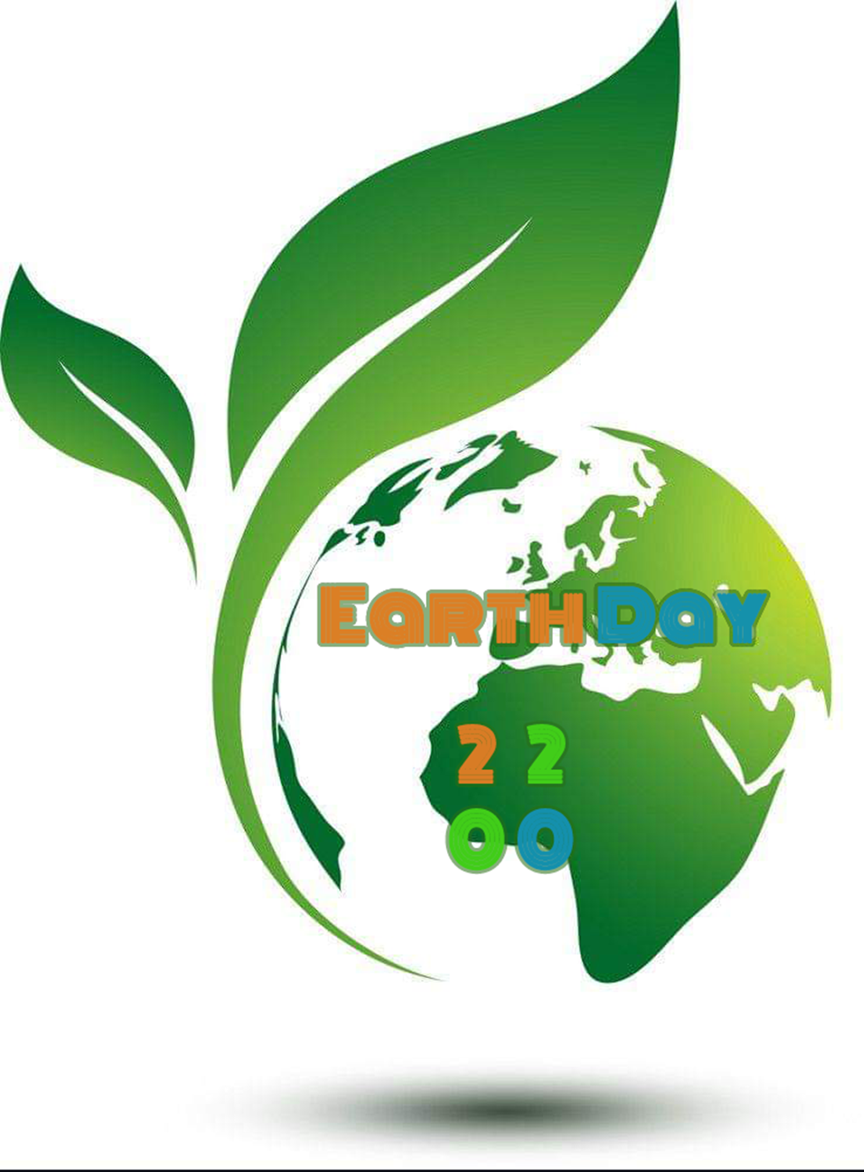
DÉGI NÁNDOR, IX.G
It’s important to recycle because the Earth is polluted, and to prevent global warming.
Yes, my family recycles what we can.
Oxygen.
Yes, we could grow some fruits like tomato, or some spices.
Selective trash cans, solar panels for electricty, bike rental.
The Co2 gas production would be reduced.
I want a clean environment.
Bike rental, selective trash cans.
It isnt necessary to own a caar.
I go out.
A clean earth is a happy earth!
A Good Planet Is Hard to Find.
Always act for safer earth!
Always Shun Earth Solution.
Away from Pollution, Towards Solutions.
I feel responsible.
If we create artificial.
Promote recycling
Natural resource, because, they are I non replenishable.
I show them what to do.
The use of solar panels.
Because we can automatize some things.

