EARTH DAY/MOTHER’S DAY

REVISTA ONLINE ÎN LIMBA ENGLEZĂ A LICEULUI TEOLOGIC ROMANO-CATOLIC ”II. RÁKÓCZI FERENC”
TÂRGU-MUREȘ

NR.2, 07.05.2020.

Editat de: Puskás-Bajkó Albina
Colaboratori: Mester Ildikó, Lokodi Andrea

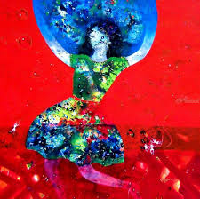

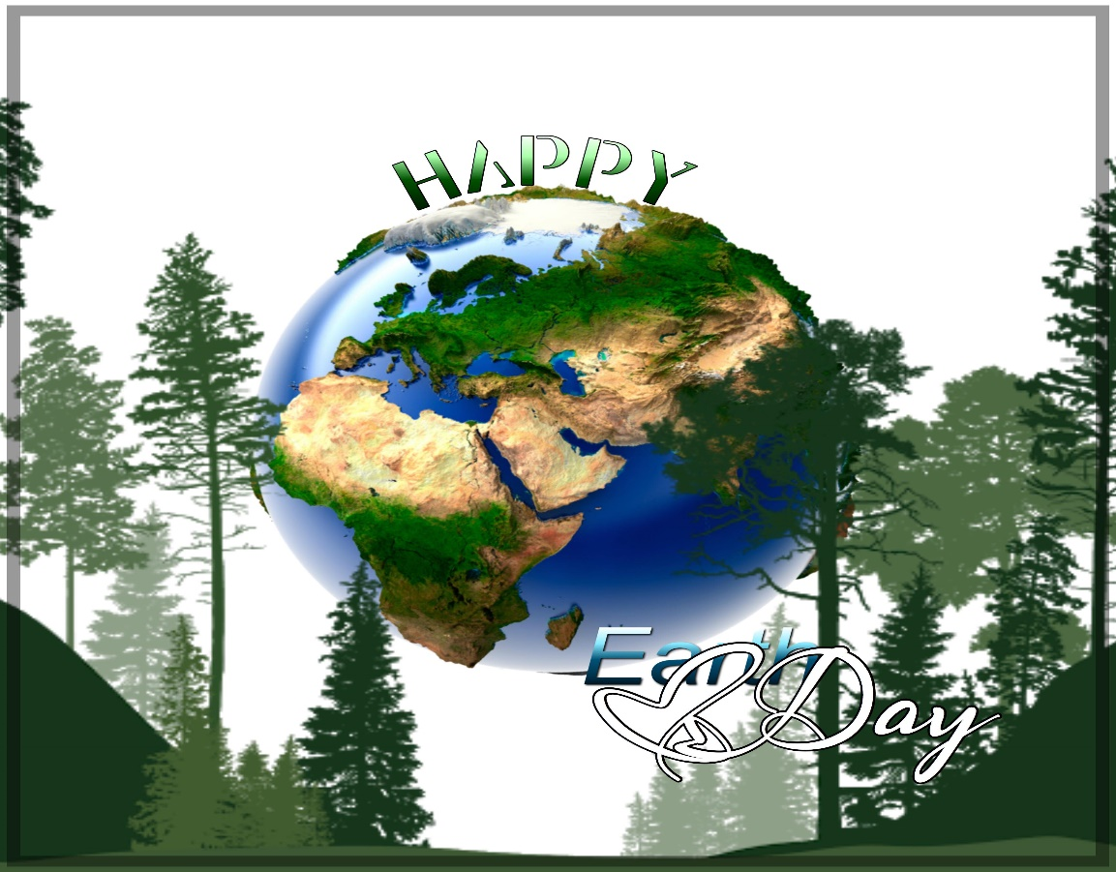

Earth Day
Mezei Andrea, IX.C

Why is it important to recycle?
.
Recycling is very important because it helps to save the environment. Recycling also helps to reduce the need to consume natural resources.

Does family recycle?

Yes, my family finds it very important to recycle.

We are lucky the Earth provides us with…

We are lucky the Earth provides air, water, food and a place to live. The Earth provides us so many things so we can survive and live here.

Do you think your family could ever grow some of your own food?

Yes, I think that my family could grow some of our food because my grandparents live in a small village and it is possible for them to grow food in their garden and my family often visits this place so we help them a lot.

What are five ways our school could start recycling?

Our school could start recycling with:
- the help of recycling bins
- students could use recycled materials for art projects
- we could reduce (WHAT?)
- we could post all of our assignments online rather than printing them out and using more paper
- we could reuse our school supplies when it is possible rather than buying new ones

Is it necessary to own a car?

I personally think that for most people is necessary to own a car because it can help them with work but I also think that people should try not to travel with cars if it is not that necessary, they should walk or maybe use a bicycle to get to places faster.

Make a list of everything you can think of to recycle.

- paper
- plastic
- magazines
- glass
- aluminum

I believe in helping the Earth because…

I believe in helping the Earth because if we recycle and try to reduce pollution we can live a much better and healthier life.

I see the effects of pollution when…

I see the effects of pollution when people get sick easily because of the air pollution.

How can you teach people about the environment?

We could tech people about environment through social media because a lot of people uses social media these days. We can also teach them about recycling through television programs and school.

How can technology be good for the environment?

Technology can help people getting to know about saving the environment, this way maybe more people will recycle and we can use electric cars that are also good for the environment, fortunately the number of electric cars has been risen in the past few years.

How can we use fewer natural resources?

With recycling we can reduce the use of natural resources.

What policies could our city make to save energy?

Our city could save energy by making bicycle lanes this way people will feel saver riding bicycles. Our city could also save energy by using solar panels.

Today, I will … for the Earth.

Today, I will recycle something for the Earth and I’ll try recycling more.

When I recycle, I feel…

When I recycle, I feel helpful for trying to help save the environment.

I am thankful for … resources, because…

I am thankful for every resource the Earth provides us because without them I wouldn’t be able to survive on Earth.

Create five Earth Day slogans to promote recycling.

- Help save the Earth and your future
- Earth is our only home
- You can’t change the past but can change the future
- Show your love for Earth
- Keep Earth clean

How could saving the environment make people healthier?

If we stop climate change it will make us healthier.

EARTH DAY, 2020
Moldován Boglárka, IX.C

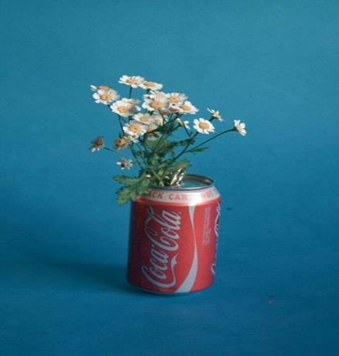
- Why is important to recycle?
For me recycling is important because we can save our planet, we can use raw material and by this we can assure a better future and livable planet.

- Does your family recycle?
My family is trying to be increasingly to pay attention for the recycle. We separate our garbage different collectors and we trying to use less plastic bottle.
- We are lucky the Earth provides us with…
We are lucky the Earth provides us with a place where we can live with gorgeous wildlife, fresh air, water. We should be thankful for our varied animals, from the little cute bunny, to the animal’s king, the lion; for our landscapes, seas, waterfalls, canyons, mountains etc.
- Do you think your family could ever grow some of your own food?
Yes, and we doing this exactly. In our garden we grow vegetables example: tomatoes, cucumber, onion, carrots, and cabbage. In mu grandparent’s farm they grow chickens, gooses, sheep and pigs we only eat their meat and never buy this in the market.
- What are 5 ways our school could start recycling?
First we need selective waste collectors so we can separate the garbage. Secondly, more presentation in the school time about the importance of recycling. Thirdly races where we can encourage the children to be more environmentally friendly. Fourthly in the school’s market the packages should made by paper instead of plastic. And the last way is a compost in school, where the kids can put their rest from the food.
- How could save the environment make people healthier?
The leadership of the town should introduce days when not allowed to travel with cars. They should ban to the factories build in the city.
- I believe in helping the Earth because…
Decrease the carbon monoxide emission and the air will be cleaner.
- What policies could our city make to save energy?
They can talk about the renewable energy, the recycling, the environmental awareness and the responsibility of our planet during their campaign.
- Is it necessary to own a car?
In a family where live 4 people and from this 2 has drive license I don’t think necessary own cars. Because if we want changes in world we should resign few thing for the planet.
- Today, I will ….. for the Earth
Today, I will pick up the garbage from my neighborhood and I won’t use plastic bottle and straws for the Earth.

- I see effects of pollution when
I see effects of pollution when I don’t smell the fresh air in the city. I don’t see the sky because of the smog, when I watch the news and I hear about the melting of ice, the rising of the sea.
- Create 5 Earth Day slogans to promote recycling.
Save the planet, do recycling!
Use your brain, don’t use plastic!
Take home the garbage, take in the right collector!
I think you don’t want to eat plastic so believe me animals don’t want too!
- When I recycle, I feel
When I recycle, I feel I’m a useful member of society and I feel a made a small step for a better future
- How can we use fewer natural resources?
We can try to make an alternative solution instead we use the nature.
- Make a list of everything you can think of to recycle!
I think recycling is very important for us and our planet where we live.
By the recycling our live place will be cleaner and livable.
We can make less waste with this way.
- I’m thankful for …… resources, because
I’m thankful for the renewable resources, because it saves the planet, it is good for the people and for the wildlife.
- How can you teach people about the environment?
With performances, TV shows about it, opened talking.
- What are some great strategies for the environment that are already in place?
I think using selective collectors and using less plastic packages is good strategies.
- How can technology good for the environment?
The evolution of the natural friendly technology results in the environment.
- Write a letter to a local politician about the importance of saving the environment!
Dear Sir
My name is Moldován Boglárka from the local environmental board .I’m writing for you the case of the importance of saving the environment.
We have so many ideas to make our city to a better place where everybody pay attention to the nature and to the recycling. One of our proposal is a community house which will be able to sustain itself with renewable energy example with solar power for the heating etc.
We hope we can talk about more solution in a meeting.
Yours faithfully:
Moldován Boglárka

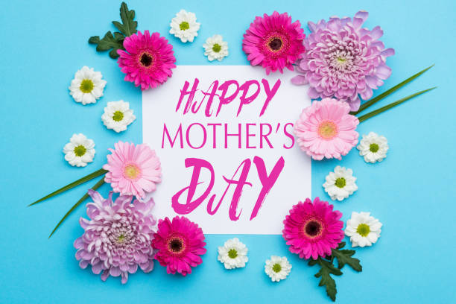

Dear Mom,
I always says to you “I love u”, but I never told why. I know daughters should be love their moms, but the full story is very complicated. So, now I will try to write down my feelings.
Your face was the first thing that I saw when I was born. The connection between us was already created then. You are my guardian angel, who’s protected me when I was bullied in elementary school, who’s came to my room when I had nightmares, you sat next to my bed all night when I was sick.
You are my perfect mother even sometimes we mad at each other I never stop love you. You teach me every day, because of you I became more polite, I had a little bit more self-confidence and learnt we should be nice with others. You and dad are my best things in my life and I always try to be proud of me.
So mom, I hope you know how special you are, and I’m very grateful for you.
Love,
your fan No.1
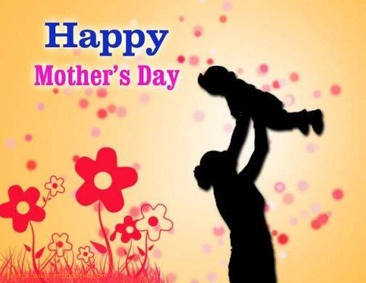

Dear Mom,

I love you to the moon and back. I am really lucky to have such an amazing mother like you.

You are the kindest person I know and you are always there for me. You are understanding and I love that I can talk about everything with you. I am really happy that you are my mother because you are a wonderful person. You always try to make me happy and you always help me with everything you can.

I am really grateful for taking care of me and for everything you have ever done for me. You are really important to me and I am grateful for having you as a mother.

With love,
Andrea

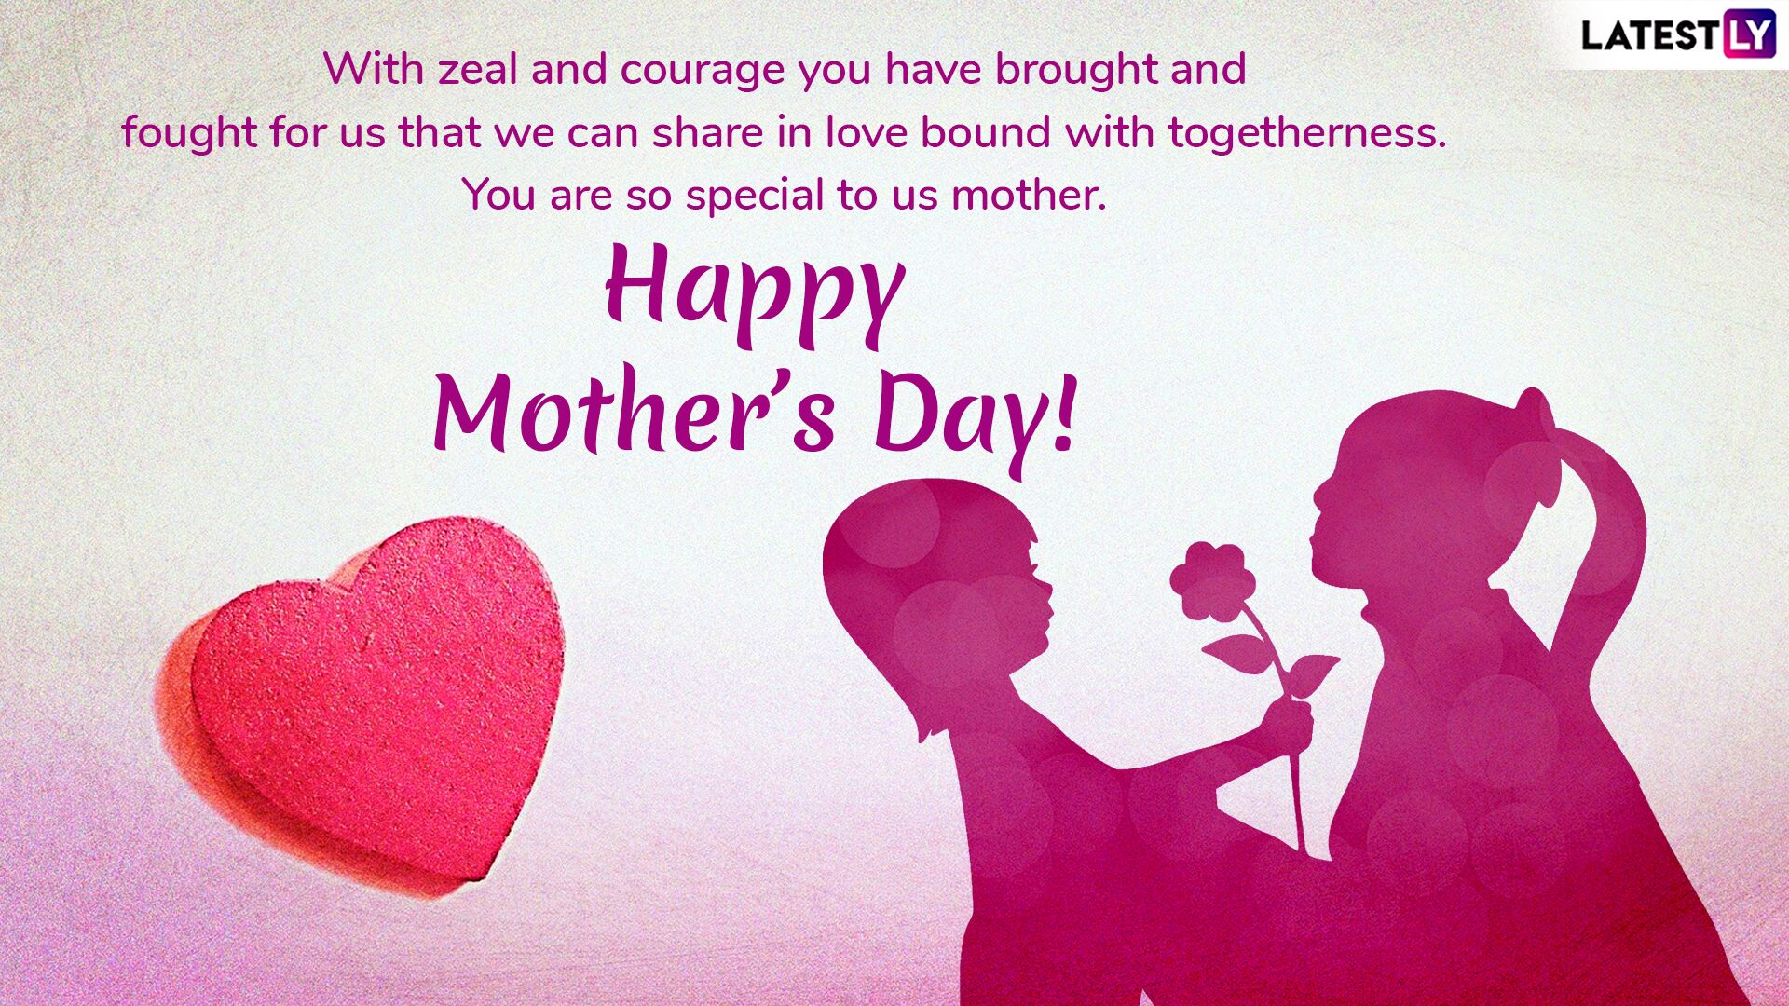

Dear Mom,
It’s Mother’s Day, so I would like to send you this letter.
Mom, I am grateful to you for everything. I am so lucky to be your daughter.
First of all, you gave me birth, you endured all the pain I caused you. I am thankful because you nurtured me, dressed me, taught me, fought for me, hugged me every time I needed and most importantly loved me unconditionally. For always stood up for me and defended me. You did and I am sure you will do the same for me every single day.
Mom, I hope one day I can give back everything you did for me! I would like you to be proud of me, to see that I become a strong and happy person, just like you. I have plenty of wonderful memories that can help me, guide me from now on.
There are not enough words I can say to describe how important you are for me.
Mom, I love you to the moon and back!

Your daughter,
Anita

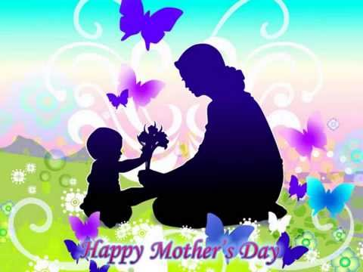

Dear Mom,

I just want to tell you, you are the most beautiful, amazing woman in my life. In my eyes, you’re a hero. I want to be a mom in the future than you. For me you are the biggest exemplar.

This day is just yours! I just wish you were the happiest in life, without problems, without sadness...Because you deserve to be happy.
I know, sometimes I’m annoying and I'm not listening to you and I know too these are mistakes. Many times I say stupid things, but I want to tell you, those are not true...

In this little letter I want to say, how much I love you and how grateful I am for having you! I hope you know, I’m always been with you and I always be with you. Never will anyone or anything separate you!

Love
Your daughter,
Barbi

