REVISTĂ ȘCOLARĂ ”HUGS, NOT DRUGS” LICEUL BOLYAI FARKAS, TG. MUREȘ

Hugs not drugs
Adorján Kriszta, IX.C
There are many different reasons why people are addicted to drugs or any other similar substance. One of the primary reasons is a lack of self-confidence. Besides, people get drug-addicted due to professional pressure, lack of inspiration, excessive stress, or lack of parental love or family problems.With drugs come many different problems.
Drugs in the present day are causing people to make bad choices and bad decisions like committing crime and getting people very addicted to bad habits.
Common bad habits of drugs are skipping school, skipping work.Off skipping school will get you nowhere, because when you skip a lot school you will get kicked out. Once you’re kicked out you have a slim chance of getting to college. Once college is ruled out then you have a very shy chance of getting a good paying job.
If using drugs starts to consume your life, your relationships become less important, and you lose interest in school, sports or work. You may withdraw from family members and activities. You may verbally and physically assault others or start stealing things: money, credit cards, and other valuable items.
Imagine a world where there are no drugs. We wouldn’t have to fear as much about crime. No more worrying about what you chose to try because it wouldn’t drugs in it. No more worries about what kids are doing when parents don’t know where they are. I think love works like drugs. When you are loved you feel good and you forgot about your problems, you are not stressed.
Hugs, not drugs
Bakó Blanka, XI.H

Have you ever wondered how many drugs a person consumes a year? Intoxicants bring over one billion dollars just for America. Naturally these are the good sort of drugs I’m speaking approximately. But the point of this essay will be the opposite of this, the bad drugs and a solution, replacement for that, which is hugging.
First of all, a lot of people use drugs to deal with their health problems, but most of them are trying to escape their harsh reality. Maybe they have a negative outline of life, loss of motivation, doing less at work or school, problems with relationships. The point is that they are unhappy. So they are using psychoactive substances to “fade” away their problems, to be happier. But the sad thing is that this happiness is just momentary. Because of this they will intoxicate themselves on daily basis, and feel the urge to take more to get the same effect, outcome. Their happiness will depend on this.
Second of all, according to scientists hugging is universally comforting, makes us feel good, happy and healthy too. Giving another person support through hugs can reduce the stress of the person being comforted. When we hug, or touch someone the level of oxytocin in our bodies rises, which means this chemical can reduce stress and also is responsible for our happiness.
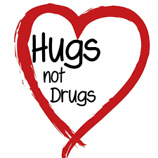
As has been noted hugs are associated with happiness, and people who are sad, depressed or unmotivated are more likely to use drugs. Their main reason is to feel better. My point of view is that, with one hug we can change someone else’s life. I mean we can save them in advance or at least we can help them to replace drugs with hugs.
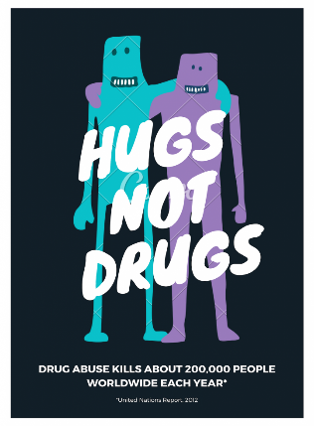
Balogh Boróka, IX.E
Hugs Not Drugs

In our generation so many people and teenagers feel that they are not good enough, they are lonely and for this reason sometimes they try drugs, they drink, smoke and this is harmful for their health and for their mental happiness. Lot of people think that drug is an opportunity to resolve their problems, but with this decision they only accumulate their problems. There are many reasons for someone to start taking drugs. It can be someone’s death, domestic violence, or even if somebody gets in the wrong company.

In my opinion, turning on the love hormone for a solution to serious substance-use disorders is the best thing people can do in this horrible situation. There are so many good therapies, where those who suffer from quitting drugs can change their life by talking, by meeting some new friends. It is a fact that love alleviates pain, helps to move one and helps you achieve better results. For this type of development the hugs are necessary in our life.

Finally, in my view the choice is in our hand, what we think is good for us, but the drugs, alcohol makes the biggest troubles in humans’ life and these are not the right decisions to solve our difficulties.
HUGS NOT DRUGS
Bámbó Péter, IX.G
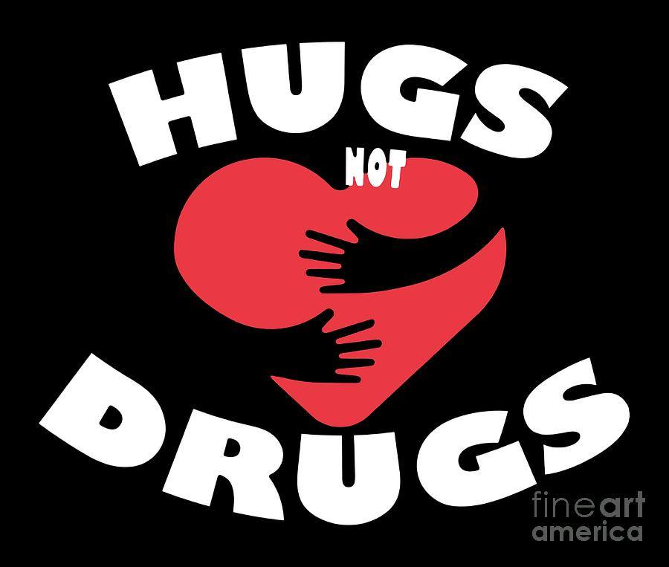
Drugs are one of the most addictive products used today. Every time you use a drug, you are killing yourself. A survey showed that about half of the teens had used a drug once in the past year. Drugs are made out of chemicals that change the way a person's body or mind works. The most common type of drug is alcohol. Drinking too much alcohol causes you to become dehydrated, which can lead to dull, dry skin and premature wrinkles. Drug users are more likely to commit crimes. Caffeine causes sleepiness, headache, and irritability. Drugs also kills about 600,000 people every year. Drugs also affects your physical appearance. Drugs can cause hair loss in both genders, dry mouth, teeth clenching, and poor dental hygiene.
So, whenever offered a drug- JUST SAY NO!
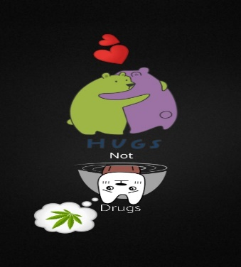

Hugs Not Drugs
Benkő Orsi, IX.E

Nowadays, unfortunately many young people suffer from addiction or some kind of harmful passion. One of the most common deleterious passions is the drug.
In my opinion the lack of a drug in a person's life can be largely replaced by social expression of love, faithfulness, and perseverance.
To begin with, I think the person who turns to use it escapes from something in life, sees it as a way out, and sees it as her problems being solved. It could be a family problem, such as divorce of parents, or some egregious event like death. This is how people run into the dangerous and injurious world of drugs, especially to forget about their problems and pain, and to look into a world without problems.
However, in my opinion escaping to passion is not a solution for problems. The more we should turn to the community, the more useful is to communicate between people, as this is the basis of our society. Rehabilitation is useful for addicted people. Its purpose is to get to know ourselves, to listen to and help each other, and to bear the common burden. In rehabilitation, people always hug each other, because hugs have the ability and the power to make you feel comforted and loved. They have the ability to show you that there is someone out there in this world that will hold onto you when you need it when you are broken.
All in all, I think drugs are not a good way to solve your problem. If you have a bad day, or if you are sad, rather, look for your friends or parents, tell them what's wrong, discuss your problems with them and hug them closely. Sometimes all you need is a hug from the right person…and all your stress will melt away.

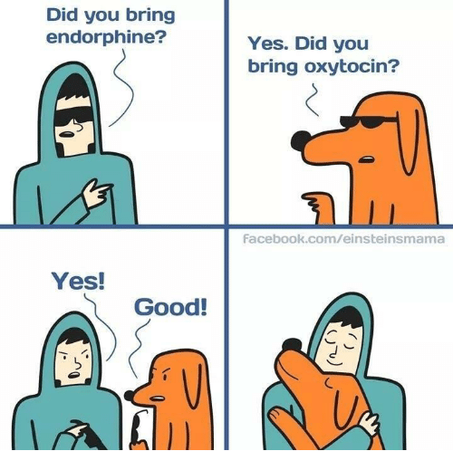

HUGS NOT DRUGS
Csapai Renáta, IX.G
Nowadays, millions of people suffer from drug addiction all around the world.Drug abuse and addiction is considered as a very serious social problem by all society, more likely to affect young people.Many teenagers use drugs in order to help with their personal issues/problems like loneliness, sadness, frustration and depression or simply they just try them bcause someone suggested it, not knowing or caring about the consequences.
Scientific studies and research show that drugs,not only affects and interfere with normal brain function,it also generates a a strong feeling of pleasure and will also have a long term effect on brain metabolism and activity and at some point during the drug abuse,changes will appear in the brain that has a possibility turning abuse into addiction.Drug addicts suffer from an resistible drug craving and usage that they can no longer quit by themselves,that's why they need therapy.Drugs also can be really expensive so it can cause impoverishment.
People dealing with these kind of problems need a lot of attention and caring. Supporting them,taking care of them and showing them love can be really useful and it can prevent falling again and again in the same trap.
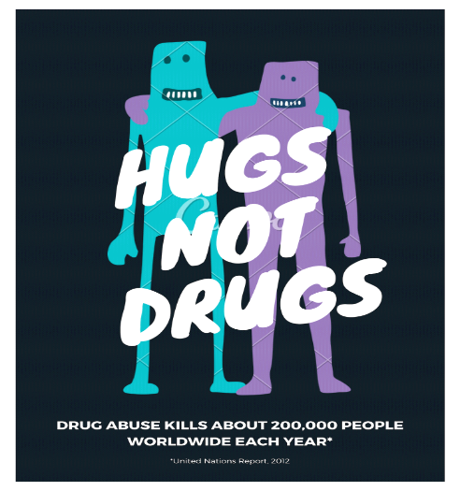

Hugs, not Drugs
Dégi Nándor, IX.G

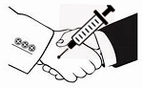
As the title says metaforically hugs or just caring with the other one can result a major personality change. Drugs can end someone’s life easily. Why do people take such risks when other options can leave them with a healthier mind, body and soul? In addition, there are various drugs available to people of all ages. When an individual is alone he/she would not try a drug alone, there is always someone there. Individuals are responsible for their own choices; some people are forced to try something there not interested in. In today’s society, there are various drugs in different categories such as over the counter, tobacco, alcohol and illegal drugs. For example, some legal drugs that are prescribed can be addictive or non-addictive. Medicines are legal drugs, meaning doctors are allowed to prescribe them for patients, stores can sell them, and people are allowed to buy them. But it’s not legal, or safe, for people to use these medicines any way they want or to buy them from people who are selling them illegally. Tobacco is another drug that is sold in public stores. Stogie is another name for cigarettes. It’s up to an individual what they want in life. When someone tries something, it’s obviously another person has to try it. Friends or strangers can peer pressure someone who really does not want to try. However, an individual tries new adventures just to be like others. Likewise, individuals can have jobs, but will not have them for long. In fact, people abuse themselves.
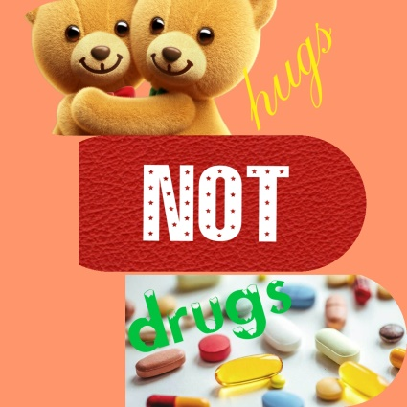
HUGS NOT DRUGS
Dósa Brigitta, IX.C
In our world there are many teenagers who don’t know what to do with their problems. They don’t talk their parents or friends. Nobody helps with their problems and they start to use drugs, because they think that will be the solution. I want to tell what I think about drugs, people who use drugs and my opinion what is their reason.
First of all drugs. I know that there are many types of drugs. Drugs that will make you crazy. Drugs that will make you don’t know about yourself and another what will make you can’t move. I know about drugs, but I don’t use them, and I will not use drugs after that.
I think people who use drugs are sad, lonely and have problems. Those people do not want or do not know to talk to someone. After the first time they use them and feel like they haven’t problems, they use more drugs. They do not think that drugs are dangerous. My opinion is that people are sick and their family or friends can help. Talk with them or send them to a psychologist. To my mind these people will be healthy if someone helps them. But there are some people who use drugs, because they think that is funny. I think those people are crazy.
In conclusion, I do not judge people who use drugs, because they have some problem, but I do not agree with them, because I think if you talk with your friends, you feel like don’t have problems. But if someone uses drugs, because it is funny, that person is very crazy. My opinion is that a friend who talks to you and hugs you is much better than drugs.
HUGS NOT DRUGS
Farkas Szilárd, IX.G
In the following little text, we are going to discuss the next subjects: “drugs & love” projected at the current situation and give the reader some ideas on what to do in the isolation.
Firstly, let`s discuss about the medicines:
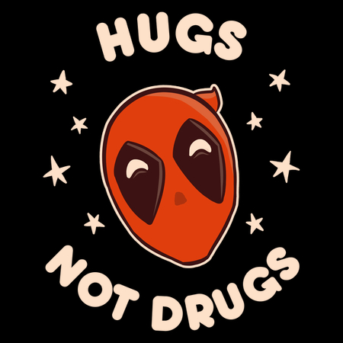
Most people who become ill with COVID-19 will be able to recover at home. But you can do the same things you do to feel better if you have the flu — getting enough rest, staying well hydrated, and taking medications to relieve fever and aches and pains — also help with COVID-19.
Most importantly: Is there a antiviral treatment for COVID-19? Currently there is no specific antiviral treatment for COVID-19.

Secondly, at our current situation, I advise to look over a little bit on these facts, and focus on some other things, like the following:
Let`s spread the new LOVE^{ID} – 19! Having significantly more time, we have the perfect opportunity to show kindness to others.
Spend more time with your loved ones, friends, get to know them better, or do things you love to do, explore new hobbies, improve yourself, spend your time intelligently.
And lastly, as a short summation, things change rapidly in the current pandemic, but don`t let this turn you down, look up, and spread the LOVE^{ID} – 19!
HUGS, NOT DRUGS
Feketics Hunor, IX.G

We live in a world where not only adults, but also teenagers consume drugs, mostly because many believe that everybody is experimenting with drugs but them. They feel a pressure to try drugs themselves, because they see them used in movies, social media, parties or concerts and they feel like they are weird for not doing it, whereas in real life there are much less drug users than it seems. For this reasons, the younger generations start doing drugs, developing addictions, ruining their own lives and hurting those they love in the process.
I believe that people should be more responsible with what they post on social media, or what they implement in their movies, because we all have a duty towards our community, to help the lives of everyone improve and prevent life-destroying choices like drug use. We as a community should encourage everyone to not live their lives in fear of not being like the more famous individuals on social media, and to let themselves be more free and unique.
In my opinion, everyone needs to make their own choices, and no one should try to pressure them into something they could regret, just because they think that otherwise they could never fit in.
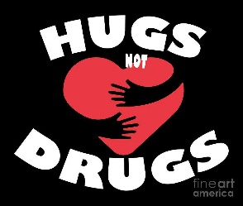
Hugs, not drugs
Pataki Előd, IX.C

In my opinion we should chose love instead of drugs, because: if we consume drugs, they will have many awful consequences; drugs are very harmful for our health. However, our loved ones take care of our health; when someone is drugged, he can do imprudent and terrible things.
If we consume drugs after a time we will be addicted, and we could and up making bad decisions. The drugs are also very expensive. Unfortunately, sometimes because of this, spouses divorce, the addict person steals from his loved ones and people became poor. The love is very important to the people but it is not expensive. The love gives us happiness and the sense of security.
Sadly the drugs destroy the people’s health too. Some of them are especially dangerous. For example, the zombie drug. Our loved ones ensure us. And they do not let us to do harmful things.
When somebody is drugged, he does not think for the consequences. Sadly, there were cases when teenagers and adults died because of drugs. However, if we chose the love, our loved ones help us to keep clear from the wrong way in the life. Ones begin drugging to prove something. If someone is loved he does not feel the need to prove anything to anyone.

Based on the statements above I think that we should chose the hugs and the love, not the drugs.

Hugs, not Drugs
Kelemen Kriszta, X.B

In my opinion, drugs are bad because they can influence our thoughts , our acts, or put simply they can influence us. We forget about loving our family, going out with our true friends,and step by step, we lose our control over ourselves.

On the one hand, if you do a lot of drugs, you will become addicted and you cannot imagine your life without drugs. Your family will be disappointed in you, because they love you and they want the best for you. Doing drugs, at the moment it could be amazing, but probably you lose the most important thing in life, which is your loving family. But if you don’t do drugs then you will be more calm and happy. Perhaps people look at you better, they are showing much love and respect for you.(They give to you hugs and kisses and you should too)

On the other hand, being high and patying all night and all day, let’s say it is okay for a while, but not too long. You have to think about the future and develop yourself. Find something , what makes you happy and you are good at.(for example:writing,reading,singing dancing, drawing etc.) The drugs don’t really help you focus on these things.

In addition, focusing on our health is also a very important thing.We need to take care of both our mental and physical health(especially now), because if we don’t do we will be sick,ill. For example we can meditate or doing yoga, but we also need to eat more fruits and vegetables and less sugar or fast food.

In conclusion, doing drugs is awful and really dangerous. So, I recomend not using drugs and living without them. Instead take care of your health, and if you know people who are addicted to drugs, you should help them.
Hugs not drugs
Kucsván Levente IX.G

In my opinion three out of four doctors report that a hug means more than an orphan drug. Nobody islands to interpret this term as drugs are good things.
On the one hand, a hug furtermore means more than 1000 good drugs. When we are faced with various difficult problems, it is often better to be helped by a hug from someone who loves us than if that person were giving us drugs. An example of this occasion would be when in my childhood whenc I had to go on a trip I got a very nice hug from my mom like a drug from my friend.
On the other hand, hugs are very rare these days as can be found on the streets by junkies. When you love him, so to speak, you show your love to him, for example, if you were giving drugs to a person, you would only express your hatred for him.
A third aspect would be, hugs are very important because they show the care you have. An example of my life when we went on a class outing with someone was offering me drugs for free just to try them out. It really upsets me.
In the end, then, one thing is clear: try to give hugs as drugs to each other, because that will change your life.
Hugs not Drugs
Nágó Dániel, IX.E

A drug is any substance which, when taken into the body, alters the body's function either physically and/or mentally. Drugs may be legal (alcohol, caffeine and tobacco) or illegal (cannabis, ecstasy, cocaine and heroin).
Throughout history, we have been fighting against drug and alcohol abuse in teens and adults. Many ways people try to prevent drug and alcohol abuse is through education in schools. They teach young students about drugs and alcohol before they risk being around them, and they teach older students about drugs while they are around in their daily lives.
It might feel good taking drugs for the first few times, but it could be really harmful if you abuse it. They may consider doing drugs because they think it will help them fit in. Instead of helping you fit in, drugs could actually destroy your friendships. Drugs can waste your time and money, leaving little of either to spend with your friends. You do not have to do all the same things your friends do, just to keep your friendships.
Teenagers might think that everybody but them is using drugs. This may seem true because they see drug use on television, in movies, on social media when hanging out with friends, or at parties and concerts.There are ways to prevent teen drug abuse, like knowing the teens’ activities, knowing the teen's friends and setting a good example for them.
In conclusion, drugs are not the key to your problems they just create even more difficulties, they ruins friendships, they can make you broken and mentally unstable.

Hugs not drugs
Béres János, IX.E

Drugs are a really bad thing, like Real bad. Drugs damage our nervous system, intoxicate us, and in many cases even leave permanent damage.
If we concluded that drugs are bad we need a solution to eradicate them off the face of the earth. If we want to restrict drug usage we need to know why so many people use them. Why are drugs used? They are used either to party or to relieve pain (psychical or physical). No matter how someone started to abuse a drug they proceed using it because they became addicted to it. To overcome an addiction what do they need? They need support, self-determination and lots and lots of love. That's where the motto comes from "hugs not drugs". Every human on Earth needs 8 hugs/day. Nowadays for many people, this number is almost never reached and that causes emotional pain. We should not try to stop drug trafficking, we should try to minimalize the dangers that a human soul is faced with. So if we really think hugs and by that extent love is the ultimate weapon against drugs, it prevents drug usage and it can save people from the bottomless pit in which they fall called addiction.
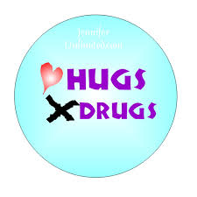
HUGS, NOT DRUGS
KRISTÓF MÁRTON, IX.G
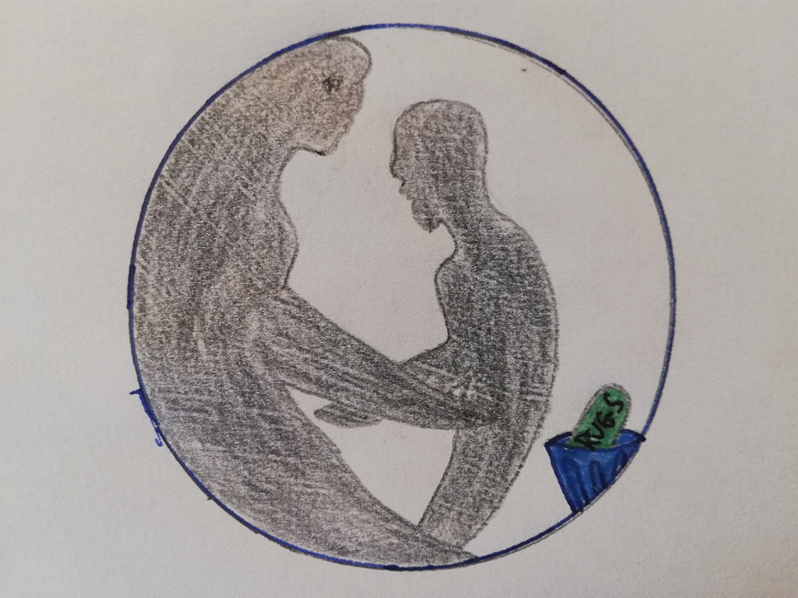
We always say that the love is the best medicine for everything. We can express it in many ways, like saying pleasing words, helping others or touching, like hugging.
But first, what is hugging?
A hug delights and warms and charms, it must be why we all have arms. Ever wonder why God gave us arms (except to work with them)? Perhaps to be able to hug the one you love and show him or her your compassion is one of the possible answer. Hugs have the ability and the power to make you feel awkward, comforted, breathless and loved. They have the ability to show you that there is someone out there in this crazy world that will hold onto you when you need it - such as when you are shattered and broken. Many things can be conveyed with a simple hug. And personally I think that the hug has been shafted in society and that people underestimate it.
Hugging is a beautiful language of love: it’s unsaid, but effective. It’s just a little movement. Hugging can mean that someone understood you, she/he is happy to see you, or just simply likes you.
How can you receive hugs? Just behave well and love others to love you, because the love is inexhaustible.

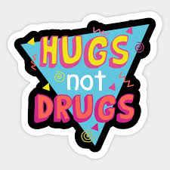
HUGS, NOT DRUGS
HEGYI ZSOMBOR, IX.G

A drug is any substance that causes a change in an organism's physiology or psychology when consumed. Drugs are typically distinguished from food and substances that provide nutritional support. Consumption of drugs can be via inhalation, injection, smoking, ingestion, absorption via a patch on the skin, or dissolution under the tongue.
Drugs are so dangerous. A lot of people can’t imagine what power that drugs have. Sadly in our daily life we had a lot of drug addicts everywhere around the world. That type of people are insane. They are crazy about drugs, they spend their whole life for drugs. They change a lot in a bad way.
If you ever try drugs, it is nearly impossible to say no next time, a drug can take your health, your family, your friends, the people you care about, you lose your everything, u will do anything for drugs, stealing money, getting aggressive, getting depressed, getting hurt. Is this worth it? I think we already know the answer.
A lot of good people died because drugs. A lot of celebrities and innocent people. In three years I lost three young rappers that I listened to. This people were an inspiration for me and for others, they were good peoples but they were not enough powerful against drugs. Jarad Anthony know as Juice World died at age of 21 (2019), Mac Miller died at age of 26 (2018), Gustav Elijah know as Lil Peep died at age of 21 (2017).
After you try a drug, u feel like never before, you think that is your best feeling ever, but you must notice that a drug could be your lover, your mother, your best friend and WORST ENEMY. Say no to drugs, do not try them, you do not need them. Go and share some love, hug your friends, your family. Be thankful for what you have. Be proud of who you are and focus on your future.
Hugs, not Drugs, is a well-meaning phrase, which means we should give hugs to people with any (serious) problems instead of letting them using drugs. This is true, especially for children/teenagers. More and more teens take drugs because they feel they can't face their problems. Most of the later drug addicts are children with difficulties inside their environments. Maybe they have issues inside their families. Their father is an alcoholic who usually beat them (physical factor), so perhaps they think nobody loves them. They can also be forced to prostitution (sexual factor). Or maybe they get shocked by an event, such as the death of their mother, or of somebody they love and feel depressed.
The good news is that we can help depressed people who feel lost, or sometimes we can help even those who are already drug addicts. According to some scientists, these people can be helped if we show interest in them. Such kind of attention towards them can be showing that we love them. Our love can be demonstrated by hugging them. When they feel they are loved, their brain produces oxytocin (also called the 'love hormone'), and this helps them in their war with drugs, it does not matter if they are already drug addicts or they only think about it!
Overall, in conclusion, we really can help people with problems by giving them a huge hug! So, whenever you think somebody from your environment needs support, give him/her a hug.

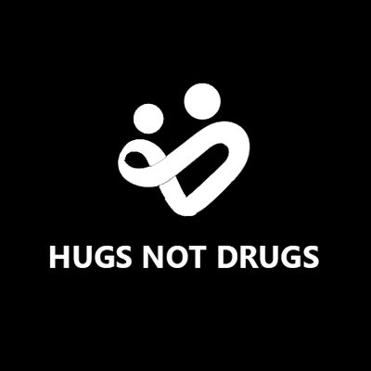

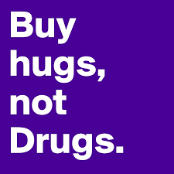
Hugs not Drugs
Kántor Csongor, IX.E

Why do people use drugs? Don’t they know what are they using, that that’s bad for them? I think that they know just they do not want to care, because they live by it, because they are addicted to them.
Can we help ourselves not to use drugs to live a drug free life? Actually the answer is no, because we use lots of drugs in our lives, but these drugs are allowed, these drugs help you not make you feel like an animal or if you were flying, this are medicine. But the sad part is that if you use it wrong some of them can give you addiction, and there are so much drugs that use medicine as their base element. So we need drugs for medicine, but those drugs are not the same as what we consider to be drugs here.
Drugs make you happy, weightless, makes people not think about something strange, sad or unforgettable, this is why a lot of people use drugs. Let’s see what can we replace that with? For example there is our title HUGS, love, friendship, family these are what really mater’s on our world this is what we are, not selfish people that just care about drugs and themselves.
The biggest side effects of drugs are that you hurt yourself and others not just physically but mentally too.
Let’s keep ourselves away from drugs, le us find another way to find that what we were looking for. Hugs not drugs!!!
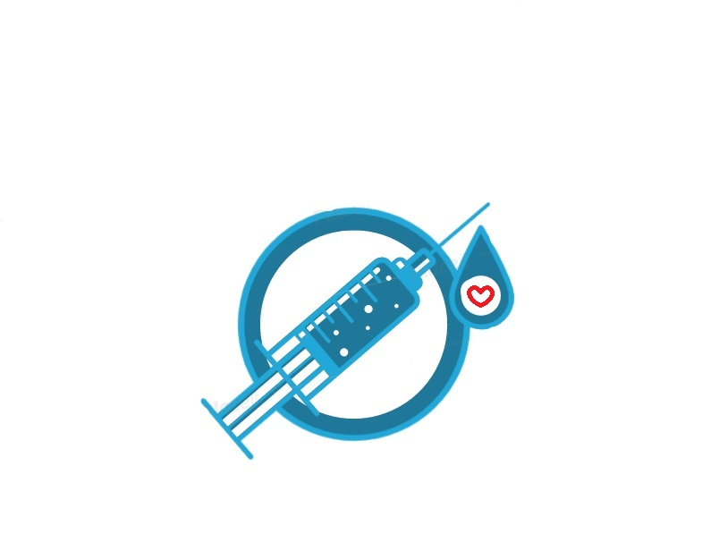

Hugs not drugs
Orbán-Balásy Kata, IX.C

In today’s world drugs are quite prevalent. Some people who lost hope, and are struggling in their lives, are trying to escape through drugs. In this essay I’d like to write about the dangers of these substances, and what options are to fight against them.
There are many types of drugs. I’m not going to list all of them, but the most common are Cannabis, Speed, Ecstasy and many others. Drugs can also be severely addictive if the users can’t control themselves. If a person is dependent of drugs, it can have serious consequences such as lung disease, stroke, HIV, cardiovascular disease, or even cancer. These substances can have different forms, as tablets, powders, herbal leaves, etc.
Each drug has different effects, but I’m only going to talk about the effects of Cannabis and Speed. From Cannabis, people will feel cheerful, uplifted, and become more creative. Speed makes consumers feel alert, they can experience hallucination, excitement or even anxiety. This substance have long been a popular consumer product due to its appetite suppressant effect. 18.6% of drug addicts are able to quit the drug, which is a very low rate. I think drug addiction can be fought either through sports, willpower, or someone can be asked to help the addicted, but quitting can be very difficult, so be careful not to start using drugs, because then it is hard to climb out of it.

Hugs not drugs
Orbán Gergő, IX.G
Hugging is a very good thing, because with a hug we can make someone’s day happier, and we can reduce stress level with hugging, and showing support.
This effect was caused by oxytocin hormone, because oxytocin is associated with happiness and less stress. The stress-reducing effects of hugging might also work to keep someone healthier. In a study of over 400 adults, researchers found that hugging may reduce the chance a person will get sick. The participants with a greater support system were less likely to get sick. And those with the greater support system who did get sick had less severe symptoms than those with little or no support system.
The drugs: A drug is any substance that causes a change in an organism's physiology or psychology when consumed. Drug is a very bad thing, it probably cause happyness for peoples who use it, but drugs damage organs, and many people is escaping from the world under the effect of drugs. Drugs can cause damage in organs, example: persistent cough, chronic cough, lung damage, heart attacks, shortness of breath, and many more damages in brain and other organs.
There is an addiction which name is hug addiction, but the hugs does not cause phisically or physiology damages as drugs, but the hugs has more good feature than drugs, so hugs are not drugs.
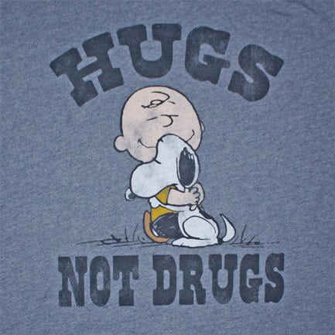

Hugs not drugs
Kacsó Laura, IX.G
Both hugs and drugs can make you addicted, because they activate the same hormons and for the brain they are similar activities. Anything can be a drug, hugs can be too, but they are not as harmful as drugs.
Drugs are not good at all. You can became addicted to a small dose. They do not give you anything good, just bad things, because it's addictive, it causes diseases, at least it can kill you if you overdose. It gives you just momentary pleasure which is not real joy. In contrast, hugs give you real joy, they are not as harmful as drugs. It is true that you can become addicted to them, but that is not bad thing, they don't have horrible effects at all. A lovely hug can raise big dose of love in you, also the feelings of hope and joy, so it is really good when you hug somebody who is close to you, who loves you, and who you love.
Every person addicted to drugs needs love, they want to get love form drugs. They can get this love from a simple hug, but because they think that they don't have any people from who they get this,they use drugs to replace this lack of love.
In conclusion, because every person needs love, give more hugs, they are better than hugs.
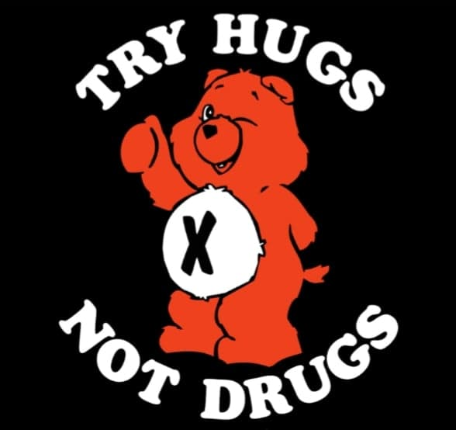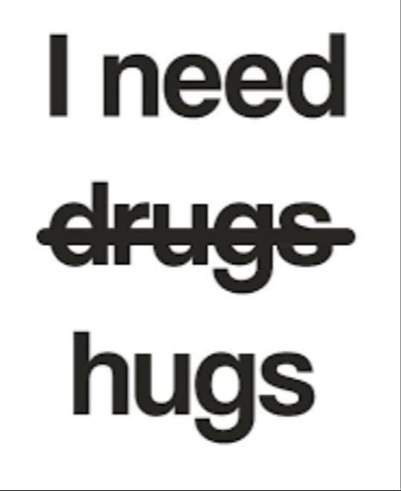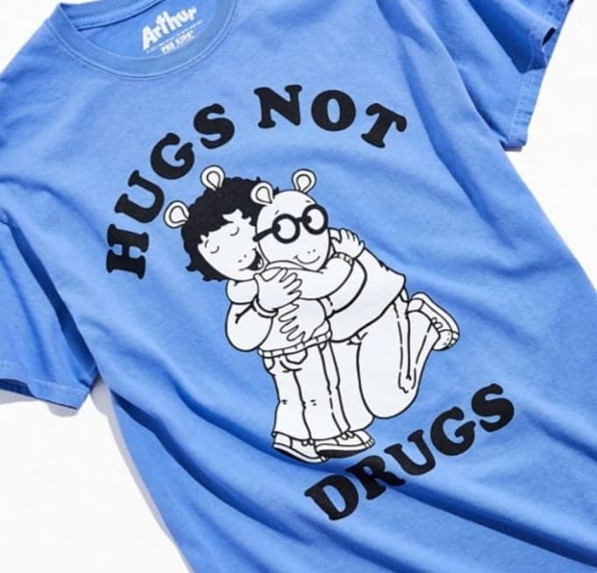

HUGS NOT DRUGS
Kakucs Hunor IX.E

Everyone needs to be loved, and wishes to be happy in life. This is how life is balanced, we don’t need to be the happiest, but neither the saddest.
If people are not loved, and always sad, and not happy with life, they will use drugs in order to heal these situations, or worse just simply kill themselves. In order to avoid these, we should use hugs instead of drugs or even worse stuff, like I mentioned above. Drugs are bad, or at least that’s what they say. But I can really give my opinion for this because I have never had drugs in my life, but reading articles about it, I don’t really want to try it either. Mostly problems with drugs happens in America because we can say that is the center of drugs. Unfortunately we can’t help this issue, but we always need to spread love and socially help people. There is unfortunately a lot of drug abuse on this planet, and it cannot be stopped all. We need to do the best we can and spread love and give hugs to people instead of being depressed alone and use the alternate, some drugs.
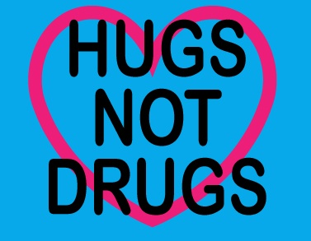
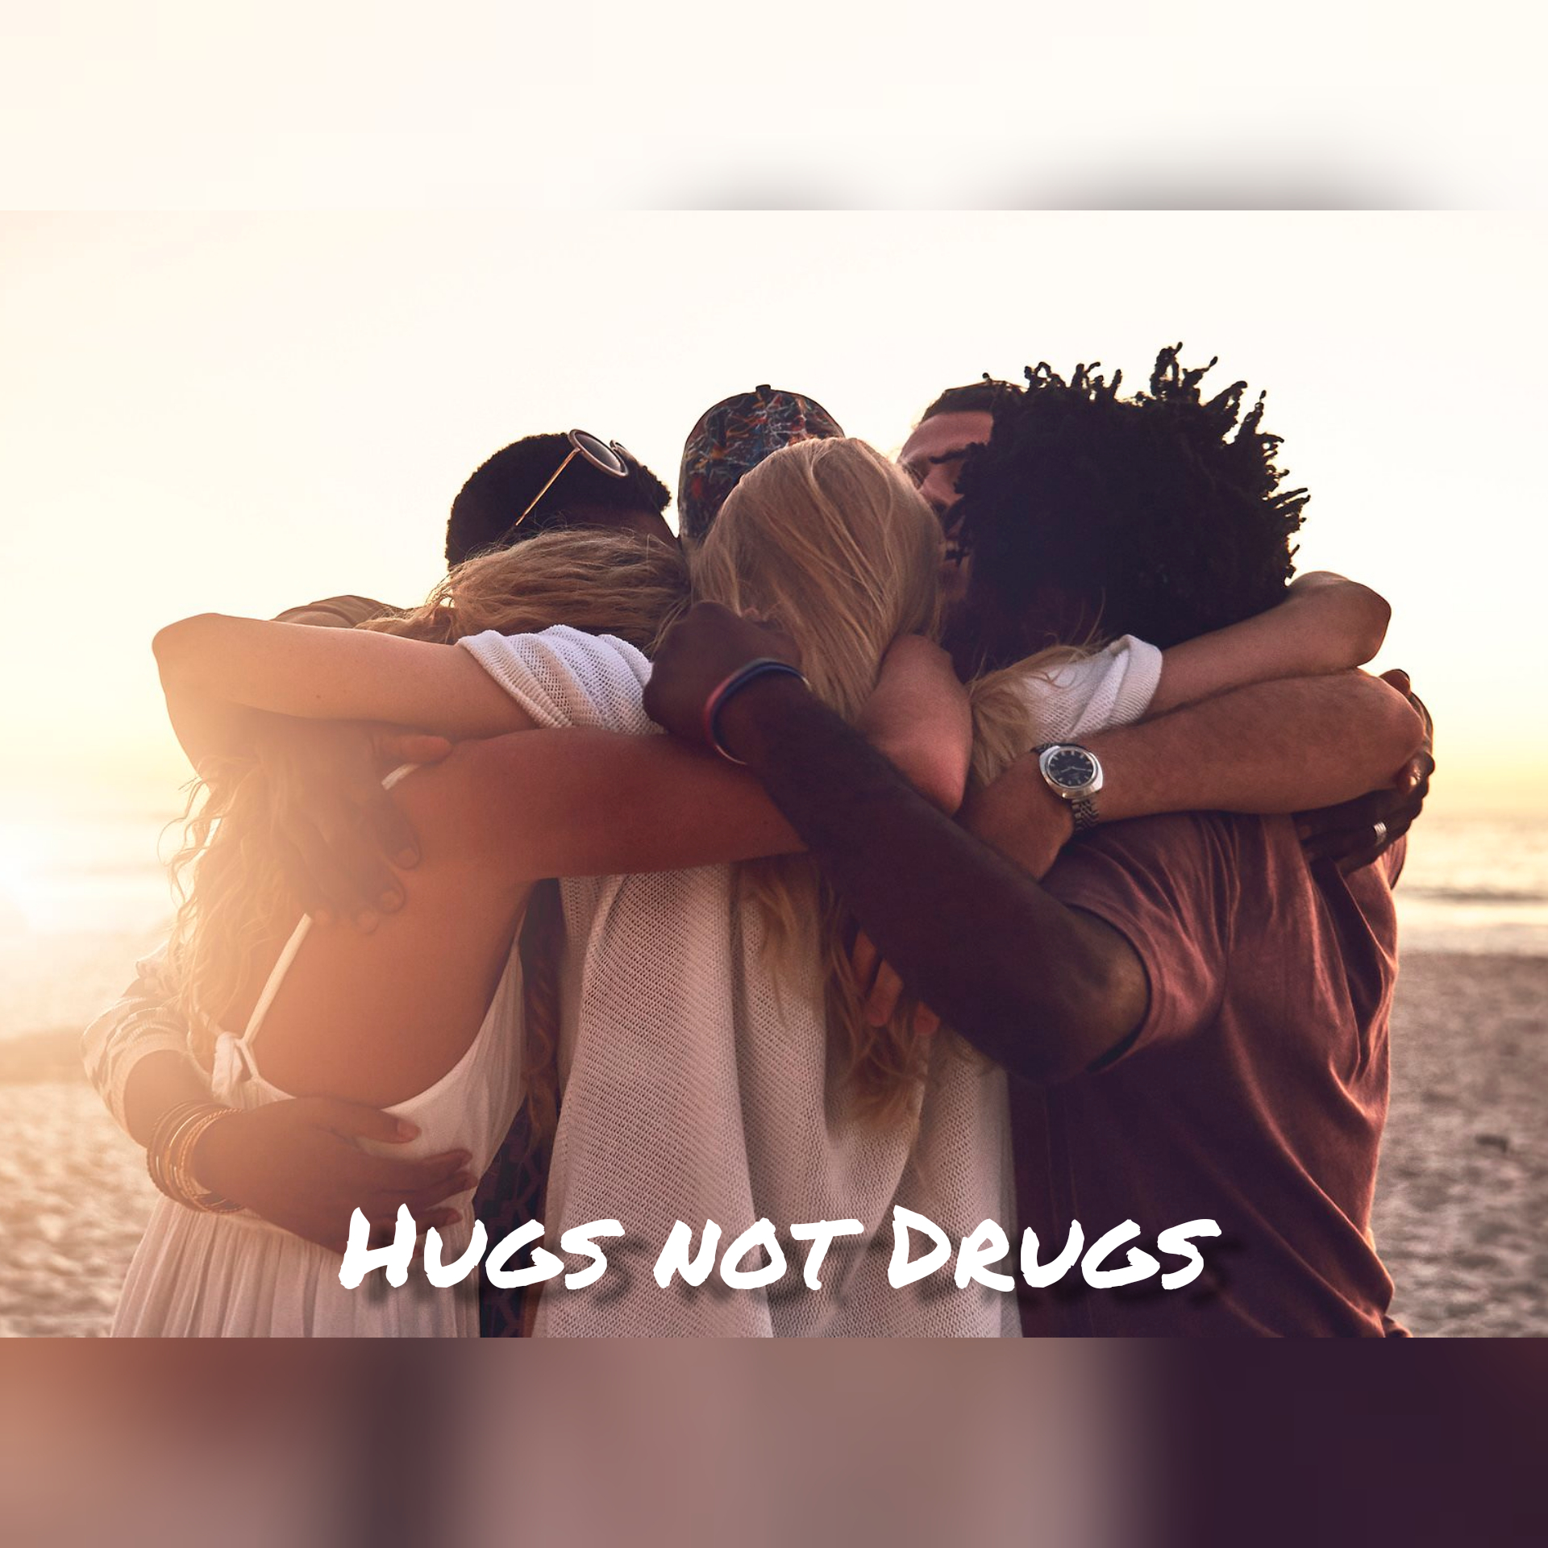
Hugs not drugs
Kováts Eszter-Tímea

We all thought, that using different type of drug it is very harmful. We condemn those people who use it regularly. Some people think everyone who takes drugs will end up dead. Other seem to think that drug use is not so dangerous. In history there have always been drugs. Now America is the drug capital of the world and it is an over a one hundred billion dollar industry.
Drug use it is not always as dangerous as people think. The dangers of drug use depend on drug, set and setting factors. Drugs are not the same, different drugs have different dangers. The dangers of drug use depend on: how much is taken, how often the drug is taken, how a drug is taken.
Drug addiction can be managed effectively like other chronic diseases such as diabetes, asthma etc. The treatment of drug addiction is becoming personalized. There are many options to treat drug addiction, but it is not easy. Drug addiction is a chronic disease and the patient can't stop using drugs within a few days. The treatment must stop the person from using drugs or keep him away from drugs.
Healing is also facilitated by patience of the family, relatives and the patient. In my opinion, it is much better to avoid drug use than afterwards to quit it.

HUGS, NOT DRUGS!!
Kulcsár Lóránt, IX.E

A drug is any substance that causes a change in an organism's physiology or psychology when consumed. Consumption of drugs can be via inhalation, injection, smoking, ingestion, absorption via a patch on the skin, or dissolution under the tongue.
The drug has been present for a long time in people's lives. Drugs not only mean cocaine or these, but they can be, for example, a machine or a series. Which you can't just finish, for example you can't easily put down the cigarette.
But the drug can have very serious effects, for example the cocaine: extreme sensitivity to touch, sound, and sight, intense happiness, anger/irritability, paranoid feeling. I don't think anyone wants that, mostly to be addicted for drugs.
Those who do drugs do not think the future, because if you are addicted to something, it will not be a good future. Everything you can be addicted to must be finished. After a while if you are addicted to something, you would give anything for the addictive things.
I think drugs have a bad effect on people. A hug would be much better than a thing that would ruin the future. Drugs need to be tackled and could be stopped in time.
HUGS, NOT DRUGS
Lengyel László, IX.G

Drugs are bad, or at least that was what I was told, I never tried them myself actually. But in my point of view the most destructive drug related problem is drug abuse. As an example let’s take athletes into consideration. How many athletes have fallen prey to drug abuse? Drug abuse across our planet only gets more frequent these days, people are becoming addicted to painkillers along with other pharmaceutical stimulants and depressants. Kids are stealing pharmaceutical painkilling drugs like Oxycontin and using them as inhalants. A study by the University of Michigan in 2002 showed that nearly 50% of 12th Grade students had used Marijuana at one time. It also showed that 60% had used cigarettes and that 55% had used any illicit Drug at one time or another.
From all this I conclude that drug addiction is one of the scariest things in our society and the attempts of solving it that I had witnessed are almost futile and effortless. Our community tends to overlook this problem that’s why we need to educate, convince ourselves to avoid using drugs and falling prey to addiction. And this is where hugs come in, hugs can help you reduce stress by showing your support, like when a friend or family member is dealing with something painful or unpleasant in their lives, give them a hug. Hugs can even preserve your health by reducing stress levels.
All in all, you should not underestimate the power of hugs and don’t be afraid of giving hugs which helps you stay away from drugs and keeps you healthy. Not only are they more beneficial than drugs, but hugs also could have the same effect.
Hugs not Drugs

A drug is any substance that causes a change in an orgasm’s physiology or psychology when consumed. Consumption of drugs can be via inhalation, injection, smoking, ingestion or else. In my opinion drugs are one of the biggest stupid creations ever made by humanity after guns. There are also numerous governmental offices in many countries that deal with the drug manufactuers such as drug laws and else. In case of that, drugs are strictly illegal in all around the world. On the other hand there are also some of them use in medical cases. But otherwise, in my opinion, drugs are totally not good for mental health, I strictly do not recommend it for anyone consuming it. Instead of it, DO HUGS, and spend as much time as you can with your lovely friends, family members and more.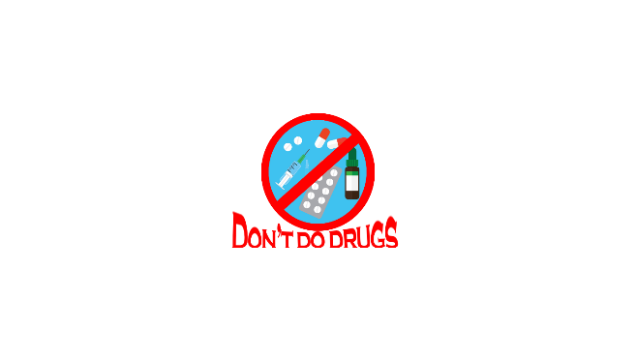
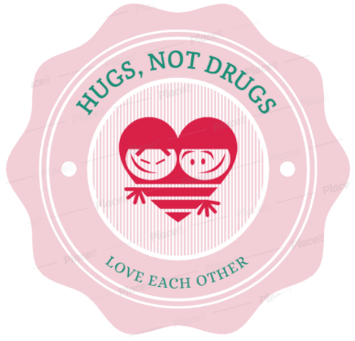
HUGS, NOT DRUGS!
Lukács Orsolya
Nowadays, drugs are very popular. You can get them whenever and wherever you want. Besides, there are a lot of countries where using some kind of drugs is legal. The question is: are they good? Many people use these awareness modifying drugs, and at the beginning they think it will be just one-time, but later, one day, they will wake up and realize that they are dependent, and then it would be very hard to get out of that habit.

Fortunately, there is a cheaper and better way to be a positive and happy person. HUGS! I know, it sounds strange, but there are several scientific searchings which confirms this affirmation. Scientists says that hugs can make you happier, protect you against illnesses and reduce stress, pain and fears.

A hug is good for everybody. After a hard and stressful day, a hug from your loved ones can help you relax. Have you ever thought about the fact, why goes a little child to their parents bed, when he has a nightmare? Because his mother hug can reduce his fear and protects him from anything.

Scientists have found, that those people who hug more have better blood pressure and heart rate. In a study of over 400 adults, researchers have found that hugging may reduce the chance of a person getting sick. The participants with better immunsystem were less likely to get sick. Apart from that, the oxytocin (oxytocin is a hormone in our body, which is associated with happiness and less stress ) level rises when we hug, touch, or sit close to someone else .

A family therapist once said “We need 4 hugs a day for survival. We need 8 hugs a day for maintenance, and 12 hugs a day for growth.” So stand up now, hug somebody around yourself and don't be shy to show up your feelings! Let's hug!

Hugs, not Drugs
Nágó Márk, XI.H

Throughout history, the world has been fighting against drug and alcohol abuse in teens and adults. Many ways companies and anti-drug groups try to prevent drug and alcohol abuse through education in school systems and out of school systems. They teach young students about drugs and alcohol before they risk being around them, and they teach older students about drugs while they are around in their daily lives.
Some of the illegal drugs are marijuana, ecstasy, cocaine, LSD, crystal meth and heroin. Drugs are consumed in different ways, by inhaling, taking by mouth, injecting, applying on skin, and smoking. When a person is addicted to a drug, the drug becomes so important that the person cannot manage without it. Drug use distracts attention leading to academic failure and poor social skills. Stress plays a major role in drug use and continuing drug abuse. It also creates problem in our family, school and with our friends.
Drugs are chemicals that change the way a person's body or mind works. Drugs are not good for health as they have many side effects and damage our brain, heart and other important organs. Few people deny the dangers of drug use, while many teens are curious about drugs. They should stay away from drugs and install other things in their lives instead, like for example love, friendship, hugs and all the good things that can maybe give you the same feelings but without the dangers that drugs can lead up to.
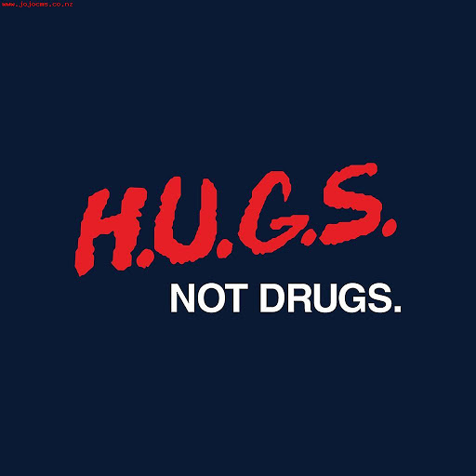
Hugs not drugs
Nagy Ferenc, IX.E

There are many reasons why people use drugs. More often than not, a person is trying to fix an issue within their life and they see drugs as the solution.
If you have a family history of drug addiction, you may have a genetic predisposition to develop an addiction to drugs or alcohol. It stated that about 40% - 60% of a person’s risk of addiction.
For some alcohol stops doing the trick. A few beers after work or school, or having drinks with at a local bar just doesn’t have the same effect that it used to.
Or men and women drink essentially because they like the effect produced by alcohol. While this seems obvious, some people like the effect so much that they are unable to stop. It may be difficult to see the wrong side of something that makes you feel good.
In order to be happy and balanced in life, all the people need to be loved. If they are not loved and cared for, there is an emptiness inside their soul that they need to fill with something or which they wish to get rid of. One way to do this is to use drugs to feel better and forget their misery. But aren’t hugs a much better remedy and treatment for this?
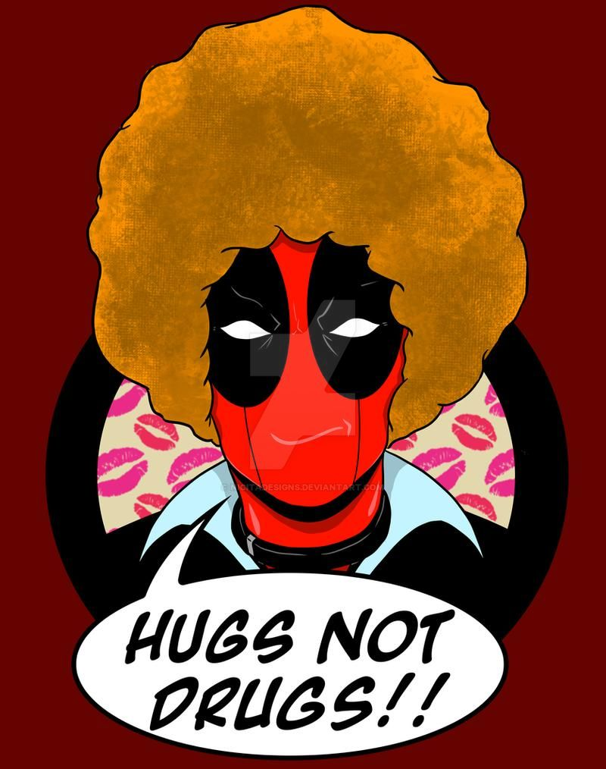

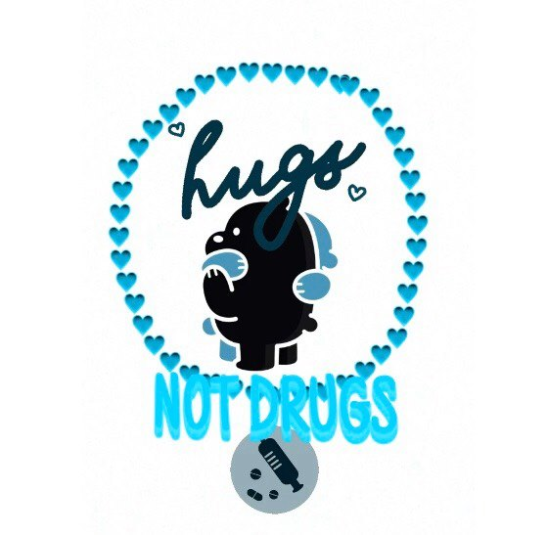

Hugs no drugs
Nagy Sámuel, IX.G

People use drugs because they are not happy enough or because of their friends’ influence, who make them to try out the drugs. Drugs make the user happier, feel cool, but besides this it has a lot of harmful effect. The users cannot stop using it, and if they want to finish this addiction they suffering from the withdrawal symptoms, and the other thing is cause the drugs are very expensives. Many users become less sociable than healthy people, when start using drugs.
My opinion is: drugs are bad but the hugs are much better than any effect of drugs. It is a scientific fact because hugs, showing our feelings make us happier. True thing is that cause the relationships with other people makes us much happier then any other thing in the world cause, in my opinion this is life’s meaning. So we have not to use drugs to feel ourself happier, if we have a good family and friends who love us, it has to be enough. It can happen because we are not happy with our family and friends, then we have not to use drugs only we have to change our life so it can be better.

Hugs, Not Drugs
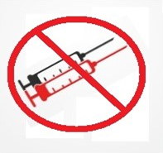
Simó Tamás, IX.C

Drugs have been a major part in the life of humans ever since the dawn of civilization.
Those primitive drugs were mostly used as painkillers or other medicines, and these became the ancestors of modern medicines. Those early versions helped scientist develop modern medical technologies such as vaccines, which play a pivotal role in our everyday lives. Without these early natural drugs our medical science would have got nowhere.
But lately drugs have also started to be used not only as physical painkillers but as temporary mental ones. The use of drugs as a way of dealing with mental problems or depression has significantly increased in the last period. The reasons for depression mostly include social isolation, financial problem and exclusion, the last of which other people are to blame for.
To prevent the usage of these substances and to prevent the significant side effects such as addiction and major health issues, and in some cases even death. We need to be careful not to let anybody to isolate themselves or pushed away by society, especially if they are already consuming a form of drug.
Selling drugs also took up a sizeable portion of the black market, ever since many governments banned their everyday use. This made them a target to dealers to hardcore gangs.
We need to look out for each other, we need to help our fellow humans, so none of us end up in a situation, from where there is no turning back. We can make the world a better place together.
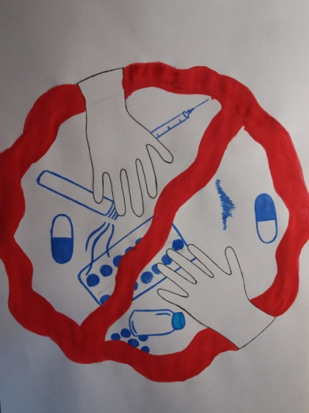
Hugs not drugs
Suba Orsolya, IX.C

A hug can make your day, if someone hugs you, gives you energy and power. When you are tired and somebody hugs, you can relax in his arms, you don’t feel any danger. But some people, who didn’t know about a hug’s power, choose drugs in frightening situations. In my opinion a hug is better then the use of drugs. Firstly because the use of the drugs has side effects. Secondly because it leads to addiction. In addition usually one leads to another, and so on, until from gateway drugs you get to more heavy ones.
If you are sick, and you need to get medication, the doctor warns you if the medication has side effects. If you buy a drug it can have side effects too. Some drugs affect the nervous system, they can cause panic attacks and PTSD. Others affect the heart and cause vascular problems. There are some that affect personality or basic life functions but all of them are known to cause cancer and frequent loss of consciousness.
I think everybody has addictions, some are computer addicts, others are kleptomaniacs, some cannot thrive without a person, and there are a lot of addictions.
if you use drugs more than once, certain substances are incorporated into your cells, so you can no longer live without it.
If you buy something regularly from a market the employees will get to know you. This is true even if you buy drugs, you enter a „system”. The dealers will know everything about you, and they will use it to blackmail you if you don’t buy drug from them.
In conclusion a hug is better than drug use. A hug has no side effect. It can cause side effects, but this is not bad, and nobody will blackmail you, just your crazy friend.

HUGS, NOT DRUGS
Szabó Krisztián, IX.G

So, how are you? How was your day exactly? Yeah, I think I know the answer to this one. I’ll guess that it wasn’t the best. It was just like yesterday, right? If I’m wrong, then, maybe this small text isn’t for you. But, you can still stay. Maybe I somehow will change your mind. Let’s hope, that that’s not going to happen.
For the rest of you, who are reading this, I’m guessing that you are have a problem with addiction. I think that you are a bit surprised reading this article. By the title of this, I think that you were not expecting a text like this one. This is not going to be like all the other motivational texts about addiction and drugs. I know that you already read or heard those other things a bunch of times. I’ll that guess they did not work. At least for me they didn’t. Yeah, that’s right, I was in the same situation as you. I had an addiction just like you do right know. Do you want to know, what I was addicted to? Social media. Some of you might think that this is not even close to your kind of addiction, and you might even feel offended. But trust me, social media can be just as addictive, as any other drug. If you are not convinced, I’m not going to judge you. I know how absurd it might sound. Before, I though the same thing.
What is addiction? Addiction is defined as the psychological and physical inability to stop consuming a chemical, drug, activity, or substance, even though it is causing psychological and physical harm. By this definition my case can be considered an addiction, just as yours. Social media harmed me a lot. It affected my motivation, my productivity and it made me miserable. Isn’t this how you feel?
Now you might be asking the question “Then how did you get rid of it?” You might be disappointed of what you are going to read, but my answer is “through willpower”. I’m sorry to disappoint you, but there is no secret formula. You can only do it through will. I know that it is not easy. No one said that it is going to be. It wasn’t easy for me either. You might not realize that by reading this, you already made the first step in the right direction. You need to act now.
Let’s, for the sake of the argument, suppose that there is absolutely nothing after death, that there is no afterlife. Let’s suppose that this is it. Are you willing to spend your only life on this? Being miserable? I hope not. There is always a way out. I want you to find it. I know that you can do it. You are stronger than you might think. Every time you have the urge to do something that you are going to regret later, remember this text. I’m sending lots of hugs. Now go out there, and make your life what you really want it to be. Be strong.
Hugs not Drugs
Varga Zsófia, IX.E

A drug is any substance that causes a change in an organism’s psychology. There are many reasons why some people use drugs, to fit in, to relax or even certain religions require using drugs. But why do teenagers use drugs?
There is a common misconception that teenagers who experiment with drugs and alcohol are “bad kids.” Many parents assume that teenagers experiment because they are rebellious and want to lash out, but the dangerous trend is not that simple.
First of all: boredom. It can be surprising, but it is the most common reason. They are simply bored and have no deeper interests so they start experimenting. And that is the second reason: “A Bonding Experience”. Many teenagers, usually around freshman year in high school, start consuming drugs and alcohol to help them feel more confident or to bond with a social group that is known for using these substances. Thirdly teenagers, especially between the ages of fourteen and sixteen, low self-esteem due to physical appearance or lack of friends can lead to self-destructive behavior. They start using drugs and after a time everything turns worse.
There is something that every teenager needs, and that is not a literal drug: care. So let us just say to them: “You’re important”, and go, hug the teenagers. Because hugs are the best drugs: we cannot live without and always causes smile and happiness.

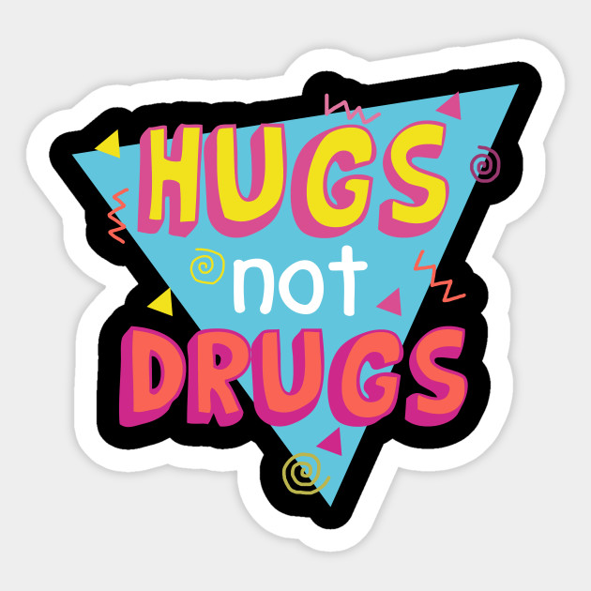

Reference: https://www.health.harvard.edu/diseases-and-conditions/treatments-for-covid-19

