The Rocking- Horse Winner, by D. H. Lawrence

TASK 1 Warm-up
The students are told that they are going to read a short story called The Rocking-Horse Winner, by D. H. Lawrence. They are asked to work in 5 groups and predict what the short story is about, the main characters and the ending of the short story. Each group presents the predictions it makes. Mention to the pupils that the images are from the movie with the same title.
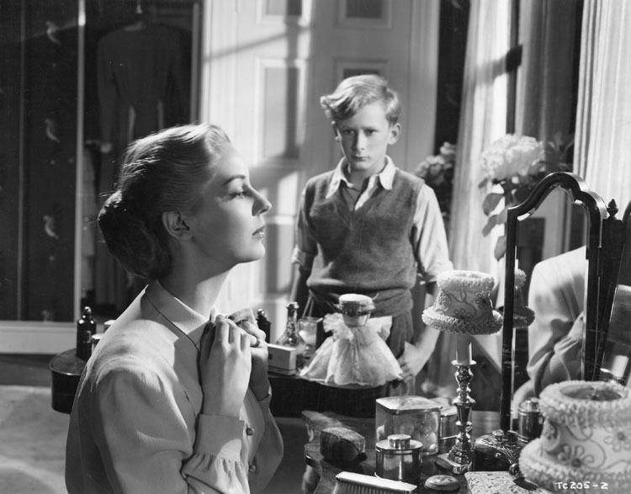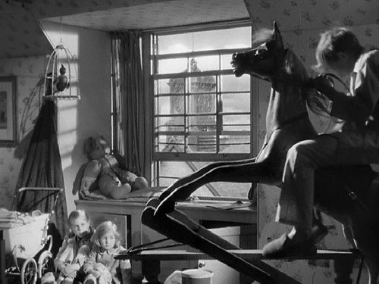
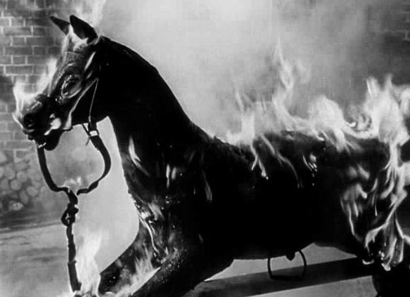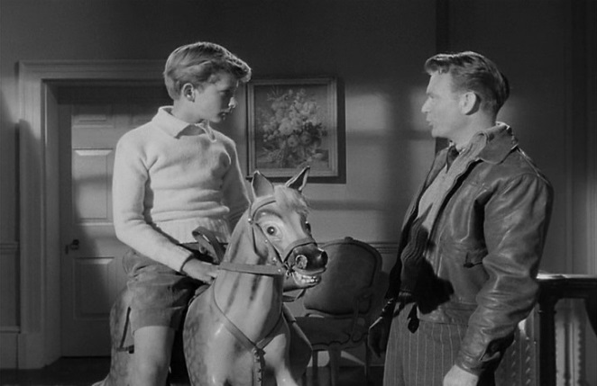

TASK 2 KWL Method - Reading Comprehension
This is a pair, individual and whole-class activity. The teacher will draw a chart with three columns, each column having a capital letter meaning:
K – What we Know?
W – What do we Want to learn?
L – What did we Learn?

What we Know? | What do we Want to learn? | What did we Learn?
- In pairs the students have to make a list with the things that they know so far about the story. The pupils have to look at the title, the pictures they have and the pupils can read only the first and the last paragraphs to be able to find out some more details. Each student has a copy of the short story. Then the ideas are written on the blackboard or flipchart.
- The next step in this activity is to write questions through which they may find more about the plot, characters of the short story. They work in pairs again. Some questions like these may arise:
- Who is the woman?
- What is her name?
- Why is the woman praying?
- What is the relationship between her and the boy?
- What is his name?
- Why does the boy ride the rocking-horse?
- Who is the man that stands near the boy?
- How does the man influence the boy?
- Why is the boy always sad?
- Why is the rocking-horse destroyed?
- Who are the negative and the positive characters?
- What happens to the boy?
- The students are asked to take turns and write the questions in the right column. After that the students have to read the short story by themselves paying attention to the information they have to find to answer the questions written in the previous step of the activity. The answers to the questions are written in the right column. The students name themselves to answer. If there is a student that has another answer to a question a debate can be performed. The students should go back to the text and find the correct information.

TASK 3 Question answer – Reading comprehension
The students are asked to answer the following questions individually to find out more information about the short story:
- Why was the mother dissatisfied?
- How did Paul get obsessed about making money?
- Why were Paul’s sisters uneasy in his presence?
- How did the boy behaved at the Lincoln races where his uncle took him?
- Who was Bassett?
- Why was Paul the frantic about the Derby?
- What was Paul’s secret of secrets?
- What was the last prediction the boy made?
- What was Paul’s mother attitude towards her children?
- What was the unspoken phrase that hunted the house?
- Why was Paul’s family full of anxiety?
- How does Bassett try to save the boy’s life?

TASK 4 The Puzzle Method or The Task Cards Method – The Characters

The teacher divides the students into groups of three. They receive cards that contain information about the characters of the short story. The pupils of each group have to match the three parts that will ‘build’ the character. In each group two pupils will fulfill the task and the third one is the supervisor.

TASK 5 The main themes of the short story - Listening, watching and speaking
The students are first asked to identify the repeating word and sentence which causes such much trouble in everybody’s lives. (They should say ‘money’ and ‘There must be more money.’)The students are going to watch a fragment from the original movie ‘The Rocking Horse Winner’, the fragment ‘There must be more money’. Teachers can find this on the Internet at http://www.tcm.com/tcmdb/title/88522/The-Rocking-Horse-Winner/videos.html, and there teachers can find what they need. After watching this video, there is a debate on how money can influence people’s lives, especially this family member’s lives, and where the greed for money can lead to.
At this point the students are asked to work in groups of six and each team has to identify the main themes (four) of the text and to try to comment on each in two or three sentences. After they work together for about 15 minutes, the teacher draws a chart on the blackboard for the pupils in each team to be able to fill in with the necessary information.
Theme 1 | Theme 2 | Theme 3 | Theme 4
Neglect | Obsession | Opportunism | Deceit
Hester is too preoccupied with the material things, that she neglects her son, she does not provide him the necessary love to develop into a normally, mentally stable child. | Hester is obsessed with money. Her son, Paul becomes obsessed too. He wants to make money for his mother not for himself. The more money his mother wants. The more obsessed he becomes to make more money. | Paul’s uncle, Oscar is the opportunist. He takes advantage of the little boy. He has no pity for him even when Paul lies deadly muttering the name of the winning horse, he just flees to bet on that horse. | The greatest deceit in this story is Hester, who pretends to love her children. What is more strange, people think that she really does it.

TASK 6 Vocabulary practice – Money (Antonyms)
The students are asked to match the words from 1-7 with their opposites from the sentences below:
- Loss –
- Poor –
- Pricey –
- Rip-off –
- Save –
- Worthless –
- Generous -
a. Ian is quite well-off. He bought two computer games last week.
b. Don’t waste your money on clothes; you need money for your holidays.
c. These trainers are quite reasonable. I think I’ll buy them.
d. Simon is very mean. He doesn’t like spending his money.
e. The record company made a big profit in its first year.
f. The painting is very valuable. It’s signedby Monet.
g. Clare’s new Levi jeans were a bargain. They only cost £20.
Key to the exercise: 1.e; 2.a; 3.c; 4.g; 5.b; 6.f; 7.d.

TASK 7 Grammar Practice – Wishes – Type II (wish/if only + past perfect)
The students are asked to write sentences using the second type of wishes and the prompts given, in order to express regret of what had happened. They have to use the beginnings given.
- ‘She married for love.’
She wished she……………………………………..
- ‘She had bonny children.’
She wished she……………………………………..
- ‘They looked at her coldly.’
She wished they……………………………………..
- ‘There was never enough money.’
She wished there……………………………………..
- ‘And the mother, who had a great belief in herself, did not succeed any better.’
She wished she……………………………………..
- ‘I married an unlucky husband.’
She wished she……………………………………..

TASK 8 Narrative paragraph - Writing
The students are asked to write a different ending to the short story. The ending shouldn’t be longer than 10 lines. The most interesting and original ones will be exhibited.

