The Hitchhiker, by Roald Dahl

TASK 1 Warm-up

The students are given each a sheet of paper with four photos that show some hitchhikers. They have to decide if they would give them a lift or not, and to give arguments for their choice. The students can compare their ideas or bring additional information.

Study the following pictures of hitchhikers and fill in the necessary information for each. For the beginning you may assume the following:
- You are alone in your car.
- You are not in a hurry.
- It is safe to stop your car if you want to.
- Hitchhiking is allowed along this road.
- It is daytime.
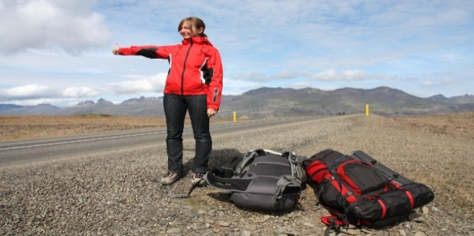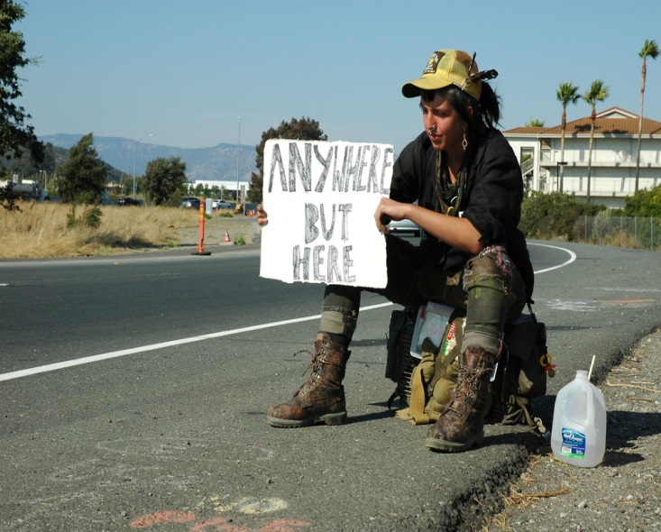
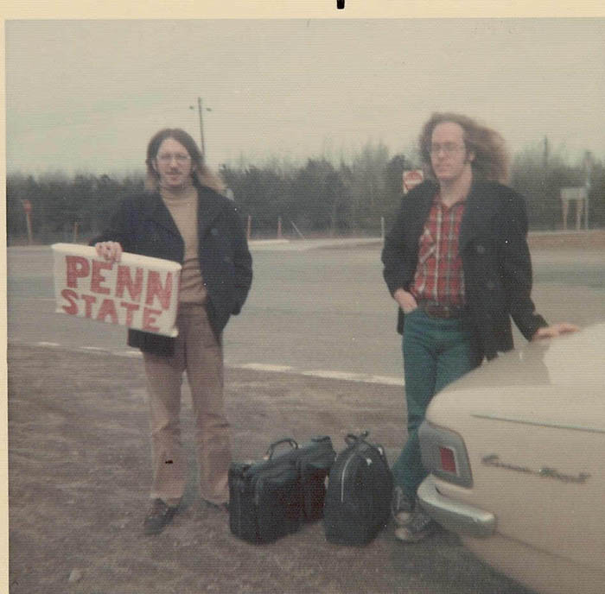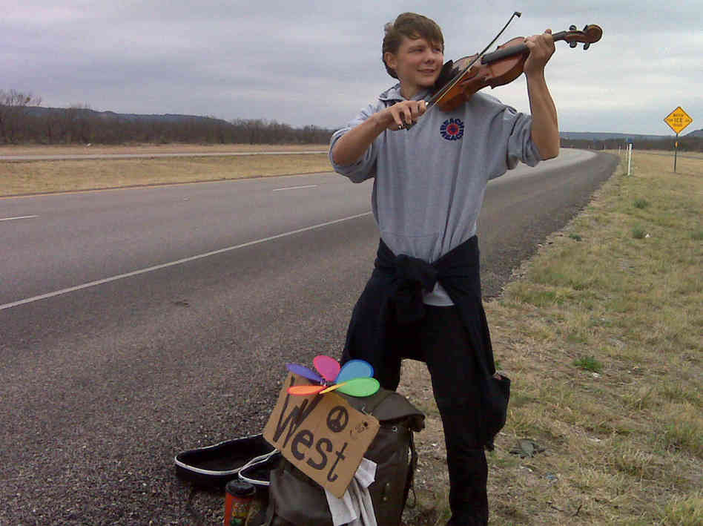

TASK 2 The Quarters Method – Main ideas
The students are let to know that they are going to read the text ‘The Hitchhiker’, by Roald Dahl and that they will have to work in teams to get the main ideas and, at the end of the activity, the summary of the short story. The class is divided into four teams. The text has been divided into four parts by the teacher as follows:
- Part1 up to: ‘It was so loud…………and raised a hand for us to stop.’
In this part the writer picks up a hitchhiker but he is unable to find what he does for a living.
- Part 2 up to: ‘Then he kicked the starter and roared off up the road out of sigh.’
In this part of the story it is described the encounter with the policeman.
- Part 3 up to: ‘Because you’ve got fantastic fingers.’
The readers will find out in this part that the hitchhiker is a pickpocket.
- Part 4 up to the end of the short story.
In this part the students will find out that the hitchhiker has pickpocketed the policeman’s notebook in which there were all the details about the two men.

A member of each team will come and choose a piece of paper on which was written a number. Each number corresponds to the part of the text the team has to read and work on. Each student will receive the printed part of the story. The students read individually the text then each team has to write the main ideas of the part that has to be read. They have to work as a team. After the job is done a member of each team presents the team’s ideas and another member of the team can write them in the right quarter of the circle. At the end of this activity the students will know the summary of the short story.

TASK 3 Vocabulary understanding – Types of Crime - Speaking
Match the words defining types of crimes with their definitions. The students can use their dictionaries and they will work in pairs:
- robbery | - the use of violence such as bombing, shooting etc. for political purposes
- theft | - intentionally damaging public property, or property belonging to other people
- burglary | - killing somebody intentionally
- mugging | - obtaining money illegally, usually by using clever and complicated methods
- shoplifting | - taking things illegally from one country to another
- smuggling | - using violence to steal from somebody in a public place (a street, a park etc.)
- kidnapping | - stealing money and things
- fraud | - stealing from people and banks
- bribery | - stealing from houses and flats
- murder | - stealing things from a shop while it is open
- arson | - taking a person by using violence, often in order to get money for returning them
- vandalism | - trying to make somebody to do something you want by giving them money, presents etc.
- looting | - starting fire in a building in order to damage or destroy it
- terrorism | - stealing from shops or homes that have been damaged in a war, natural disaster etc.
Key to the exercise: 1.h; 2.g; 3.i; 4.f; 5.j; 6.e; 7.k; 8.d; 9.l; 10.c; 11.m; 12.b; 13.n; 14.a.

After matching the words with their definitions the students have to answer the following questions in pairs and then present their solutions in front of the class, taking turns:
- which of the crimes above do you think are:
- very serious;
- quite serious;
- not very serious;
Bring arguments.
- Which crimes are common in your country? Which are not very common?
- Have you, or has anyone you know, been a victim of crime? If so, what happened?

TASK 4 Vocabulary checking – Crime and Punishment - Speaking
The students have to work in pairs and match the verbs with the word or phrase in the second column. Then they have to decide who normally does the things in these situations:
- A criminal;
- The police;
- The judge;
- The jury;
- A witness;
- Commit | - Somebody to court
- Arrest | - Evidence
- Charge | - Somebody for a crime
- Take | - A crime
- Give | - Somebody with a crime
- Find | - Somebody (£500)
- Acquit/convict | - Somebody to prison (for 10 years)
- Send | - Somebody (not) guilty
- Sentence | - Somebody of a crime
- Fine | - Somebody to (ten years) in prison
Solution to the exercise: 1.d; 2.c; 3.e; 4.a; 5.b; 6.g; 7.i; 8.g; 9.j; 10.f.

TASK 5 Fill-in exercise - Vocabulary
The students will work individually to fill in the gaps with one word.
- The police ………….three men last night.
- Two boys were charged………………vandalism.
- She has been……………………to eight years in prison.
- Why did he……………….such a terrible crime.
- The thief was……………£200.
- The first witness gave……………….in the trial today.
- The man was……………….of all charges and was allowed to go home.
- He was taken to………………………for stealing a car.
- The jury found the man…………………………..and he was………..to prison for five years.
- She’s been convicted………………..a serious crime.
- My cousin was arrested…………….shoplifting.
Key to the exercise: 1.arrested; 2.with; 3.sentenced; 4.commit; 5.fined; 6.evidence; 7.acquinted; 8.court; 9.guilty, sent; 10.of; 11.for.

TASK 6 Grammar practice – Reported Speech
The students are asked to turn into reported speech a fragment from the text of the short story ‘The Hitchhiker’, by Roald Dahl.
‘And who are you?’ he asked sharply.
‘He’s a hitchhiker,’ I said. I’m giving him a lift.’
‘I didn’t ask you,’ he said. ‘I asked him.’
‘Have I done something wrong?’ my passenger asked. His voice was soft and oily as hair cream.
‘That’s more than likely,’ the cop answered. ‘Anyway you are a witness. I’ll deal witi you in a minute. Driver’s license,’ he snapped, holding out his hand.

TASK 7 Article writing
The students are asked to write a newspaper article with the following headline: Hitchhiker pickpockets a policeman on the highway. The teacher can organise an exposition with the most inspiring articles. The teacher can suggest the pupils that have talent to draw a picture of the hitchhiker.

