The Black Cat, by Edgar Allen Poe

TASK 1 Warm-up - Prediction
The students are asked to work in groups of four and try to predict what the short, which they are going to read, is about. They have to make notes on sheets of papers then to fold them and put them aside.
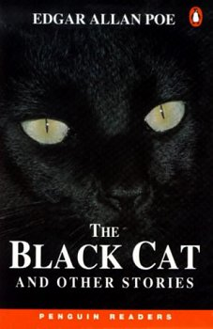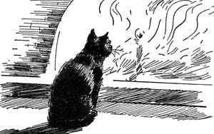
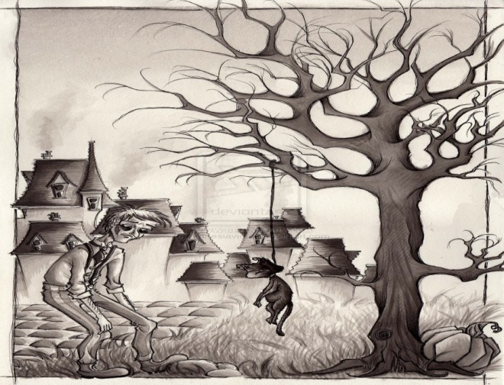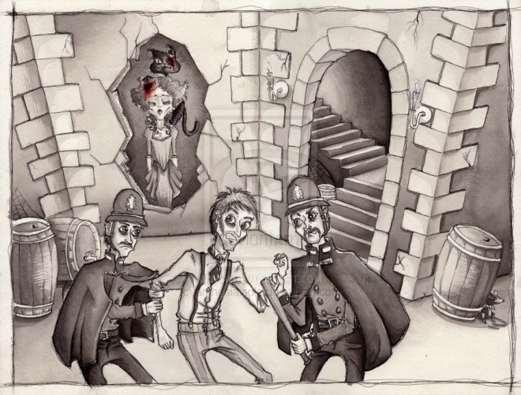

The

TASK 2 Speaking
All the students receive a copy of the short story and they read it alone. After that they go again into the initial groups and open the sheets of paper to read their predictions. The papers will be stuck on the board or walls. The closest prediction to our short story will be awarded. The most imaginative one will be awarded too.

TASK 3 The Four Musketeers Method – Reading comprehension
The students are organized in groups. Each group will receive a task. A member of each group will pick a ticket on which is written: THE QUESTION MAKERS, THE CLARIFIERS, THE PREDICTORS and THE STORYTELLERS. Each group can use a different colour to write on their papers. This activity is based to make all students understand the short story.
- THE STORY TELLERS will write a short summary of the short story. Again they write on sheets of paper.
- THE QUESTION MAKERS will make ten questions based on the text and they have to know the answers. The questions can sound like that:
- Who is Pluto? (Pluto is the narrator’s cat.)
- How is the relation between the narrator and Pluto? (At first they are very close. The relationship changes later because of the narrator’s alcohol problem.)
- What were the acts of violence the narrator did to Pluto? (First he cut Pluto’s eye out, then he hung Pluto from a rope and killed him.)
- What was left of the narrator’s home after the fire/ (One wall with the figure of a cat on it was left.)
- What was the second cat like? (The second cat looked a lot like Pluto, but it had a white mark on his neck.)
- Did the author like the second cat? (At first he liked it, but soon grew to hate it. He was afraid of it, so he didn’t kill it.)
- Why did the narrator kill his wife? (She tried to stop him from killing the cat. He killed her in his rage.)
- How did he dispose of the body? (He bricked it up in the chimney wall.)
- How did the police discover the body? (The narrator hit the wall that covered the body. The cat screamed from within.)
- When is the climax of the story/ (The climax is when the cat screams.)
- THE CLARIFIERS will take out from the story the paragraphs that best present some key moments of the story:
- Pluto’s description
- The acts of violence against Pluto
- The fire
- The moment the author finds the second cat
- The killing of his wife
- The moment the wife is found
- THE PREDICTORS will try and change the ending of the story, imagining that the wife is not killed. What may happen next? They decide if we have another sad ending or a happy ending.

TASK 4 Jumbled Paragraphs – Reading comprehension
The students have to put the following sentences into the correct order:
- I searched for another black cat, the same size and type as Pluto.
- For years, he and I lived happily together, the best of friends.
- I saw a black shape in the new white plaster.
- I caught the cat and hung him by his neck from a tree until he was dead.
- I took my knife from my pocket, held the poor animal by the neck and cut out one of his eye.
- And there was the cat, standing on her head, his red mouth wide open in a scream, and his one gold eye shining like fire.
- But the more I hate the cat, the more he seemed to love me.
- I knocked hard on the part of the wall where my wife was.
- Pluto didn’t have a white hair anywhere on his body; this cat had a large white shape on his front.
- I took the axe and tried to cut the animal into two. But as I brought the axe down, my wife stopped my arm with her hand.
Key to the exercise: a. 5; b. 1; c. 4; d. 3; e. 2; f. 10; g. 7; h. 9; i. 6; j. 8.

TASK 5 Vocabulary practice
The students are asked to work in pairs. They have some sentences from the short story and in each sentences there is a word or two underlined. They have to match the underlined words with their meaning A – J. The pupils will name themselves to answer:

- I suffered myself to use intemperate language to my wife.
- My original soul seemed, at once, to take its flight from my body; and a more that fiendish malevolence, gin-nurtured, thrilled every fiber of my frame.
3-4. And then came, as if to my final and irrevocable overthrow, the spirit of perverseness.
- I am above the weakness of seeking to establish a sequence of cause and effect, between the disaster and the atrocity.
- When I first beheld this apparition-for I could scarcely regard it as less-my wonder and my terror were extreme.
- …I came to look upon it with unutterable loathing, and to flee silently from its odious presence, as from the breath of a pestilence.
- It followed my footsteps with a pertinacity which would be difficult to make the reader comprehend.
- …the feeble remnant of the good within me succumbed. Evil thoughts became my sole intimates…
- Upon its head...sat the hideous beast whose craft had…whose voice had consigned me to the hangman.

- Can’t be turned back.
- Quality of being directed away from what is right or good.
- Not moderate.
- A ghostly figure.
- Handed over.
- Ill look toward others; rancor; malice; evil influence, especially supernatural.
- An appalling or atrocious action, situation or object.
- Gave in.
- Evoking feeling or repulsion.
- Persistence; tenacity; without quitting.
Key to the exercise: 1. C; 2. F; 3. A; 4. B; 5. G; 6. D; 7. I; 8. J; 9. H; 10. E.

TASK 6 Grammar practice – Past Simple (Regular/Irregular verbs) – Revision
The students are asked to work individually. They have to put the verbs in brackets into the correct past simple form:
‘Upon the fourth day of the assassination, a party of the police…….(come), very unexpectedly, into the house, and ……….(proceed) again to make rigorous investigation of the premises. Secure, however, in the inscrutability of my place of concealment, I …………(feel) no embarrassment whatever. The officers …………(bide) me accompany them in their search. They ………………….(leave) no nook or corner unexplored. At length, for the third or fourth time, they ………………(descend) into the cellar. I quivered not in a muscle. My heart beat calmly as that of one who slumbers in innocence. I ………………..(walk) the cellar from end to end. I ……………..(fold) my arms upon my bosom, and ……………..(roam) easily to and fro. The police …………..(be) thoroughly satisfied, and ………………..(prepare) to depart. The glee at my heart …………..(be) too strong to be restrained.’

(The Black Cat, by Edgar Allen Poe)

TASK 7 Writing and Role - Play
Ask the students to form pairs. They will have to choose one of the tasks below to do and then present it in front of the others. A contest can be organized for the best news reporter or the best interview.
- Imagine you are a TV reporter and you present the news about the latest horrible killing in your region. You may have a partner during the presentation.
- You are a TV reporter and you take the killer’s interview when the police arrest him. Choose a partner to play the role of the killer.

