Colegiul de Industrie Alimentară ” Elena Doamna” Galati

THE FIRST INTERNATIONAL MEETING

The deputy headteacher Moscaliuc Cornelia, Burtea Marieta, teacher of vocational training - food industry and two students of the XIIth grade Buțurcă Iulia and Ion Avram Denis, at the College of Food Industry "Elena Doamna" Galați, during the 6th – 10th of November 2023 participated together in a mobility within the Erasmus+ project, TRAVEL, LEARN AND TASTE THE WORLD, 2023-1-PL01-KA210-VET000152029, in Poland.
On Monday 06.11.2023, students and teachers set off on a beautiful journey eager to get know people, places, to experience new tastes and technologies.

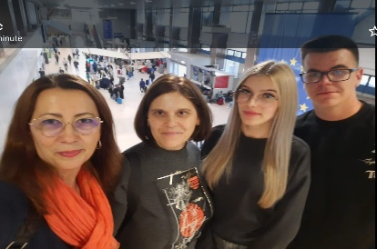

The host school was Technikum High School no. 6 in Nowa Slupia, a welcoming school with good equipment, where the hospitality of the people impressed us from the first moment.
During this mobility, various activities were carried out, such as:
Tuesday 07.11.2023, in the first part of the day, the opening activity of the project took place, on which occasion we met our partners, teachers and students from the partner countries involved in the project, Portugal and Poland, each country having a small presentation of the school and the region of origin. Later, Romanians, Polish and Portuguese, joined our culinary experiences and found out the secrets of vegan cuisine with two famous chefs: Kamil Piwowarczyk and Dzukasz Wasik. They obtained dishes such as grilled cabbage, vegan sponge with fruit, pickled red onion, vegetable cream in a mushroom crust where we tasted the delicious food that we prepared and our students who were part of different work teams showed us good skills. We really liked this culinary experience, we identified new ingredients and techniques, we experienced tastes and we all learned from the experience of the chefs, but also from the background of the partner countries.

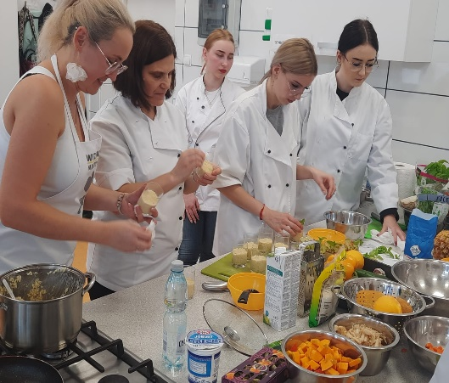 | 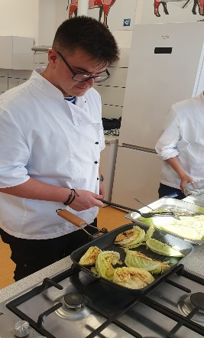 | 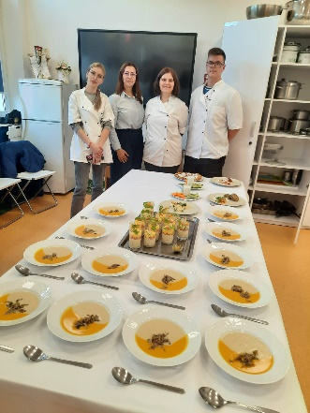

In the second part of the day, we set off on a beautiful journey on a mountain road with a superb landscape to the Holy Cross, a Dominican monastery with an impressive history. Here we ventured and we all climbed the tower of the monastery, but the reward was worth it - a special landscape over the small mountain town.

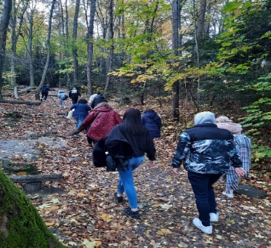 | 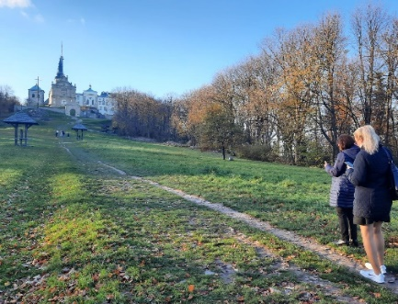 | 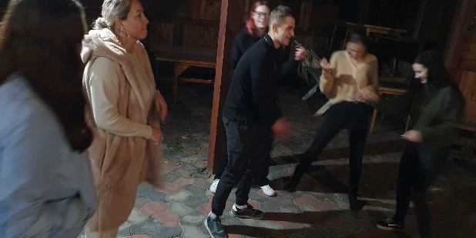

The evening culminated with a beautiful campfire where, in addition to the culinary feast on a wood fire, we danced and listened together to Polish, Portuguese, Romanian music, "Hora from Moldova" and "Braşoveanca", in the quiet of the small Polish town .
Wednesday 07.11.2023, the day started with a visit to the caramel candies factory in Nowa Slupia where we were shown how to obtain them and we were impressed by the fact that most of the operations in the technological process were done manually (portions, packaging) in order to it does not change, they say, the authentic taste of the product. Here we were invited to taste and pack caramels, which they then gave us as a gift.

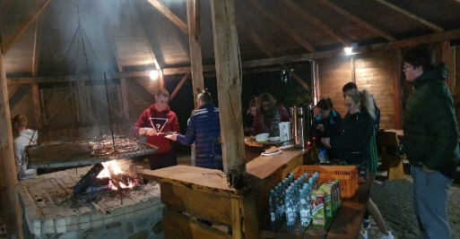 | 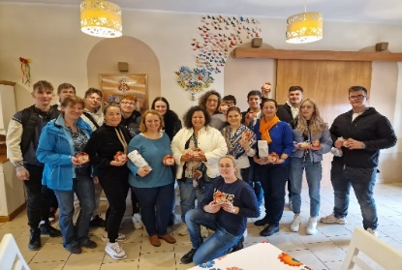 | 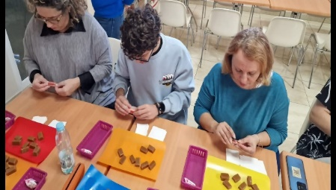

Visiting the town of Sandomir and the Sandomirez Cathedral with its impressive architecture was the second objective of Wednesday. Sandomir, a quiet little town, impressed us with the beauty of the places and the friendliness of the pigeons that accompanied us everywhere.

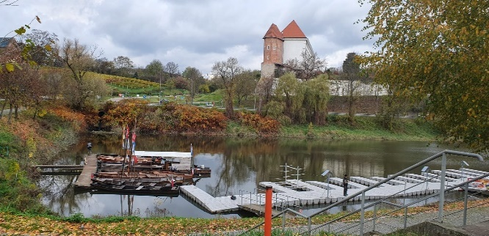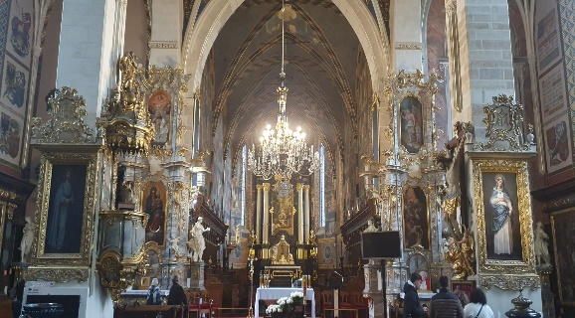

The day ended with a visit to the Sandomierska winery, where we saw the process of obtaining different types of wine, which we tasted, together with a selection of carefully chosen cheeses.

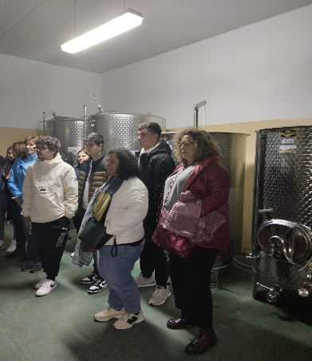 | 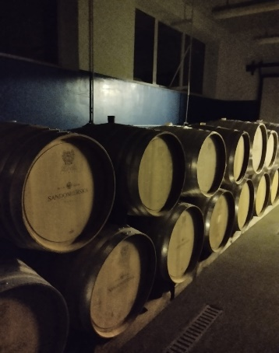 | 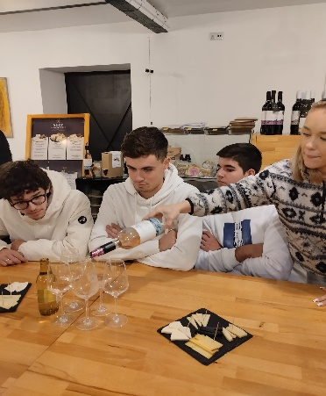

Thursday 08.11.2023, a beautiful autumn day, started with a small occasion trip. We had the opportunity to get knowing the surroundings of the place, the destination being a small rustic cheese factory "Serownia Zagrodowa", where we had a presentation . The entire journey of the milk from the entrance to the factory to the delicious assortment of cheeses (Anthony, Edvard semi-hard, Francis soft) had been obtained according to their own recipes and technologies. At the end, we tasted the local delicious food, we experienced new and varied tastes: pumpkin soup, homemade sweets, tea and delicious cheeses.

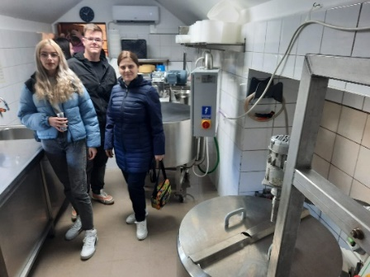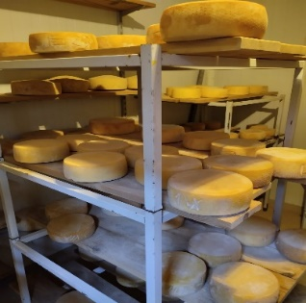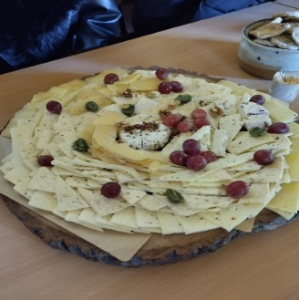

The trip continued with a visit to a museum "Daily life in the Iron Age" where in the pottery workshop we modeled and decorated clay objects and the plant workshop fascinated us with the multitude of types used in the past as food (raw material ), medicines, cosmetics. Here we took part in a workshop where we crushed the grains of different plants using tools from the Iron Age, sifted through a clay sieve and learned about the history of the places.

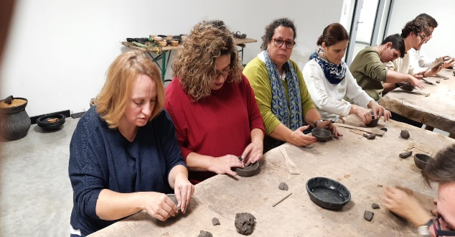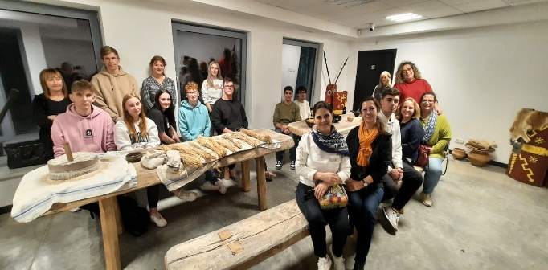

Friday 10.11.2023 was the last day of mobility. With new knowledge and beautiful memories, we said goodbye to our partners and followed our way home.

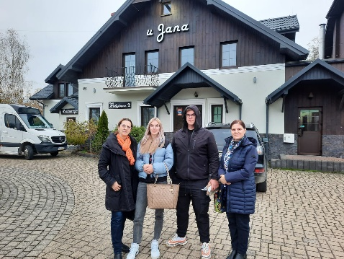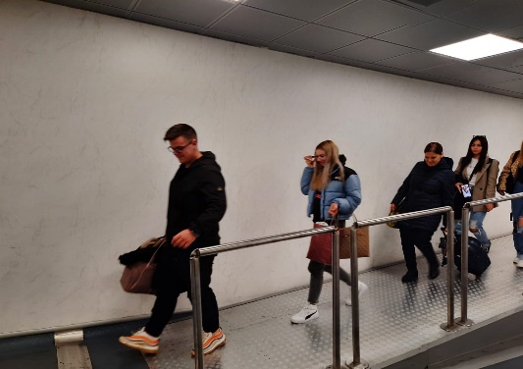
The whole experience was very helpful. We learned things, recipes and techniques for preparing dishes, we visited places and experienced new and varied tastes and on a personal level we met people with different backgrounds and cultures with whom we collaborated and we improved our communication skills in a foreign language.
Editing team

Coordinating teacher Maimon Nicoleta
Teachers Burtea Marieta, Bulboaca Mihai, student Teleuca Dragos Andrei
Headteachers
Leustean Iuliana, Moscaliuc Cornelia Adriana

