REVISTĂ ȘCOLARĂ ÎN LIMBA ENGLEZĂ
”BE SMART, DON’T START”
A elevilor de la Liceul Teologic Romano-Catolic „II. Rákóczi Ferenc”, Târgu-Mureș
Editat de: Puskás-Bajkó Albina
Colaboratori: Mester Ildikó, Lokodi Andrea
Nr.1/09.04.2020.

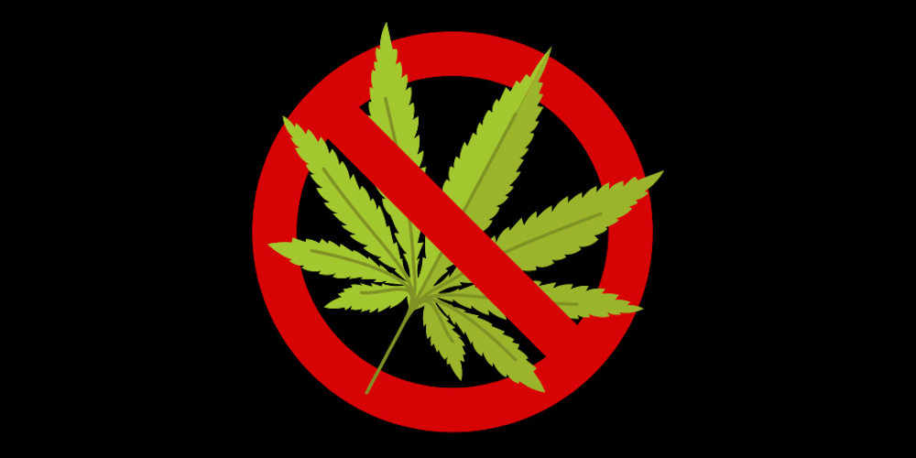

BE SMART, DON’T START
Bíró Brigitta, XII.A
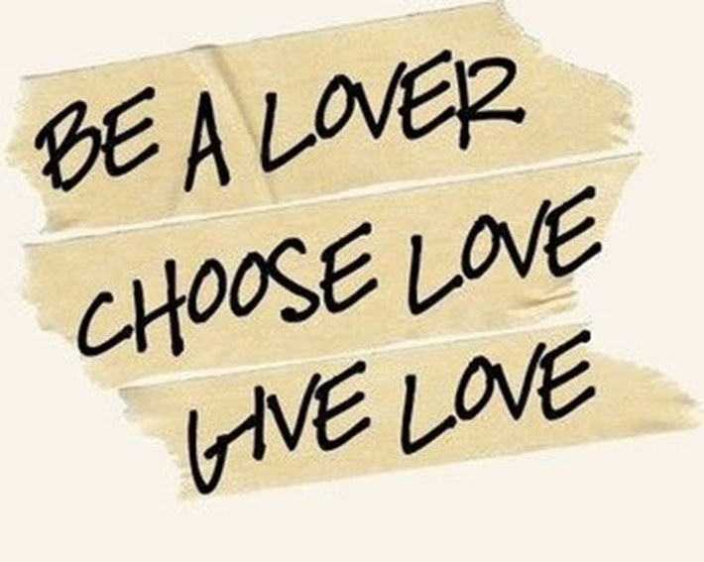

I am sure you see a lot of campaigns against the use of drugs. Some people even say it is becoming too much. Well, in my opinion, it is never enough. We have to be aware of the power of drugs that is holding us captive.
It has the ability to make you feel great for next few hours. Then what? You have to take the high with the low. And that, for some people is really hard, so they try to reach that high again. It becomes a cycle you can never escape alone.
It takes away the real meaning of life. Using drugs as an escape of reality is never an answer. It could make you feel disoriented, like you do not actually belong in a community.
In this case, people realize what they’ve done, and feel ashamed. They are scared to ask for help. This is why we have to help them if they reach out for us. Judging them is not going to make things better. Making these people realize there’s a real meaning of life, without any kind of drug, should be an importance.
Everyone hits a low point in life, so instead of reaching for drugs, reach for hugs.

BE SMART, DON’T START
Bódi Barbara, IX.C

I agree that drugs are very bad things in our lives. Some people or usually the teenagers are trapped by drugs.
Firstly, in my opinion the drugs are the worst things in the world. Sometimes the teenager just wants to try “just once” then again and again. I think the best thing instead of drugs are the sports. When you exercise, your brain switch down and you make what you love. It’s very good for ourselves and we stay healthy.
Secondly, I think if somebody has a problem, and they don’t know what they do, they can always count on their best friends. The best friends always listen, and they try to help. They are always with us. Sure not just the best friends but the parents, boyfriend or girlfriend.
Thirdly, life is a big fight for everyone. If you want to live, don’t flee from the difficultly. Don’t look for shelter at the drug...I think drugs are not a solution. If nothing helps, I think the trips are cool ideas. Such places where you have never been with people who loves you and you too.

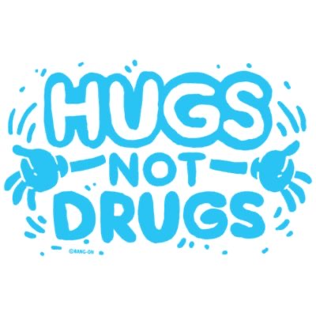
If you want to do drugs, forget it, do what you love and enjoy your life with the best things and people! Love yourself!
BE SMART, DON’T START
Cseh Bori, IX.C

I am a huge drug hater because I think a harmful passion can even take your life is not worth it.
They also cost a lot of money and you never know what you really got into this little pill. This also can ruin your life and sooner or later you will be alone.
Drugs are dangerous thinks. There were many famous victims of drugs like Anna Nicole Smith, Janis Joplin or Marilyn Monroe. These examples also show that drugs are really serious. In my opinion this risk is not worth it.
As we know drugs are not very cheap. For example LSD is 300 dollars/ g, heroin 150- 200 dollars a day, a heroin addiction could easily cost someone more than 53,000 dollars/year. In the case of ecstasy, you never know exactly what s in it. It could be rat poison or even cleaning products.
Drugs are not just bad for your health but can cause bad things for your mental health. Drugs like ecstasy or heroin can easily cause anxiety or even depression or amnesia which are very hard to bear especially for an addicted person. There were many examples of an addicted person losing his job, family, friends and even his money and eventually committing suicide.
In conclusion drugs are very dangerous and you won't be cooler if you using them. If you have a problem talk to someone or write it down because the drugs only make it worst. A hug helps a lot more.
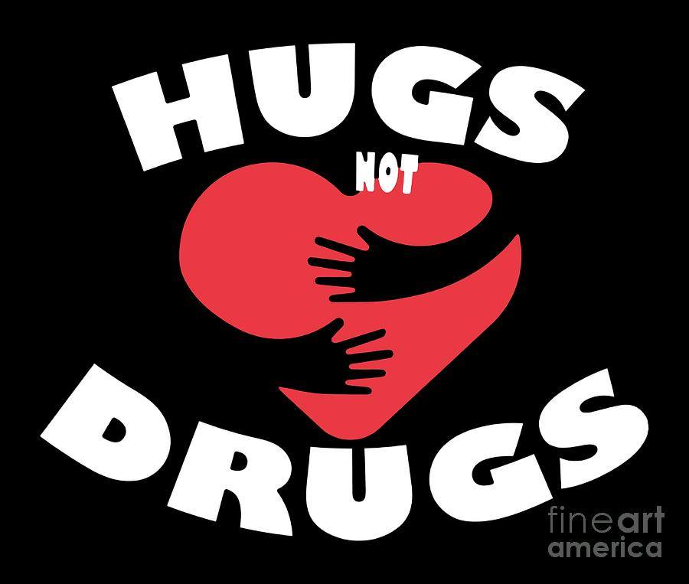

BE SMART, DON’T START
Horvát Noémi, XII.A

Nowadays more and more people are suffering from an addiction. Everything can be cause an addiction: food, drugs, games, alcohol. But people put together and call these drugs. Drugs aren’t toys so why so many people play with them? Because so many people have something wrong in their past, which makes their life a disaster. At first they are just trying it out, but when they cannot stop they are not afraid of something “bigger” than them? I mean, I think deep down everybody in this world is afraid of the unknown. The unknown that we think we know. WE DO NOT. And that’s why so many people out of there trying to reach out of their life, but they cannot because of our society. We are pretending that we are helping them, but we are not. We are just pushing these people who are trying so hard to get out of disaster lower and lower. Imagine that you are one of these people who is trying to get some help to get rid of drugs. After they cannot have a normal life, they cannot even get a normal job. That is why our society is bad. Bad with those people whose need help. Everybody have a point in their life when they can choose between drugs or “hugs”. I think if everybody be a little bit kinder and helpful whit these people, I think more people get rid of their drugs. I know, sometimes life is hard enough to not be kind to ourselves but WE CAN reach for our friends and families for help. We are not alone! We can do it, a motivational talk, one good word, a hug or every kind of movement that’s comes from our heart can save somebody’s life.
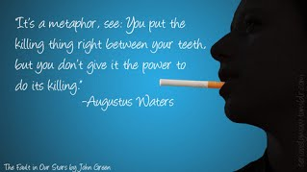

BE SMART, DON’T START
Váradi Levente, XII.A

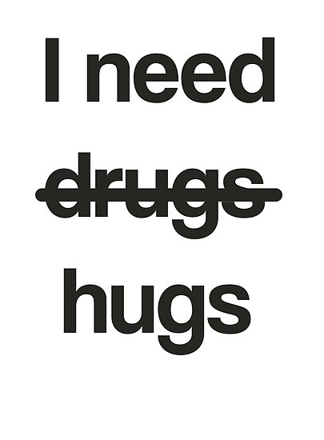
Drugs are extremely dangerous for the human body.
They make people feel absolutely amazing for a couple of hours. For example alcohol can defined as a drug, even if anyone can get legally from a certain age. There are many illegal drugs, which make people addicted to it. Once you try you want more and more until the point when you realize you cannot live without them. They become a part of your life.
I think there’s nothing wrong with drinking alcohol. For example in parties or while hanging out with friends. It is very important to know your limits and to not drink that much. I think the main problem is when a person stars using psychedelic drugs, like ecstasy or marijuana. These kind of things have a negative impact on the human body, which is bad for your health and some of the drugs make you feel mentally ill.
In my opinion people use different kinds of drugs because they find it the resource of their problems. They might have too much problems in their everyday life, or they suffer from mental illness or they feel alone.
I think it is very important to treat those people who use drugs in a right way, because we don’t know his background. Our mission is to help them as much as we can, and not to make their situation worse.

BE SMART, DON’T START
Kiss Dorottya, XII.A

Drugs are psychoactive substances which cause hallucinations and are addictive.
The drug is one indirect way of suicide, one of the activities that destroy the health, mental and psychological state slowly but surely.
I think if someone takes drugs or is living in another passion, there are psychological reasons that they are very degenerate. The drug is a kind of escape that is seemingly an "unsolvable" problem, which can cause momentary confusion or permanent psychological issues.
Drugs are very prevalent among young people today. The primary causes are social patterns. Children must show values, to dare and be able to say no to drugs whereas today's "fashion" among young people. Therefore, it is difficult to say no.
Parents also should show an example to the children. Many times the children see that their parents too (for example) reach for alcohol to escape their problems in front of others. Without passion to establish children's future, communication and love between family members ceases.
However, many other reasons why someone will drug but it must help these people. They must be approached and encouraged them to return to the right path.
BE SMART, DON’T START
Kovács Evelyn, XII.A

Youth is foolish, we used to say. With a young head, everyone loves pushing their boundaries, often trying things that are illegal. Many people rely on drugs because they want to be more popular. However, many young people can pay for it not only with their money but also with their lives.
We'd like to open your eyes to the fact that trying out illegal drugs is not a good idea.You are smarter if you never touch such drugs because you never know how your body responds to them.We consider drugs to be those substances and substances that, when they enter our body, modify our thinking, emotions and behavior. This includes alcohol, cigarettes and coffee.The most common drug in the world is cannabis. Its main forms are marijuana and hashish.Even common drug: speed, ecstasy, mefedron, ghb.
In my opinion, they would use less drugs if they were enlightened in the right picture.I think it is very important for parents to educate their children, but there is a need to educate the children with professionals in schools as well.

BE SMART, DON’T START

Lukács Tímea, XII.A
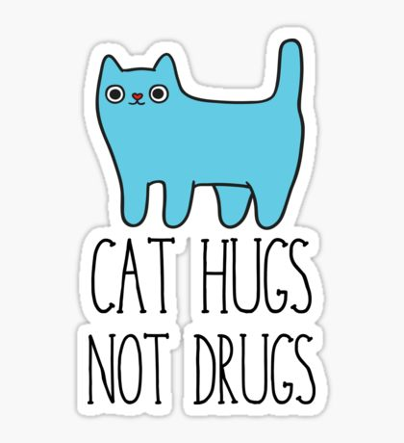

Today, more and more people in the world are deciding that they want to try some kind of drug. It doesn’t start well when you’re still thinking it would be good sometime. We humans are like that we want to know everything and with that we try everything, including drugs. Most people start using drugs because they expect something special from them. They think that if they start now he will have a little more and that he will have a feeling that is not in his life. This is why many people take it after a great disappointment, quarrel, and sadness because they want to push that feeling down in their soul. They think they can suppress that bad feeling in themseves forever but once the effect is over it is there and could be even worse. After that, you will consume even more to feel that special feeling. Many people do not think that if they paid more attention to themselves and spent a lot of time with people they love, this can be avoided. Add more to a happy moment all one night stunned. A sincere hug gives the same special feeling as one can feel the warmth in one’s heart. With that, you feel loved, they are there next to you and you don’t need more than that. If you have a pet, the same warm beloved evokes the full feeling. A small animal can give so much love that it doesn’t need more. You don’t have to take drugs to be happy and love-rich people. The word "I love you" should evoke that special warm feeling. This makes a person happy, balanced and completely myself. In my opinion, you don’t need any drugs to be yourself. It is enough to be surrounded by people who love you, no drug can surpass that.

BE SMART, DON’T START

Mezei Andrea, IX.C

Taking care of yourself is very important that is why you should avoid any kind of drugs in your life. Drugs are very dangerous and can cause serious addiction.

First of all, you should avoid drugs if you want to live a happy and healthy life. If you are addicted to something like drugs it can destroy your life. It affects your health and you can also die. Drugs are not a joke that is why everyone should take it seriously and pay attention to their lives. If you are addicted it is very hard to get rid of your addiction but with it is not impossible.

Second of all, someone being addicted to drugs can affect the lives of their loved ones too, not only theirs. If someone is addicted to spme kind of drugs it can happen that they do not know what they are doing so they can hurt others as well. These people can be dangerous sometimes.

In conclusion, doing drugs is very dangerous for yourself and for people who you know, your loved ones. It affects your life and destroys your health as well.

BE SMART, DON’T START

Nagy Anita, IX.C
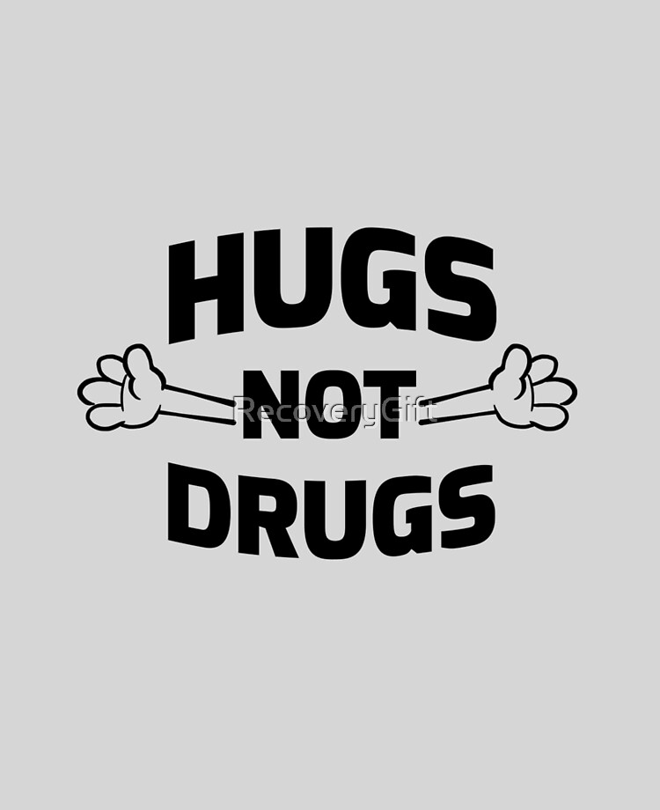

Hugs or drugs? – One of the most challenging questions that often appear nowadays.
First of all, we have to know that a drug is any substance that causes a change in an, organism’s physiology and psychology when consumed. Drugs may be legal (e.g. alcohol, caffeine and tobacco) or illegal (e.g. cannabis, ecstasy, cocaine and heroin). In any situation, we can talk about drug addiction, the frequent use of drugs in a way that is threatening people’s health, relationships, career and perhaps even their life.
Why do people use drugs? – Another question that appears so often. The variety of reasons may include.
- To fit in, out of curiosity
- To have fun, relax, forget problems, escape
- To relieve boredom and stress
- To rebel, to experiment
Friends, parents, older brothers and sisters and the media can also have some influence over a young person’s decision to use drugs.
Lack of love, understanding, and self-confidence can lead to desperate situations.
On the other hand, if someone you care about is using drugs or alcohol, you know doubt feel overwhelmed and willing to help them.
But in order to truly help those who have lost control, it is important to understand the reasons that led to their addiction and some of the realities of addiction.
I strongly believe that anyone needs understanding, long-term help and encouragement. Give people a hug, a form of endearment, and universal in our human communities. Tell them what we all need is unconditional love. A hug can make the difference, love can overcome any difficulties in our life.

BE SMART, DON’T START
Nagy Lorand, XII.A

If we are in trouble we should ask for help and not choose the wrong way to go.
Because there are situations where it is difficult to climb out alone like depression and in that case you have to resort to help rather than the easy way to go. If you offer it accept .if you can't solve it alone is not as big a problem as getting the wrong way and getting into more trouble. The drug is bad, it may seem good at first but later it will just be a bad as it can cause a problem. On the other hand, "hugging" at first may be weird and humiliating, but it may work out and solve the problem. The point is that we are never alone. And that the true friends who want the good And they don't get into the bad, who want to get on the drug they are not the friends who are the ones who want and want the good are the true friends. The drug would only be a temporary solution but eventually it would only become addictive, which could be worse for the problem.
And finally, for everything, love is the solution that can be well expressed with a hug.
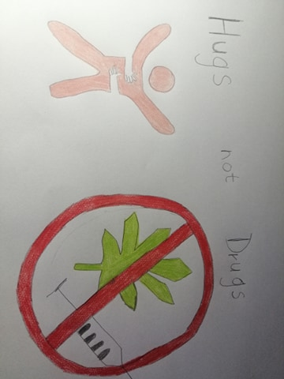

BE SMART, DON’T START
Nagy Renáta, XII.A

Lots of time people ask themselves "why not?" Why shouldn't I try drugs? But most of the times they do not think about the consequences of this decision. They do not think about the fact that drugs can ruin their lives or even the ones of their families. It may seem like that in the moment it is a good solution but in long terms it is never a good idea. For a long period of time, drugs can make us believe that everything is fine and the problems disappear and no one can harm us, but after the sensation is gone, reality sinks in. There are plenty beautiful things in the world and a long hug or caring words are always better than turning to drugs. Hugs are the universal language of people. It can help in darker times, and it can't hurt no one. Drugs kills people day by day but love brings people together. It is important to think about our choices and the consequences of those.

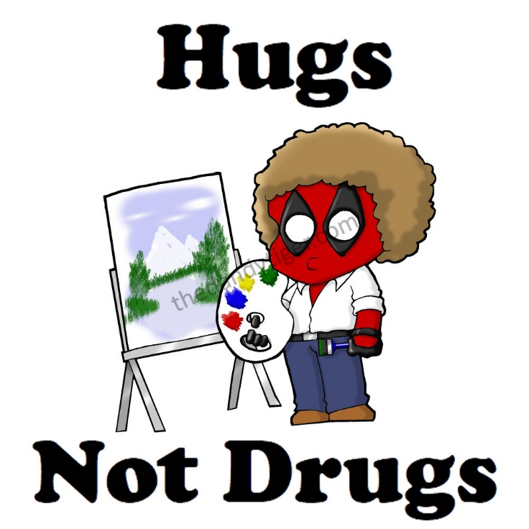
Szakács Szilárd, XII.A
It is ironic how a few letters can change a word’s meaning and it becomes a famous quote by Bob Ross and revived with the help of a funny anti-hero Deadpool.
In this short sentence we can assume that hugs can be as full of impact as drugs but without the negative outcome of a self-destructive lifestyle. Researchers are indicating that an average human needs around 12 hugs per day to a healthy, happy and long life.
In a simple hug we show the trust to each other, which is apparent at the start of a hug, when we displaying our stomach which holds the most weak spots on the body. Drugs on the other hand are a compensating behaviour for love. In the world of science, hugs have a similar effect as drugs on the brain but one of them are less drastic. Drugs are sometimes useful as medicine but as a final option, when nothing else works, but still some people are debating the idea of that kind of help, because a drug is still a drug with its side-effects.
In the end drugs are in most cases part bad but hugs are the exactly the opposite because in the most cases they are supposed to be good except when a pandemic is roaming the world, then it is illegal apparently.

Tamási Noémi-Orsolya
XII.A

BE SMART, DON’T START
Tamási Noémi, XII.A

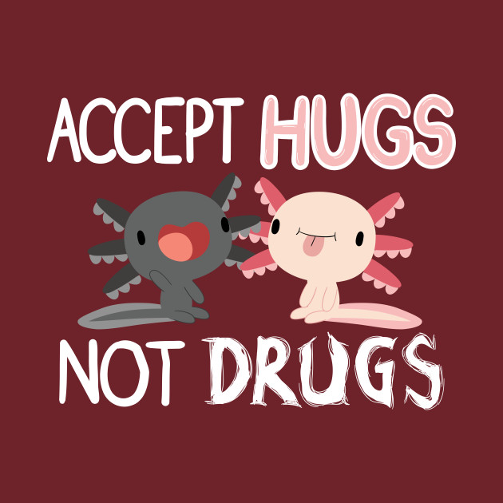
Hugs not drugs - the saying goes, and not by accident. Although it sounds like a template when someone talks about the harmful effects of drugs but it is important that everyone is aware of them.
It is not the drugs themselves that endanger people, but their consequences. Because you can become addicted even after the first try. One of the consequences of drugs is the appearance of withdrawal symptoms, that is, people want more and more.
I have no experience of my own, but according to some people, it is used for its sedative effect. In my opinion, this price is not worth it. Drugs can completely ruin the people’s life because of them they will not be themselves anymore.
I knew someone who had tried the drug and her life changed completely - and not in a positive way. She did things she would not have done before. She started to smoke, though she had previously condemned those who did. Later she smoked joint and her relationship with her environment has deteriorated. All of this at a very young age, until she got into rehab institute. Most addicts after a while don’t even use drugs because they want to, but because their body needs it against withdrawal symptoms.
If someone is in this kind of situation, dare to ask for help and let their environment help them.

BE SMART, DON’T START
Váradi Attila, XII.A

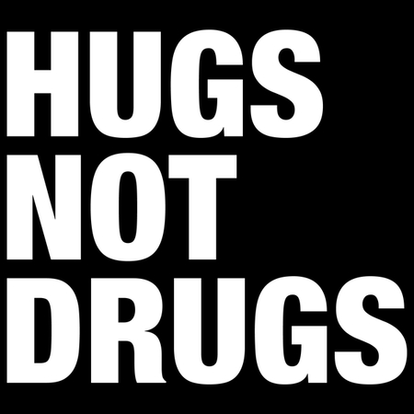
Drugs are very dangerous for us because we can get in trouble if we use them and they are harmful for your health. Drugs are medicine or other substances which have a physiological effect when ingested or otherwise introduced into the body.
A lots of people get addicted when they try drugs. Drugs basically can be alcohol, medicine, cigarettes, and so on. I think we should have a good relationship with ourselves because if we do not have a good picture if ourselves, we can get very depressed and to get away in problems we often take drugs. It is very hard to quit and we can get in a deep gap and it takes so much time to get out in this situation. There are many people who are in danger because they destroy their health and mental health. There are many people who are in this position and they just can get over it. So what is the solution for that? I think the answer is not that hard, we just have to help those peoples by using the power of love and empathy. We have to be patient and helpful to the humans who’s screaming for help. We can help for them so easily, just some positive words about them or just a simple smile.
I think we should tread everybody equally because we are humans and we must have the chance to help others.

