“Sf. Andrei School”

Mangalia, CONSTANTA

Tel/fax: 0241 751807

Email: sc2mang@yahoo.com

**Nr. 1 Anul 1**

**October, 2014**

MOTTO:

“Alice opened the door and found that it led into a small passage, not much larger than a rat-hole: she knelt down and looked along the passage into the loveliest garden you ever saw…”

Lewis Carroll





Summary

Preppy group page ……………….…p3

1st grade page ………………………..p4

2nd grade page ……………………….p5

3rd grade page ………………………..p6

4th grade page ………………………..p7

5th grade page ………………………..p8

6th grade page ………………………..p9

7th grade page ………………………..p 10

8th grade page ……………….……….p 11

Last page …………………….………..p 12

**“One thing was certain, that the white kitten had had nothing to do with it – it was the black kitten’s fault entirely…”**







GOOD MORNING.

How are you today?

I’m fine, thanks.

How are you?



CAR

BALL

**APPLE**

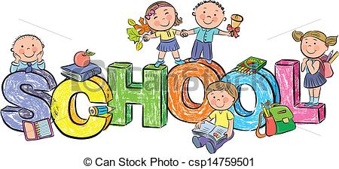

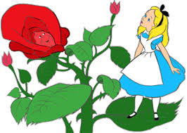

It is October. All the flowers and insects go to sleep.

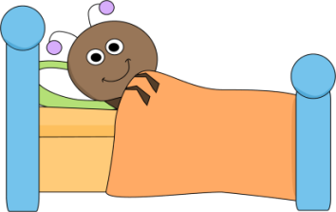









Match the insects with their names.

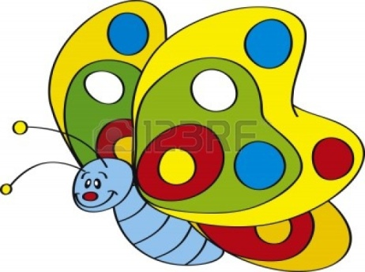





**Rain in the garden**

**Rain on the tree**

**Rain on the house top**

**But not on me.**

**Rain, rain, go away,**

**Little Tommy wants to play.**







cloud

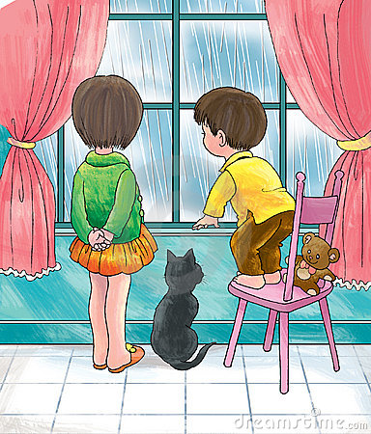





**Our teacher of English is smart.**

**She is not an owl but she reads a lot.**

Dragos reads a lot, too.

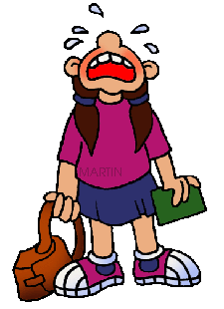

Stefan plays football every day.

Simona is always late.



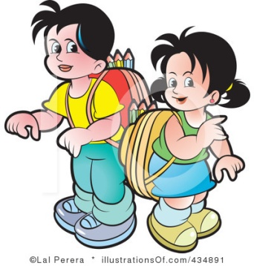

Edi eats a lot!



Ionut is a crying baby.

Larisa and Lori are nice.



Mircea, Ioana and Carla sing nice songs together.

Dani has got a big brain.

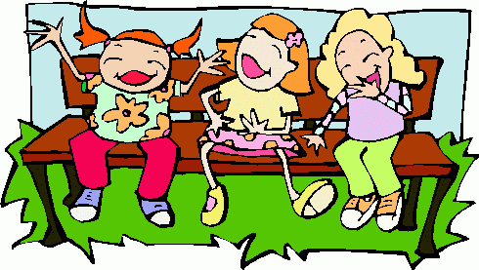

Hey, girls, have you heard that ….



**Stefan lost his cat in the park. His neighbours say the cat usually hides in the bushes and laughs at Stefan!**



**Dora’s dog has got the lonest ears in Mangalia? That’s why his name is Jumbo!**



Alex saw a real ghost last week? It happened in the park, at 10 pm.



LAST SUMMER I READ …

My mum asked me last summer to read

“Alice in Wonderland”.

At the beginning I didn’t want to … I was too busy, you know …

going to the beach, playing with friends, football, …

But one evening I was getting bored so I decided to start the book. It is funny that the book begins with a little girl who falls asleep. And then she begins to dream a lot and she meets many other creatures. Read the book! It is funny!

For today, let me introduce some of the characters to you:



The WHITE RABBIT



**THE CHESHIRE CAT**

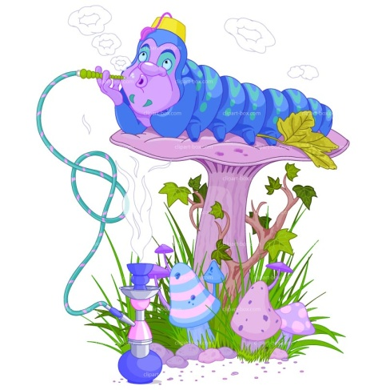



**THE CATTERPILLAR**

**THE HATTER**



THE MARCH HARE

THE QUEEN OF HEARTS

Some of the funniest moments at school are the projects for the English class. Take the “Restaurant” project, for example. We had to work in groups in order to make a presentation of our own restaurant with special recipes. We prepared the food out of paper and stuff and when we had to talk in front of the classroom, we started to laugh and …quarrel!

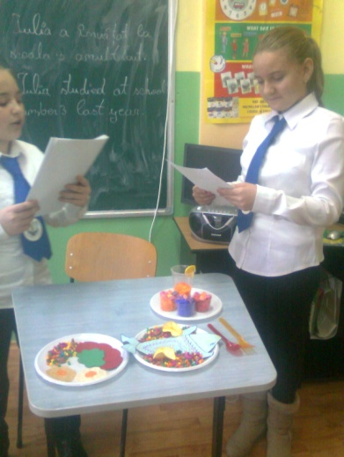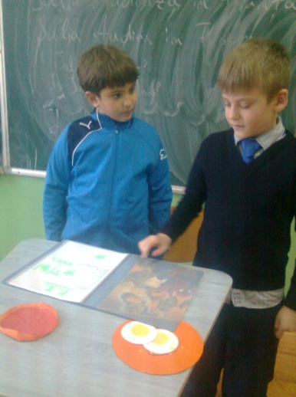

Vlad forgot the words and Tibi started to whisper.

Simona and Denisa checked the ingredients on their menus but they forgot … salt.

When their ‘customer’ (Elena) checked the recipe she complained that the food was not salty. We all laughed in the classroom.

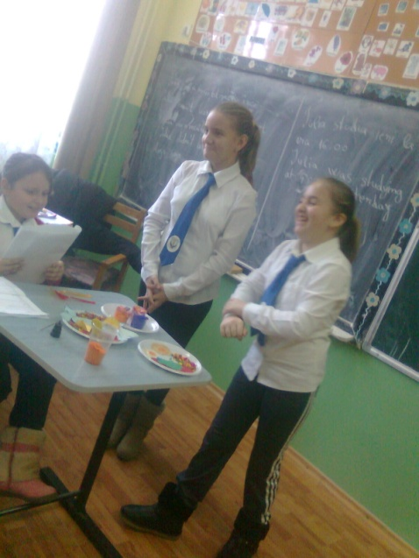

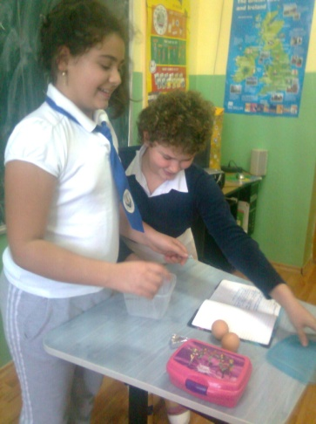

But the funniest moment was that of Flori’s and Denisa’s.They brought real food, they broke the eggs into a bowl and were ready for pancakes. It was hilarious!



I am passionate of the Internet. I like to explore pages with information about nature, history and geography. The other day I discovered something amazing about the origin of some sayings and customs in English.

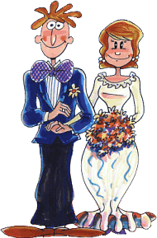

In 1500 most people got married in June because they took their yearly bath in May, and they still smelled pretty good by June.. However, since they were starting to smell . ...... . brides carried a bouquet of flowers to hide the body odor. Hence **the custom today of carrying a bouquet when getting married.**

Baths consisted of a big tub filled with hot water. The man of the house had the privilege of the nice clean water, then all the other sons and men, then the women and finally the children. Last of all the babies. By then the water was so dirty you could actually lose someone in it.. Hence the saying, **"Don't throw the baby out with the bath water!"**

Houses had thatched roofs-thick straw-piled high, with no wood underneath. It was the only place for animals to get warm, so all the cats and other small animals (mice, bugs) lived in the roof. When it rained it became slippery and sometimes the animals would slip and fall off the roof**... Hence the saying "It's raining cats and dogs."**

In those old days, they cooked in the kitchen with a big kettle that always hung over the fire.. Every day they lit the fire and added things to the pot. They ate mostly vegetables and did not get much meat. They would eat the stew for dinner, leaving leftovers in the pot to get cold overnight and then start over the next day. Sometimes stew had food in it that had been there for quite a while. Hence the rhyme: **Peas porridge hot, peas porridge cold, peas porridge in the pot nine days old.**

Bread was divided according to status. Workers got the burnt bottom of the loaf, the family got the middle, and guests got the top, or the upper crust.



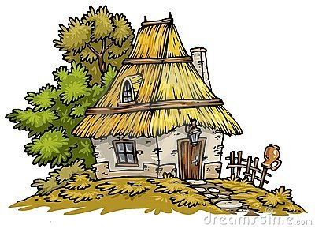

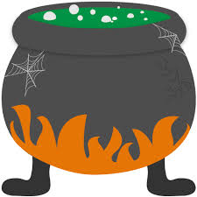





Do you sometimes dream to live in a castle? Nothing unusual! People have been dreaming of this for ages. In fact, castles are an old obsession of humankind.

In the ancient Egyptian society the idea of kingship and divinity was a combination between the divine and the mortal*. “Ideally the kingship was passed down from father to son, and each king was usually keen to demonstrate to his subjects that he was the "chosen" heir whose right to rule was ensured by his own divinity. Relieves in temples, tombs and palaces stress the King's divine birth and his function as a representative of the gods was to preserve and restore the original harmony of the universe, imposing order and preventing chaos.” (*http://www.bbc.co.uk)

The British idea of sovereignty comes mainly from the personal effort that approaches the person to the God. Therefore a palace is a rather late residence of the King, deriving from the idea of “castle” (human effort to win a battle and become the leader of it) and from the idea of “cathedral” (like an ode to the divine power who entitled the King’s person to be the recipient of the God’s “grace” and power).

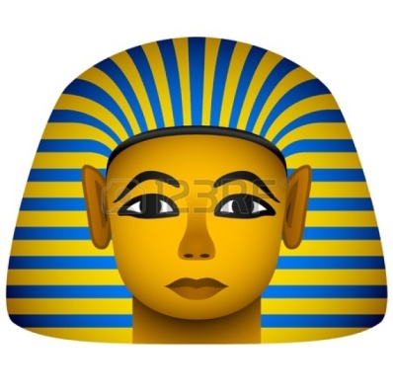

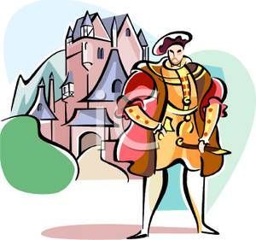

The term "palace" has its origins from the Palatine Hills in the city of Rome. But the idea of a palace as a symbol for a whole civilization comes from immemorial times. The Chinese emperors usually possessed not only a huge building to live and lead from but also a small city around it.

The idea of an ancient Chinese palace was that the maintenance of the 10,000 rooms inside should not exceed the budget proving by that the emperor is able to take care of his belongings and his State.

A British palace has never been as grandious as a Chinese one but the costs for some of the most famous royal residences often exceeded the State budget. The European idea of “court” (unlike the Chinese idea of “courtyard”) usually implied a long row of noblemen who had to be paid and kept very close to the royal person because of the violent times the first palaces were built at the beginning. Moreover, while for the Chinese, through their philosophy, the emperor was indisputably a divine presence so everyone obeyed in an instant, for the British kings history recorded a huge gap between the institution of Church and the Monarch and thus a long number of fights for power.



ROYAL PALACES

EPISODE 1



**RAIN**

**Sometimes I cry with the rain.**

**My eyedrops fall down with its**

**And we both fall on the ground**

**Giving a final hug**

**To the horizon.**

***didi***

Members of the “Golden Key” team:

Mihnea, Darius, Andreea – preppy group

Nicoleta, Ana, Georgiana –

1st grade

Gabi, Costi, Edi, Miruna, Mario – 2nd grade

Dragos, Alexia, Ianis, Vlad – 3rd grade

Alex, Sara, SDabina –

4th grade

Gabi, David, Adina, Simona, Cristiana – 5th grade

Oana, Alexandra, Diana, MIhai – 6th grade

Ana, Coti, Andrei, Claudiu, Costina – 7th grade

Ionut, Monica, Oana, Didi – 8th grade

Teacher of English: Angela Soare





**SUN**

**Today I stole the sun in the sky**

**And hid it deeply in my pocket**

**Since then**

**I’ve been carrying**

**it with me**

**Everywhere.**

***Oana***